Control your step….
LAST UPDATED ON WEDNESDAY, 21 JANUARY 2015 09:43
WRITTEN BY STONE51
WEDNESDAY, 21 JANUARY 2015 09:43

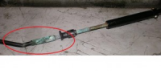
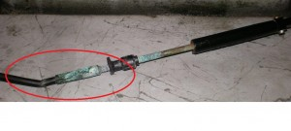Control your step
It’s very common to find tight controls on most of the boats we service.
As you can see in this pic the cable has about a 30 degree bend in it.
In most cases the customer has had someone step on the cables, located at the rear of the boat.
Other possibilities are when the motor is tilted the control cables contact an area in the well of deck of the boat.
Over time this will break the internal cable and you could be faced with a very dangerous situation.
So if you have a tight control- check the area where the cables enter your motor; if they look like this replace them.
By the way – stop using grease to lubricate your steering arm. It traps dirt inside the cylinder and builds up. Simply use motor oil and coat it, and wide it down. A few good turns will help it stay good for the next time you’re on the water.
TAGS: BENT STEERING CABLE, BOAT RIGGING, BOAT STEEERING, DON'T GREASE YOUR STEERING, GREESE STEERING, STEERING ARM, STEERING CABLE, STEERING CABLE ISSUES, STEERING CABLE REPAIR, STEERING ISSUES, STRREING CABLE

