More Ethonal Problems … an every day occurrence
LAST UPDATED ON THURSDAY, 19 JULY 2012 01:02
WRITTEN BY STONE51
TUESDAY, 19 JUNE 2012 08:05

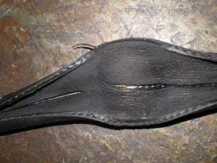Every day we see evidence of ethanol damage in fuel systems…. but it’s not just in your carburetors or your gas … here is another picture of a bad fuel line … you can see where the fuel line particles break away and get lodged in your carb jets …. We are hearing of boaters getting carb jobs and end up back in the shop in a few weeks believing their carburetors were not serviced properly … but in actuality they needed to change their fuel lines as well … the benefits of using a certified mechanic at Stone and Sons Marine would of caught this, and given the boater more time on the water and out of the shop
TAGS: CARBURETORS, ETHANOL, ETHANOL DAMAGE, HOUSTON, OUTBOARD REPAIR

