Ethanol Treatment – when it goes wrong – and what to do
LAST UPDATED ON MONDAY, 24 SEPTEMBER 2012 08:17
WRITTEN BY STONE51
MONDAY, 24 SEPTEMBER 2012 08:17

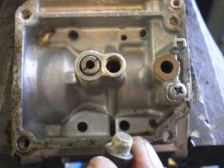
This client of ours has been using a certain fuel treatment with enzymes.
What went wrong? – Well it still left some dried up waste in the carbs that clogged up the jets.
No Beneno!
This product is supposed to eliminate and prevent ethanol fuel problems.
We have now seen FOUR boats with this issue using the same product.
Sometimes what you think is helping you, is your own worst enemy.
What should you do? We suggest using clean fresh fuel and try running your motor at least once a month and skip the additives.
TAGS: ETHANOL, ETHANOL DAMAGE, ETHANOL FUEL PROBLEMS, ETHANOL TREATMENT, FUEL ISSUES, MARINE FUEL

