Prop Shaft – save yourself money and time with free advise
LAST UPDATED ON FRIDAY, 14 SEPTEMBER 2012 10:03
WRITTEN BY STONE51
FRIDAY, 14 SEPTEMBER 2012 10:03

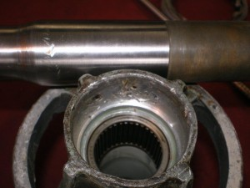
We love our customers, and hate to hear it when someone causes themself more pain. This guy removed his prop shaft seal without removing the bearing carrier and as a result damaged his prop shaft seal surface and the seal carrier. Combined, these two parts cost him $ 520.00. If he had called or came by we would have informed him of “how to” or for a small fee removed his carrier for him. This repair should have only cost him the price of seals. Call us any time you need assistance.
We cater to DO IT YOURSELFERS
TAGS: DO IT YOURSLEF PROP SHAFT, LOWER UNIT REPAIR, LOWER UNIT SEALS, LOWER UNTI SEALS, PROP SEALS, PROP SHAFT, PROP SHAFT SEALS

