How often should you change your water pump?
LAST UPDATED ON WEDNESDAY, 16 MAY 2012 08:07
WRITTEN BY STONE51
MONDAY, 7 MAY 2012 01:31

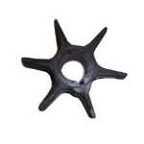
We are often asked how long will a water pump last? – The one above has seen better times
This is the part that helps water, pump through your motor and cool it down.
In short – change it once a year. Here on the Gulf Coast we have numerous things that put excessive wear and tear on a part designed to wear down. Your time on the water is too important. Take the time and have it changed by a trained professional at Stone & Sons Marine.
TAGS: BOAT ENGINES, BOAT SERVICE, SERVICE, WATER PUMP

This entry was posted on Monday, May 7th, 2012 at 1:31 pm and is filed under Blog. You can follow any responses to this entry through the RSS 2.0 feed. You can leave a response, or trackback from your own site.

