Even a new part/ new motor can be bad
LAST UPDATED ON WEDNESDAY, 27 AUGUST 2014 05:37
WRITTEN BY STONE51
WEDNESDAY, 27 AUGUST 2014 05:36

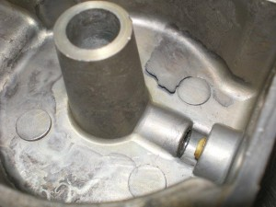
Check this out folks!
Just because you purchase a new motor don’t think all is clear!
Manufactures are people just like you and I.
And we all have good and bad days.
This is a brand new carburetor bowl, and as you can see there will be a problem!
It’s just a matter of when? Once that piece of metal flakes off, who knows what issues it will cause… and when. Hopefully not right after your manufactures warranty expires.
This is another reason to do regular maintenance to inspect your motor for any possible actions that might leave you “STUCK” on the water.
Most of all having a competent shop to take your boat too, with “experience”.

TAGS: BEST BOAT SHOP IN TEXAS, BEST OUTBOARD REPAIR SHOP, NEW BOAT MOTOR ISSUES, NEW OUTBOARD PROBLEMS

