Trailer Bearing Grease – to much of a good thing
LAST UPDATED ON MONDAY, 10 SEPTEMBER 2012 11:52
WRITTEN BY STONE51
MONDAY, 10 SEPTEMBER 2012 11:52

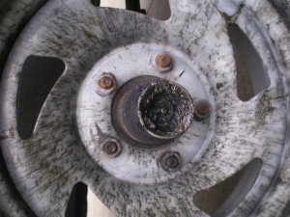
Over greased bearings; a common sight that rolls into the shop parking lot all to often.
This is not a good thing. The owners believe they are doing something that is good, but actually, they are blowing out the seals on the back side. A good indication is all the excess grease that is being slung all over the wheel. Sometimes you see this, stuff being slung on the hull itself and even on the steps of the trailer.
You are now damaging what is protecting you!
How much grease should you use? – Look on the inside of the race- and find a tiny groove. This is where you stop.
Have your hubs checked by a professional once a year, to determine if it’s time to repack new bearings. If you are making long hauls, and use your trailer a lot, you might need to have your bearing repacked once a year.
Simply use marine grade bearing grease when you maintain your trailer.
TAGS: BEARING GREASE, BEARINGS, MARINE BEARINGS, MARINE GREASE, TRAILER BEARINGS

