The effects of ethanol on fuel hose
LAST UPDATED ON TUESDAY, 5 JUNE 2012 01:05
WRITTEN BY STONE51
MONDAY, 4 JUNE 2012 02:31

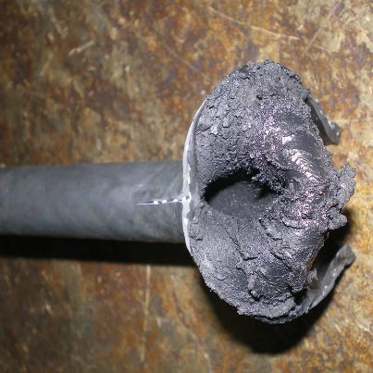This is a factory installed ethanol friendly hose, In the 20 inch run of this hose this was the low spot in it where ethanol would stand. This motor required a 385.00 fuel pump to be replaced due to the rubber particles. Old hoses should be replaced. Cheap preventive maintenance
TAGS: BAD GAS, BAD HOSE, ETHANOL, FUEL LINE, HOSE, OEM HOSE, OUTBOARD REPAIR, PREVENTIVE MAINTENANCE

