“I didn’t hit anything!”…. “Did I?”…
LAST UPDATED ON FRIDAY, 19 OCTOBER 2012 08:02
WRITTEN BY STONE51
FRIDAY, 19 OCTOBER 2012 07:58

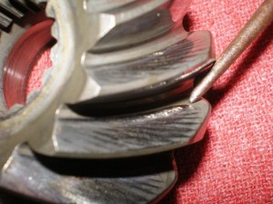
All to often we have customers with lower unit failure that tell us, “I didn’t hit anything” , ”I was in open water”.
This particular type if damage does not show up right of way. It is a degenerative condition.
This picture is an example of what we commonly find in gear cases. We generally are taking them down, due to needing the seals replaced and this is what we discover. It is important to have a trained mechanic, who knows what to look for.
The pic. shows damage to the pinion gear from a prior impact; like running aground and hitting sand or mud at high RPMs. Also trying to plain out while on the bottom can be the cause. This can be caused from improper shimming or metal fragments from any parts in the gear case such as clutch dog ratcheting. This is the biggest reasons to check your lower unit oil often. It should be amber or common oil color.
- Black lower unit oil means it’s time to change
- White to cream color oil (your seals need to be changed)
- Metal in oil means there is a good chance you need a rebuild
WATER in oil = Lower unit Rebuild
Neglet of what goes under the water, could cost you big time.

TAGS: LOWER UNIT, LOWER UNIT GEARS, LOWER UNIT NOISE, LOWER UNIT OIL, LOWER UNIT REPAIR, LOWER UNIT SEALS, LU, LU OIL, WATER IN LOWER UNIT

