Need a part sent to you … we got that!
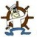
LAST UPDATED ON MONDAY, 4 MARCH 2013 07:37
WRITTEN BY STONE51
THURSDAY, 28 FEBRUARY 2013 01:10

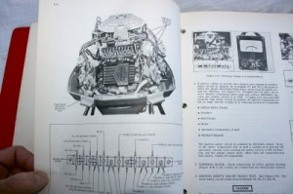
Let’s say you need a part, but are not sure which one.
You want to make sure that who you’re buying it from will get you the right part, the 1st time.
Not only do you need the part, but have a question to go along with it.
Who do you call? Sons and Sons Marine of course!
Our parts department ships parts worldwide. We have sent parts to Russia, Asia, and Southern Africa. You can’t get much more worldwide than that.
How does a small shop in Houston have that kind of customer base? Well this small shop has one big warehouse! And it comes with 40 plus years of experience to tell you what you needand how to put it on.
We know of the discontinued parts and have the updated parts to substitute. We even have manufactured some parts for our clients.
Stone and Sons Marine cater to do-it yourselfers, and want you on the water no matter where that water is….
Let our experience and inventory help you get there.
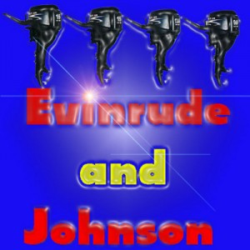
TAGS: ANTIQUE EVINRUDE PARTS, ANTIQUE OMC PARTS, ANTIQUE OUTBOARDS, JOHNSON OUTBOARD PARTS, MAIL ORDER OUTBOARD PARTS
Nee

