When A Memory is a BAD Thing
LAST UPDATED ON THURSDAY, 13 MARCH 2014 08:03
WRITTEN BY STONE51
THURSDAY, 13 MARCH 2014 08:00

When A Memory is a BAD Thing
Your outboard water pump is a two-stage pump containing a rubber impeller.
At low speeds ,the pump operates as a full displacement Friction pump. At higher speeds, the impeller blades bend back under the increased water pressure and the pump becomes a centrifugal action pump.
In the photo you can see on the right side the impellers have blades that have developed a memory from sitting in the housing for an extended period of time, they have lost their blade tension and this will result in low pump pressure at lower RPM or slower speeds of operation.
You will see water exiting your motor ” BUT ” you may be running it in the upper range of operating temperature.
It’s a good idea to replace your water pump every two years, even more so if it’s had little to NO use.

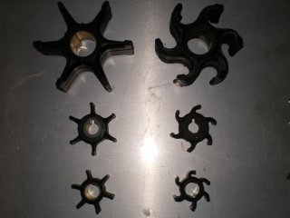
This entry was posted on Thursday, March 13th, 2014 at 8:00 pm and is filed under Blog, OMC outboard motor. You can follow any responses to this entry through the RSS 2.0 feed. You can leave a response, or trackback from your own site.

