Having a “Meltdown” on the water is never a good thing …..
LAST UPDATED ON THURSDAY, 30 OCTOBER 2014 03:57
WRITTEN BY STONE51
THURSDAY, 30 OCTOBER 2014 03:56

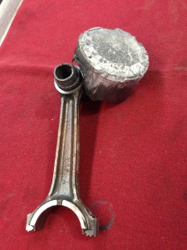
Sooner or later there will be a decision you make, that you wish you could have gone back and choose differently.
Perhaps you are walking down the isle of a boating section, shopping for 2-stroke oil…Hey, lots of choices, and “they must all be the same since they have the TC-W3 on the label?” … you might think again on that.
They are not all created equal, and yes you do get what you pay for…. as the old saying goes.
We are not scientist, here to show you graphs and data …blah, blah, blahhhhh …..
What we can provide are result of going cheap on oil for your outboard. SEE PICTURE
You want to save a few dollars and buy the cheap stuff …go ahead … you keep repair shops like us in business, and we appreciate your money.
BUT if you want to stay on the water, go with a quality named brand oil, not found on the bottom shelf of a box store.
It would be tough to go wrong, with the same name brand that you are already running on the back of your boat.
TAGS: 2 STROKE OIL, 2-CYCLE, CITGO 2-CYCLE OIL, DIFFERENCE IN 2 CYCLE OIL?, PENNZOIL MARINE, SUPER TECH, SUPERTECH, TC-W3, TC-W3 OUTBOARD 2-CYCLE OIL, TCW3

