Money to burn? – the enemy of the wallet & boats
LAST UPDATED ON THURSDAY, 31 JANUARY 2013 01:05
WRITTEN BY STONE51
WEDNESDAY, 30 JANUARY 2013 10:28

Over and over I’m told
“ I haven’t run it but one or two times since my last tune up”
“When was your last tune up?” …. I’m told last year or longer.
In their thinking they believe they haven’t run it enough to have any problems.
BUT ….
Here is the problem. Most motors have components on them that hold fuel.
If given enough time, fuel will evaporate or dry out, then your carbs are left with residue in them. Sometimes the remaining fuel will be mixed with oil, once the gas is gone it’s a gunky oil mess.

Think of this as a clogged artery restricting fuel flow.
Another problem from non use – With today’s ethanol fuel, you can have deterioration of the inner lining of your fuel lines at low spots in the hose, where the ethanol may sit. Fragments of the deteriorated hose will clog jets, injectors, filters, and so on.
So what do you need to do?

- We suggest you run your motor once a month.
This will not give your motor enough time to dry out your fuel and keep you out of the shop and on the water.

So you see- “YOU just might be your own Pocket Book Enemy”
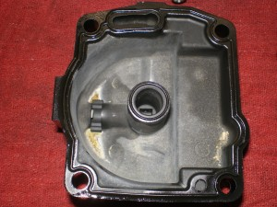
TAGS: CARBURETOR PROBLEMS, ETHANOL, ETHANOL AND CARBURETORS, ETHANOL FUEL PROBLEMS, OUTBOARD CARBURETOR ISSUES, OUTBOARD CARBURETOR PROBLEMS, WINTERIZING A BOAT CARBURETOR, WINTERIZING A BOAT ISSUES

