The Damage we do to our lower unit
LAST UPDATED ON MONDAY, 25 JUNE 2012 11:16
WRITTEN BY STONE51
TUESDAY, 19 JUNE 2012 08:26

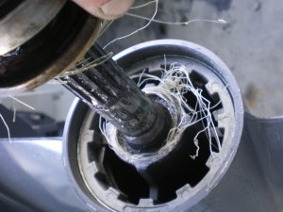
How often do you check your prop, and what lies behind it? … Is once a year enough? In some cases it’s not. This was the 1st trip out after it was in the shop. If this would have remained the line would have penetrated the seals allowing water into the lower unit $$$. With costly results in the end. Always pay attention to your prop after each day of use.
TAGS: FISHING LINE DAMAGE, LOWER UNIT, LOWER UNIT DAMAGE, LOWER UNIT SEALS, PROP, PROPELLER, WATER IN LOWER UNIT

