It might be older than you – but they are still great motors
LAST UPDATED ON FRIDAY, 25 JANUARY 2013 08:17
WRITTEN BY STONE51
TUESDAY, 22 JANUARY 2013 08:04

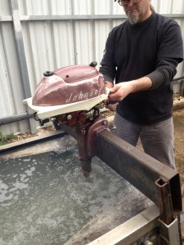
Here is a picture of one of the many kind of boat motors we work on.
1956 Johnson
These motors were built like tanks.
They require a 24;1 ratio of oil to gas, and used a badit style bearings.
Stone and Sons Marine stocks the parts for this year motor and many others of it’s age.
We ship parts all over the world for our clients and for the lucky ones in our area, we can service them too.

TAGS: 1956 JOHNSON, ANTIQUE JOHNSON PARTS, ANTIQUE OUTBOARDS, ANTIQUE OUTOBARD MOTOR PARTS, HOW TO FIX OLD OUTBARDS, OIL RATIO FOR OLD OUT BOARDS, OLD EVINRUDE OUTBOARD PARTS, STONE AND SONS MARINE

