Is it time for a new Prop?
LAST UPDATED ON WEDNESDAY, 16 MAY 2012 08:44
WRITTEN BY STONE51
WEDNESDAY, 16 MAY 2012 08:31

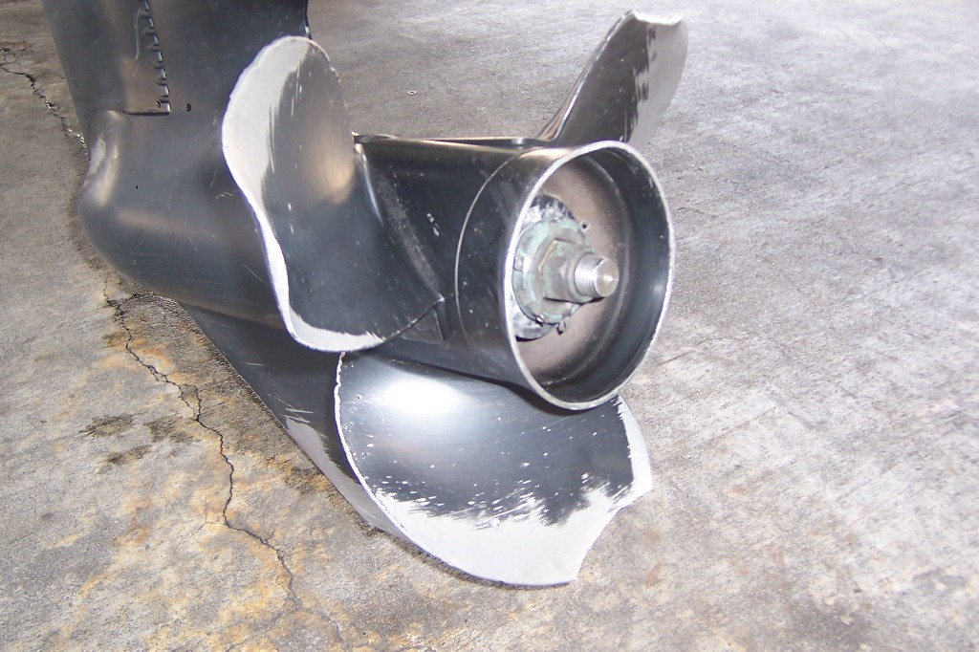Stone and Sons Marine can also have your prop serviced while your boat is being worked on….
One stop shop ….
You work hard to play hard …. don’t wait around for your boat … get it to Stone and Sons
TAGS: 3 BLADE, 4 BLADE, HOUSTON, LOWER UNIT, LOWER UNTI, PITCH, PROP, REPAIRS, SHAFT

