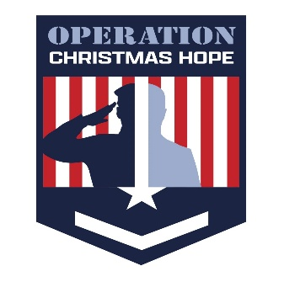
Dear Parents/Caregivers,
We’re so happy to connect with you this Christmas season! At Operation Christmas Hope, it’s our honor to support your family and show appreciation for your service to our country. Our mission is simple — to help lift some of the weight that comes with the holidays and bring a little more joy to your home.
Please take a few moments to carefully fill out the attached page for each child. Your notes will help us choose the right gifts — the kind they’d pick out themselves. Be as specific as possible when listing sizes, colors, or interests. If there’s something your family needs that’s not on the form, add a short note — we’ll do our best to include it.
Gift details for this year:
Children 13 years and older will receive gift cards. Please let us know where they like to shop.
Children 12 years and younger will receive gifts, unless you’d prefer a gift card instead. (If so, please indicate that on their form.)
We’re also providing food support for your family during the school holiday break. We will provide beef, chicken and pork, along with a gift card to a grocery store of your choosing. Please complete the food section at the bottom of this form so we can prepare your box properly.
If you have any questions or need help filling out your form, please reach out — we’d love to hear from you.
Wishing you and your family peace, warmth, and happiness this holiday season.
With gratitude,
Sheri Dove
315-730-4450

PLEASE COMPLETE
Where do you do the majority of your grocery shopping?
Meat options (circle as many as you’d like): PORK CHICKEN BEEF
CHILD INTAKE FORM
Child’s First Name: Age:

Children 13 years and older will receive gift cards. Please let us know where they like to shop.
_________________________________________________
Children 12 years and younger will receive gifts, unless you’d prefer a gift card instead.
(If gift card is preferred, please note the store they like to shop at on the line above and disregard the rest of this form.)

Child’s Size Group (circle one): baby/toddler boy/girl juniors mens/womens
Shirt Size:
Pant Size: (and circle one): short/regular/long skinny/bootcut
Underwear Size: (and circle one): boxers/briefs or bikini/boyshorts
Sock Size: (and circle one): no show/ankle/mid-calf
Bra Size:
Shoe size: (and circle one): toddler/youth/adult
Does your child need winter items? Jacket Boots
(Circle what is needed) Gloves Hat

Please tell us more about your child’s preferences.
Color: Characters:
Sports teams: Interests/Hobbies:
Books/Music: Crafts/Art:
Toys/Games: Pierced Ears/Hair accessories:
Other info:

Would you like these presents wrapped? Yes/No (If no, we provide tape and wrapping paper)
Would you like tags made out to your child from Santa? Yes/No

