Life Academy
2017-2018 SCHOOL SUPPLY LIST

K-4 | 3rd Grade | 6th Grade
• 1 box of 8 large crayons | • 10 packages of #2 pencils | • 1 bottle of glue
• 2 fat pencils | • 1 Bible (available from the school for | • 1 pair of scissors
• 1 plastic pencil box  • 2 glue stick | $7)  • 10 packs of wide ruled notebook | • 1 dozen pencils  • 1 large eraser

• 1 smock or old shirt for painting
• 1 mat for nap time
• 3 boxes of Kleenexes
• 1 box of baby wipes
• 1 pair of scissors with a blunt tip

K-5
• 1 box of 8 large Crayola crayons
(Crayola brand only please)
• 1 pair of Fiskars scissors
• 2 fat pencils
• 2 pocket folders
• 2 large boxes of Kleenexes
• 1 box of Clorox wipes
• 1 box of Huggies wet wipes
• 1 plastic pencil box

1st Grade
• 1 glue stick
• 1 pair of scissors
• 1 package of #2 pencils
• 1 ruler with Metric and English measurement markings (12 inches)
• 1 pack of 24 count crayons
• 1 small pack of markers
• 1 plastic pencil box
• 1 Bible (available from the school for
$7)
• 4 plastic pocket folders (red)*
• 4 plastic pocket folders (blue)*
• 1 large box of Kleenexes
• 1 large box of Clorox wipes or wet wipes
Please do not send in pencil sharpeners
or ink pens

2nd Grade
• 1 packages of #2 pencils*
• 1 large eraser
• 1 ruler with Metric and English measurement markings (12 inches)
• 1 box of Crayola Twistable crayons
• 1 Bible (available from the school for
$7)
• 4 plastic, pocket folders (2 red, 2 blue)*
• 1 large box of tissues*
• 1 package of wet wipes
• 4 packages of wide ruled notebook paper*
• 1 small plastic pencil box
• 1 package of construction paper Please do not send in pencil sharpeners or ink pens
paper
• 1 Webster dictionary (must label words as noun, adjective, verb, etc.)

4th Grade
• 1 bottle of glue
• 1 pair of scissors
• 2 large erasers or a package of pencil top erasers
• 1 ruler with Metric and English measurement markings
• 1 package of colored pencils
• 1 Bible (available from the school for
$7)
• 4 packs of wide ruled notebook paper*
• 2 pocket folders (one red; one blue)
• 1 pack of construction paper
• 1 box of Kleenexes*
• 1 box of baby wipes*
• Pencils (48 ct.)*
• 1 3-ring binder
• 1 small pencil box
• 1 bottle of hand sanitizer
Please do not send in pencil sharpeners, spiral notebooks, highlighters, or
markers.

5th Grade
• 2 highlighters
• 1 large glue stick & 1 bottle of glue
• 1 pair of scissors
• 1 dozen pencils or mechanical pencils (w/ extra lead)
• 1 pack of colored pencils
• 1 ruler with Metric and English measurement markings (must have both)
• 1 plastic pencil box
• 1 Bible (available from the school for
$7)
• 4 packs of wide ruled notebook paper (no binder is needed – will be stored at school)
• 5 pocket folders with fasteners and pockets
• 1 pack of mixed construction paper
• 2 boxes of Kleenexes
• 1 box of wipes
Please do not send pencil sharpeners or spiral-bound notebooks.
• 1 ruler with Metric and English measurement markings (12 inches)
• 1 metal compass
• 1 clear plastic protractor
• 1 pack of colored pencils
• 1 pack of ballpoint pens (black or blue)
• 1 plastic pencil box
• 1 Bible (available from the school for
$7)
• 4 packs of wide ruled notebook paper
• 4 pocket folders
• 1 Webster dictionary (must label words as noun, adjective, verb, etc.)
• 1 box of Kleenexes
• 1 notebook

7th – 12th Grades
• 1 Bible with References
• On the first day of school, your child needs a notebook with paper and a pencil or pen
• Each teacher will give their students a list of supplies that they will need for the class
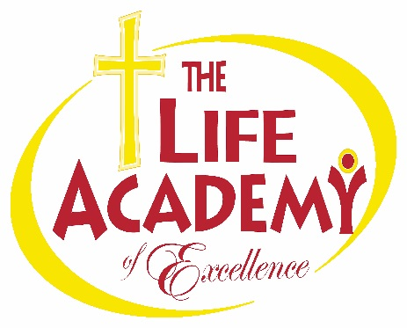

* Items marked with an asterisk above should not be labeled with your child’s name. Please note that additional items may be requested throughout the school year as needed.

Life Academy of Excellence 107 Wymore Road Eatonville FL 32751 -4107-622-1330-www.lifeacademypride.org

