The Life Academy of Excellence
Lunch Menu
October 2017

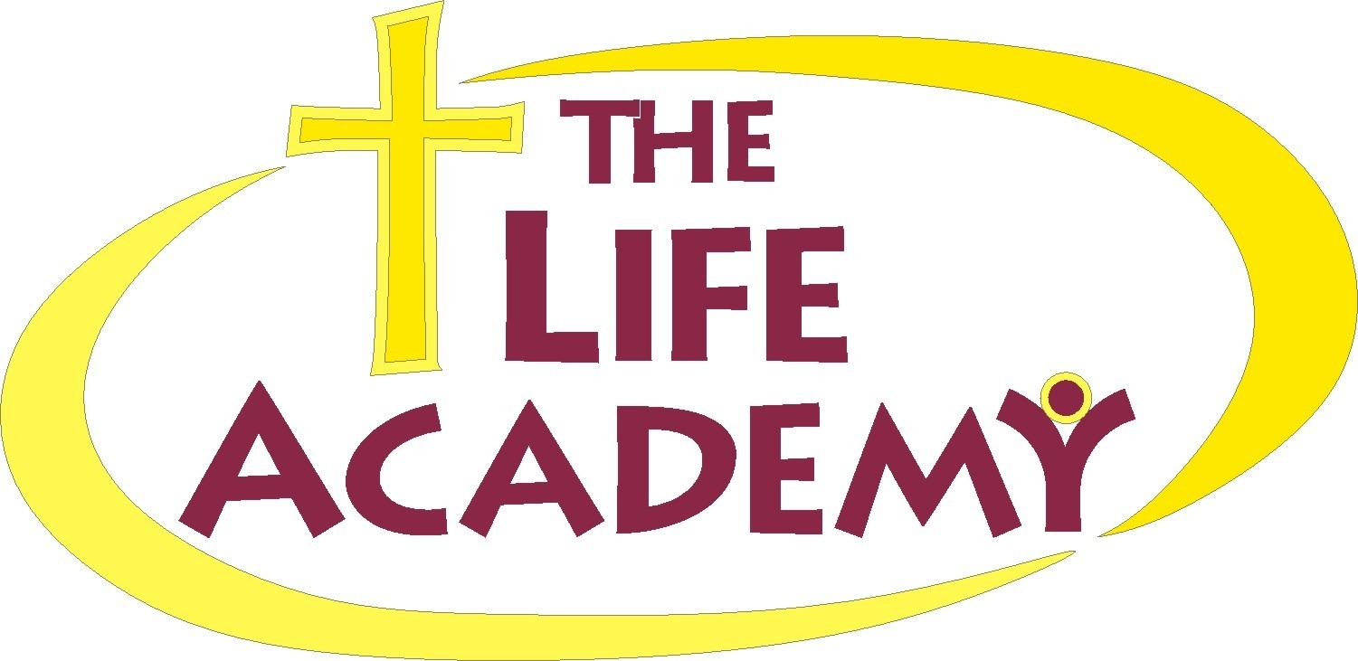
Monday
Tuesday
Wednesday
Thursday
Friday

2  Sloppy Joe  Whole Wheat Bun  Whole Kernel corn  Chocolate Pudding  Milk | 3  Hot Ham & Cheese Sandwich  Green Beans  Go Gurt  Milk | 4  Papa John’s Pizza  Lay’s Potato Chips  Fruit Punch or Apple Juice | 5  Seasoned Noodles  Broccoli w/ cheese  Buttered Rolls  Chocolate Milk | 6  Chicken Tenders w/ Dipping Sauce  Sweet Peas  Mash Potatoes  Jell-O Cup  Milk
9  Beef Stroganoff  Mixed Veggies  Buttered Roll  Fresh Fruit  Milk | 10  Breakfast for Lunch  Buttered Grits  French Toast Sticks w/ syrup  Sausage links  Milk or Orange Juice | 11  Papa John’s Pizza  Gold Fish Crackers  Fruit Punch or Apple Juice | 12  BBQ Chicken wings  Seasoned yellow Rice  Green Beans  Blueberry Muffin  Milk | 13  Hot Dog w/ Bun  Baked French Fries  Apple Sauce  Strawberry Milk
16  Chicken Nuggets  Mac & Cheese  Green Beans  Milk | 17  Turkey & Cheese Sandwich  Carrots Stick w/ Ranch  Fruit  Chocolate Milk | 18  Papa John’s Pizza  Cool Ranch Doritos  Fruit Snacks  Milk | 19  Taco Bar  Whole Kernel Corn  Ice-Cream  Flavored Water | 20  Meat Ball Sub  Coleslaw  Apple wedges  Milk
23  Cheese Grits  Fish Sticks  Apple wedges/ carmel Chocolate Milk | 24  Lasagna w/ Meat Sauce  Garlic bread  Green Beans  Choice Milk | 25  Papa John’s Pizza  Caesar Salad  Fresh Fruit  Juice | 26  Jamaican Beef patties  Seasoned Corn  Fruit  Milk | 27  Nacho Bar  Cheese, Tomato,  Sour-cream, Lettuce, Salsa  Choice Dessert  Water
30  Peanut Butter & Jelly Uncrustable  Fruit Salad  Celery Sticks  Milk | 31  Bar B Que Meatballs  Mash Potatoes  Mix Veggies  Roll  Milk

Breakfast

Breakfast

Lunch

Lunch

