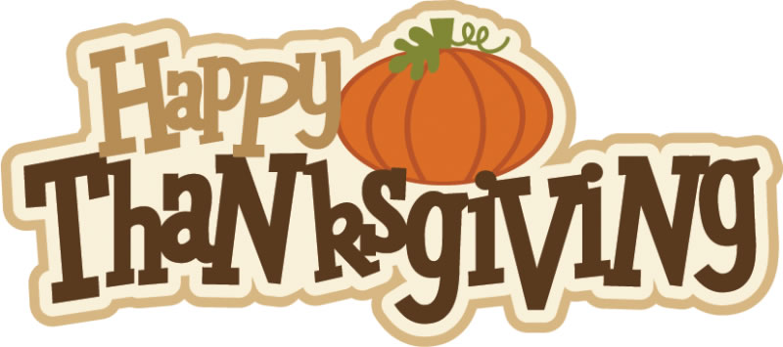

Monday
Tuesday
Wednesday
Thursday
Friday

 |  | 1  Papa John’s Pizza  Doritos  Apple juice | 2  Beanie Wienie  Whole Kernel Corn  Fruit  Rolls  Milk | 3  Grilled Cheese  Celery Stick  w/ peanut butter  Fruit  Milk
6  Hamburger Helper  Sweet peas  Buttered bread  Milk | 7  Popcorn Chicken  Tater Tots  Fruit  Milk | 8  Papa John’s Pizza  Gold Fish Crackers  Fruit Punch | 9  Chicken Alfredo  Broccoli w/ cheese  Fresh Fruit  Milk | 10  Spaghetti w/meat sauce  Tossed salad w/Ranch dressing  Brownies  Garlic bread  Milk
13  Cheeseburger  Fries  Fruit  Milk | 14  Chicken strips  Mashed potatoes  Green beans  Fruit  Chocolate Milk | 15  Papa John’s Pizza  Corn Chips  Fruit  Juice | 16  Corn Dogs  Tater Tots  Fruit  Milk | 17  Salisbury Steak  Buttered Rice  Steam Cabbage  Chilled Milk
20  Beefaroni  Mixed Veggies  Fruit  Milk | 21  Life Academy  Thanksgiving Family Luncheon  10:30 – 12:00 (dismissal) | 22  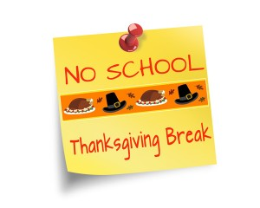 | 23 | 24
27  Hot Wings  Curly Fries  Jello  Milk | 28  Sloppy Joe w/ Bun  Corn-on-the-cob  Chilled Pears  Milk | 29  Papa John’s Pizza  Lays Potato chips  Apple Juice | 30  Shepard’s Pie  Carrot Sticks  Sliced Peaches  Milk

Breakfast

Breakfast

Lunch

Lunch

