The Life Academy of Excellence
Lunch Menu
December 2017

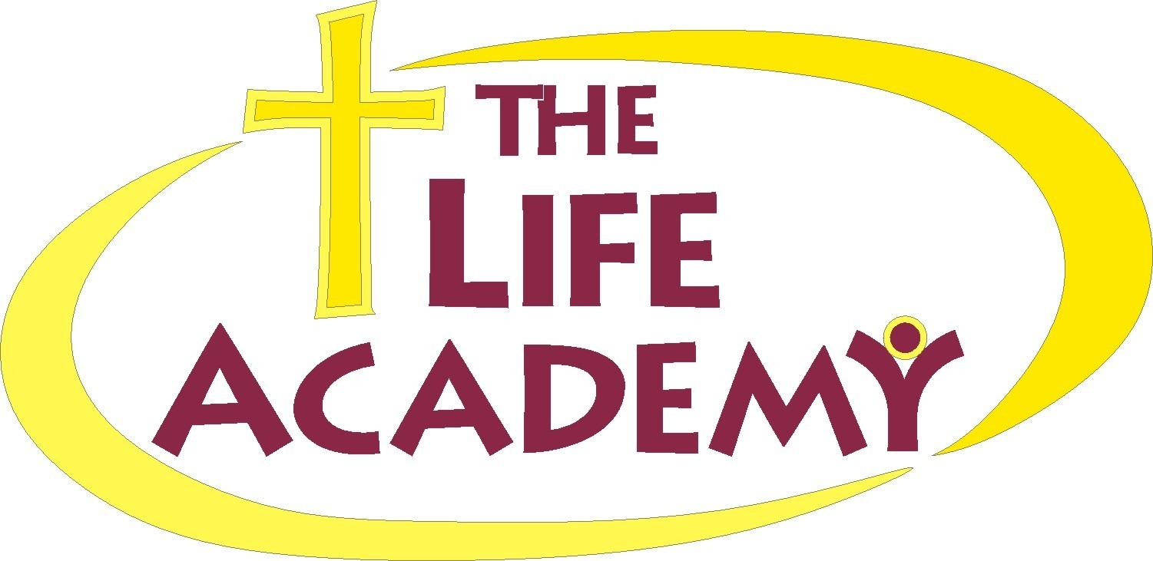
Monday
Tuesday
Wednesday
Thursday
Friday



1 Beef Sausage
Macaroni & Cheese
Green Beans
Fruit
Milk

4 Chicken Patties  French Fries  Green Beans  Fruit  Milk | 5 Lasagna w/Meat  Green beans  Buttered Bread  Fruit  Milk | 6 Pizza  Chips  Fruit  Juice | 7 Hot Dogs on Bun  Tator Tots  Chocolate Pudding  Milk | 8 Seasoned Noodles  Broccoli  Buttered Bread  Milk
11 Sloppy Joe  Corn  Vanilla Pudding  Milk | 12 Breakfast at Lunch  French Toast Sticks  Sausage Patty  Cheese Grits  Milk | 13 Pizza  Chips  Fruit  Juice | 14 BBQ Chicken  Yellow Rice  Green Beans  Milk | 15 Meat Ball Sub  Cole slaw  Orange Wedges  Milk
18 Hamburger Helper  Sweet Peas  Fruit  Milk | 19 Corn Dogs  Tator Tots  Fruit  Milk | 20 Pizza  Chips  Fruit  Juice | 21 Family  Christmas  Luncheon | 22  Christmas Break Begins
25 | 26 | 27 | 28 | 29

Breakfast

Breakfast

Lunch

Lunch

