The Life Academy of Excellence
Lunch Menu
February 2018
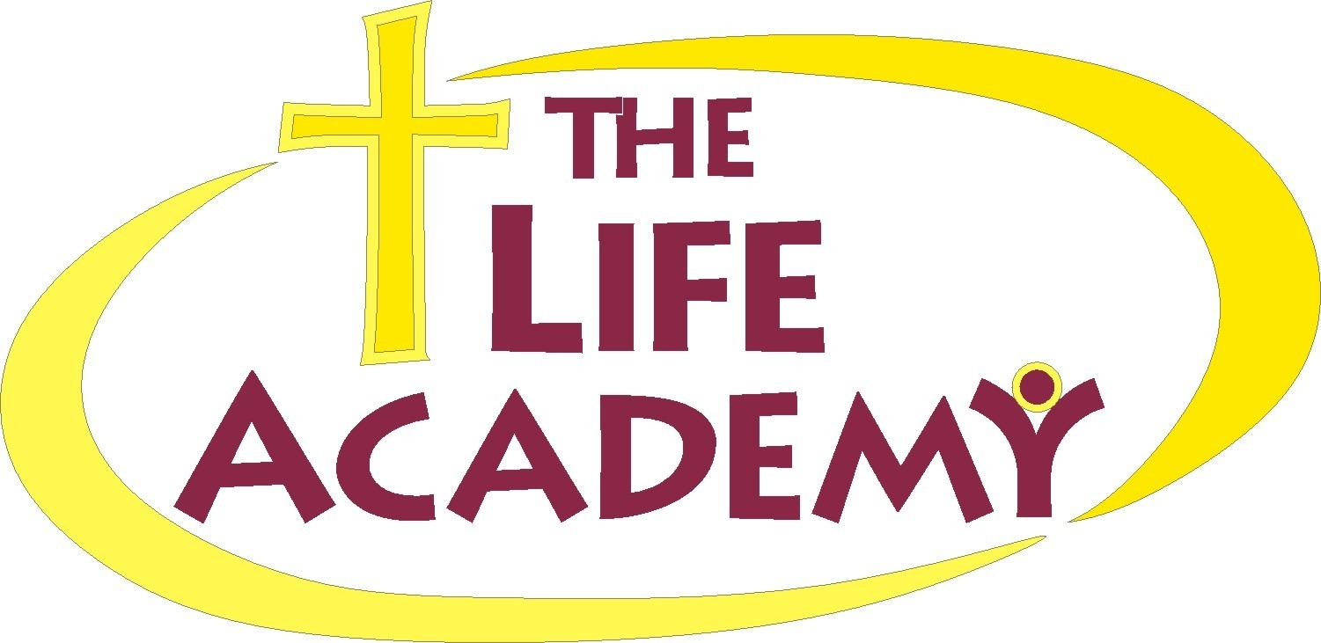
Monday
Tuesday
Wednesday
Thursday
Friday

 |  |  | 1 Beeforoni  Green Beans  Buttered Bread  Fruit  Milk | 2 Corn Dogs  Tator Tots  Friut  Milk
5 Spaghetti w/meat sauce  Toss salad  Garlic Bread  Fruit  Milk | 6 Hot Dog w/bun  French Fries  Mixed Fruit  Milk | 7 Pizza  Chips  Fruit  Juice | 8 Chicken Nuggets  Mashed Potatoes  Corn  Fruit  Milk | 9 Grilled Cheese  Sweet Pease  Applesause  Milk
12 Breakfast for Lunch  Pancakes w/syrup  Sausage Link  Cheese Grits  Milk | 13 Hot Wings  w/Ranch  French Fries  Fruit  Milk | 14 Pizza  Chips  Fruit  Juice | 15 Beef Sausage  Mac & Cheese  Green Beans  Fruit  Milk | 16 Lasagna  Buttered Roll  Mixed Veggies  Fruit  Milk
19 | 20 Barbecue Chicken  Green Beans  Fruit  Milk | 21 Pizza  Chips  Fruit  Juice | 22 Salisbury Steak  Rice  Broccoli  Fruit  Milk | 23 Chili w/Crackers  Sweet Peas  Fruit  Milk
26 Sloppy Joe  Green Beans  Fruit  Milk | 27 Ham & Cheese Sub  Sweet Peas  Fruit  Milk | 28 Pizza  Chips  Fruit  Juice

Breakfast

Breakfast

Lunch

Lunch

