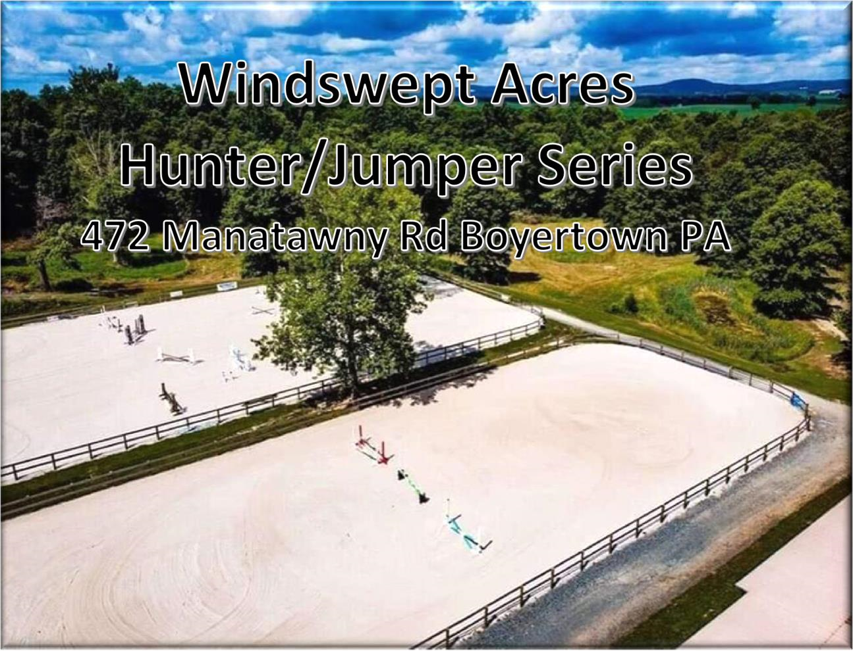

Windswept Acres All Thoroughbred Horse Show

September 26, 2026

Start Time 8am

Schooling 7:00-7:45am

Entry Information
- Pre-entries must be submitted the Thursday before the show. Pre-entries are $25 per class. Stakes and Classics are $35 per class. There will be a $15 EMT/Secretary fee.
- A completed entry form and signed liability waiver are required.
- Negative Coggins and any applicable health documentation must be available upon request.
- Management reserves the right to combine, divide, cancel, or reorder classes as necessary.
- All Hunter Classic Rounds scored together*
- All Jumper Classic Rounds scored together*
- The judge's decision is final.

General Rules
- All horses must be Thoroughbreds or otherwise meet the eligibility requirements established for the show. (TIP number is required AND free).
- TIP number must be sent in with entry.
- Proper riding attire is required.
- ASTM/SEI-approved helmets are required whenever mounted where applicable.
- Unsportsmanlike conduct may result in elimination.
- Dogs must remain leashed.
- Exhibitors are responsible for maintaining a safe and orderly stabling and trailer area.
- Go to www.ectbleague.com for League information, membership application and show calendar.
- For a new TIP number-go to www.tjctip.com
- All owners and riders may participate in ECTB League recognized horse shows, but only those owners and riders who are members of the ECTB League will be awarded points in the ECTB League.
- Use of any medications, supplements, substances or treatments outside of USEF Rules is prohibited.
- A horse is limited to no more than eight (8) performance classes per show day. In hand and leadline classes do not count towards this limit.

Facility Information
- Parking: Field Parking
- Food Vendor: Schaeffer's Catering (on premises until 3pm)
- Restrooms: Porta potty
- Outdoor Wash stall available
- Only boarders/clients of Windswept Acres inside the barn please :)

Contact Information
Windswept Acres
Show Manager: Jamie Gilbert-Kulp or Cyndi Gilbert
Phone: 610-413-1447 or 610-334-8440
Email: windsweptacrespa@hotmail.com
We thank all exhibitors, volunteers, sponsors, and spectators for supporting the Windswept Acres All Thoroughbred Horse Show and wish everyone a successful and enjoyable day of competition.

ADDRESS DAY OF THE SHOW:
472 Manatawny Road
Boyertown PA 19512
NOTE: do NOT send entries to farm address
When using a GPS do NOT take Spangsville Rd. There is a covered bridge and it cannot handle the weight of a trailer. windsweptacrespa@hotmail.com for any questions (note the PA at the end of windsweptacres ^ )

Division Description
Mares In Hand: To be judged on conformation, soundness, and suitability as a hunter. Will be required to jog.
Geldings In Hand: To be judged on conformation, soundness, and suitability as a Hunter.. Will be required to jog.
OPEN leadline- open to all non- "normal riders." Meaning- if you ride 5xs a week- no entering :) This is for the spouses, the parents, or even the non-riding kids!
Regular leadline- 8 years old and under
Pleasure: Open to all riders and horses. Judged on soundness, manners, and way of going.
Cross Rail Hunter: Open to all riders and horses. Fences to be cross rails. Trotting in corners not to be penalized.
2’ Hunter: Open to all riders and horses.Trotting in corners not to be penalized.
2’3” Hunter: Open to all riders and horses. Fences to be 2’3”
2’6 Hunter: Open to all riders and horses. Fences to be 2’6”, oxers set with breakaway cups only.
Jumper Divisions
All Jumper Divisions (Cross Rail, .70m, .80m, .90m, 1m): Open to all rider and horse combinations. 3 classes per division with the option of doing a 4th class- 36. Jumper Classic
Class 36- Will be scored at the conclusion of all jumper divisions. Ribbons for 1st-10th. Pay out for 1-6th. Must have a minimum of 10 entrants for prize money. Stake class will run concurrently with your division. Awards at the conclusion of the jumpers.

PRE-ENTRIES MUST BE RECEIVED BY THE THURSDAY BEFORE THE SHOW, PRE-ENTRY
$25/CLASS. ENTRIES THE DAY OF SHOW $30/CLASS. CLASSICS are $35 per class. ENTRIES MAY BE MAILED TO Cyndi Gilbert 91 MEXICO ROAD; OLEY, PA; 19547 or EMAILED to windsweptacrespa@hotmail.com Checks made out to WINDSWEPT ACRES OR VENMO : @windsweptacrespa (make a note of the RIDER name in VENMO)

PLEASE ADD A $15 EMT/SECRETARY FEE TO YOUR ENTRY.

Rider: ________________________________________________ DOB (If under 18): _________

Name of Horse: __________________________________________________________________

Address: ________________________________________________________________________

Phone: _______________________ E-mail: ___________________________________________

T.I.P. Number ____________________________________

Classes: _____________________________________________(PRE ENTRY $25per class/$35 Classic/ POST $30 per class/ $15 EMT/SECRETARY FEE)

Total $: ______________________

Paid: Y/N Check #: ______________ Coggins: Y/N

The undersigned agrees that Windswept Acres₂ LLC, Ken Zimmerman, employees, volunteers, etc. WILL NOT BE HELD RESPONSIBLE for any damage, injury, or loss to persons, horse/pony or property of exhibitor or spectator incurred on or off the show grounds. It shall be a condition of entrance to the grounds that this is agreed.

Signed (Rider): _______________________________________________________________

Signed (Parent/Guardian if under 18): _____________________________________________ Date: ________________

