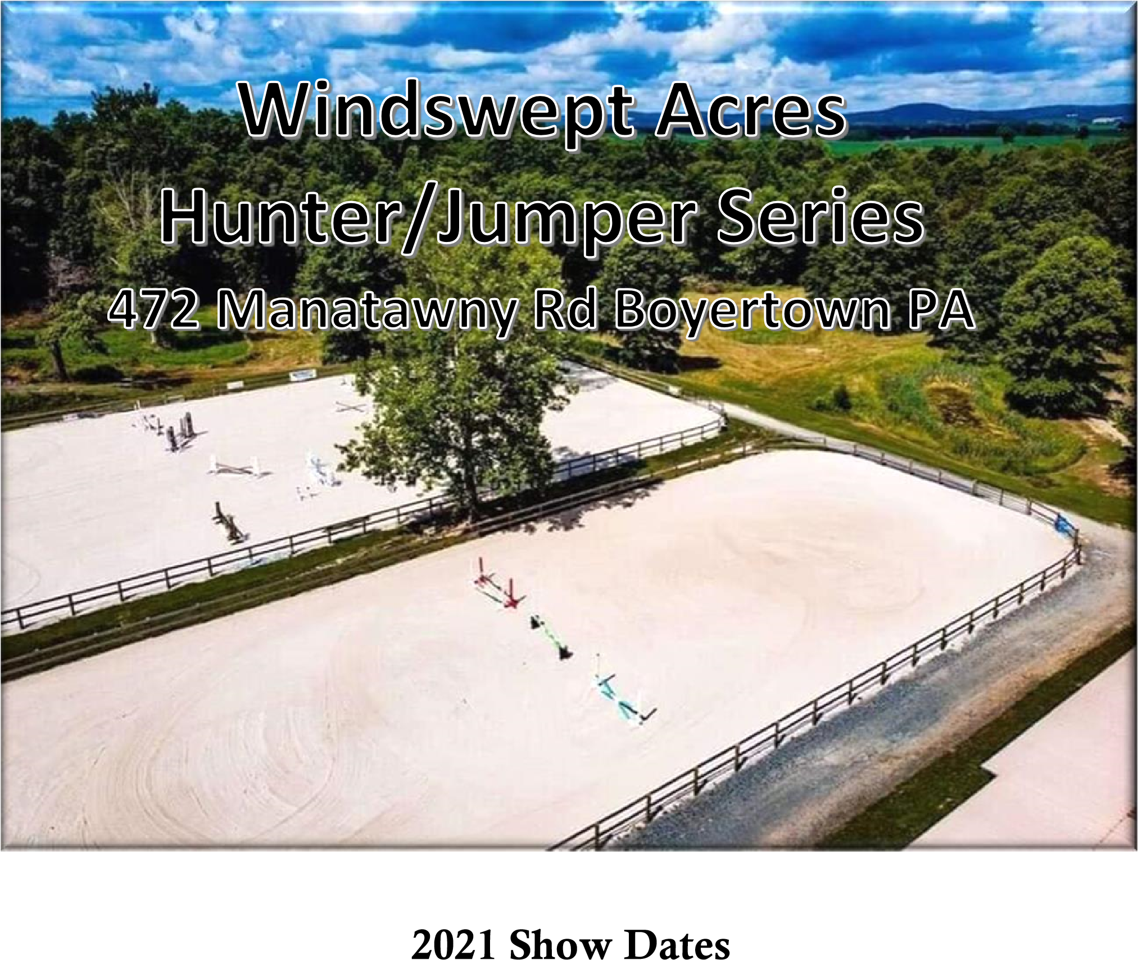

**2024 Jumper Show**

**\*\*COSTUMES ALLOWED if SAFE ☺**

**\*\* JUMPERS ONLY \*\***

**September 28, 2024**

**Show is recognized with T.I.P**

9 AM start

# CROSS RAIL JUMPERS

1. Cross Rail Jumpers- Table IV (Optimum time)
2. - Cross Rail Jumpers- Power and Speed
3. Table II Sec 2b

# Itty Bitty Jumpers – 2’ – 2’3” Sponsored by Brookledge Horse Transportation

34. Itty Bitty Jumpers – Table IV (Optimum time)

35.Itty Bitty Jumpers– Power and Speed

36 Itty Bitty Jumpers – Table II sec 2b - STAKES CLASS*

# Preliminary Jumpers – 2’6” – 2’9” Sponsored by Brookledge Horse Transportation/ TB Jumpers- Sponsored by TIP

37.Preliminary Jumpers – Table II Sec I (speed)

38.Preliminary Jumpers – Power and Speed

1. Preliminary Jumpers – Table II sec. 2b STAKES CLASS*

**Children’s/Adults Jumpers**

# 3’ – 3’3” Sponsored by Brookledge Horse Transportation (1.0-1.05m for Outreach)

43.Child/Adult Jumpers– Table II sec I. (speed)

1. Child/Adult Jumpers – Power and Speed
2. Child/Adult Jumpers – Table II sec. 2b – STAKES CLASS *

**CLASS 46. **CHASE ME CHARLIE CLASS\*\***

Will start at 2’ and move up in 3 inch increments. If a rider knocks the rail or has a refusal, they are out. Winner is the rider to jump the highest successfully.

Class Descriptions

Table II Sec 2b- Riders that go clear remain in the ring for the jump off

Table II Sec 1- Speed

Table II Sec 2c- Power and Speed. Riders that go clean during the power portion continue on to the speed portion. Riders that have a rail during the power portion do not get to complete the course.

TB JUMPERS to run at same time as Prelim jumpers- PINNED separately

All Classes are $20 EXCEPT Stakes classes ($30)

**STAKES CLASSES**

There must be 5 to run the stakes classes for the prize money EXCEPT for the TIP jumpers. There will be prize money no matter what for that division. If there are NOT 5 entries- classes will be run for $20.00 instead of $30.00. Riders will be notified BEFORE the start of the class if there are not enough entries to run for prize money. There is NO stakes class for Cross Rail Jumpers.

Prize Money for Stakes Class

1st - $45 2nd- $25 3rd- $15 4th- $10 5th- $5

Chase me Charlie winner to take 50% of the pot! Part of proceeds from Chase me Charlie will be donated to an Equine Rescue.

**SCHOOLING AVAILABLE**

**the week prior to the show, as well as anytime throughout the season. Contact 610-413-1447 for more info or windsweptacrespa@hotmail.com**

PRIZES from Windswept Acres2 as well as our sponsors!

PHOTOGRAPHY BY: ARB photography

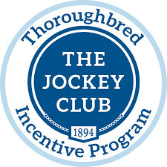

* 1. All horses must have a negative Coggins to be on show grounds. This applies for companion horses also.
  2. All riders must wear protective ASTM/SEI approved head gear.
  3. Windswept Acres2 LLC, Ken Zimmerman, employees, etc. **WILL NOT BE HELD RESPONSIBLE** for any damage, injury, or loss to persons, horse/pony or property of exhibitor or spectator incurred on or off the show grounds. It shall be a condition of entrance to the grounds that this is agreed*.*
  4. Windswept Acres reserves the right to cancel, combine or otherwise alter classes.
  5. Show management reserves the right to excuse any horse that is visibly unsound or in ill health, as well as any rider who demonstrates unsportsmanlike behavior.
  6. No draw reins permitted in classes.
  7. Schooling in ring available 7:45 AM-8:45 AM Refreshments will be available on the grounds.
  8. All dogs must be leashed.
  9. Six ribbons will be awarded in each class; Champion and Reserve ribbons in each division.
  10. Fence heights are approximate.
  11. The decision of the judge is final.
  12. There will be a $15 schooling fee for all horses not registered in a class
  13. There will be a $15 EMT/Offic

Professional photography by ARB photography

**ADDRESS DAY OF THE SHOW:**

**472 Manatawny Road Boyertown PA 19512**

**NOTE: do NOT send entries to farm address**

**When using a GPS do NOT take Spangsville Rd. There is a covered bridge and it cannot handle the weight of a trailer.**

**windsweptacrespa@hotmail.com for any questions**

**PRE-ENTRIES MUST BE RECEIVED BY THE WEDNESDAY BEFORE THE SHOW, PRE-ENTRY**

**$20/CLASS. STAKES CLASSES ARE $30. Chase me Charlie class is $30. ENTRIES THE DAY OF SHOW $25/CLASS. ENTRIES MAY BE MAILED TO Cyndi**

**Gilbert 91 MEXICO ROAD; OLEY, PA; 19547 or EMAILED to windsweptacrespa@hotmail.com Checks made out to WINDSWEPT ACRES OR VENMO : @windsweptacrespa (make a note of the RIDER name in VENMO)**

**PLEASE ADD A $15 EMT/OFFICE FEE.**

Rider: _________________________________________________ DOB (If under 18): _________

Name of Horse: ___________________________________________________________________

Address: _________________________________________________________________________

Phone: _______________________ E-mail: _______________________________________________

T.I.P. Number (if applicable) ____________________________________

Classes: _____________________________________________(PRE ENTRY $20 per class/ POST $25 per class/$15 EMT/OFFICE FEE)

Total $: ______________________ Paid: Y/N Check #: ______________ Coggins: Y/N

The undersigned agrees that Windswept Acres2 LLC, Ken Zimmerman, employees, volunteers, etc. **WILL NOT BE HELD RESPONSIBLE** for any damage, injury, or loss to persons, horse/pony or property of exhibitor or spectator incurred on or off the show grounds. It shall be a condition of entrance to the grounds that this is agreed*.*

Signed (Rider): _______________________________________________________________

Signed (Parent/Guardian if under 18): _____________________________________________

Date: ________________

HUGE THANKS to our 2024 SHOW SPONSORS!

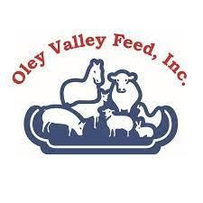

***PROFESSIONAL PHOTOGRAPHY BY ARB Photography***

**-Itty Bitty Jumpers, Preliminary Jumpers, and Children’s/Adults Jumpers** sponsored by

Brookledge Horse Transportation

**-TIP awards for highest point TB jumper and TB hunter** PRIZES from our sponsors!

**Brookledge Horse Transportation**

**Spirit Saddle and Tack-** Saddle fitting and massage needs for your equine!

**Oley Valley Feed-** top notch feed and products for all your equine/farm animal needs

**Abby’s Keepsakes-** your ones stop shop for all animal/Horse hair jewelry and memorabilia

**Jumping To Your Standards**- For all Your Wood Working Needs- from Jumps to tack trunks!