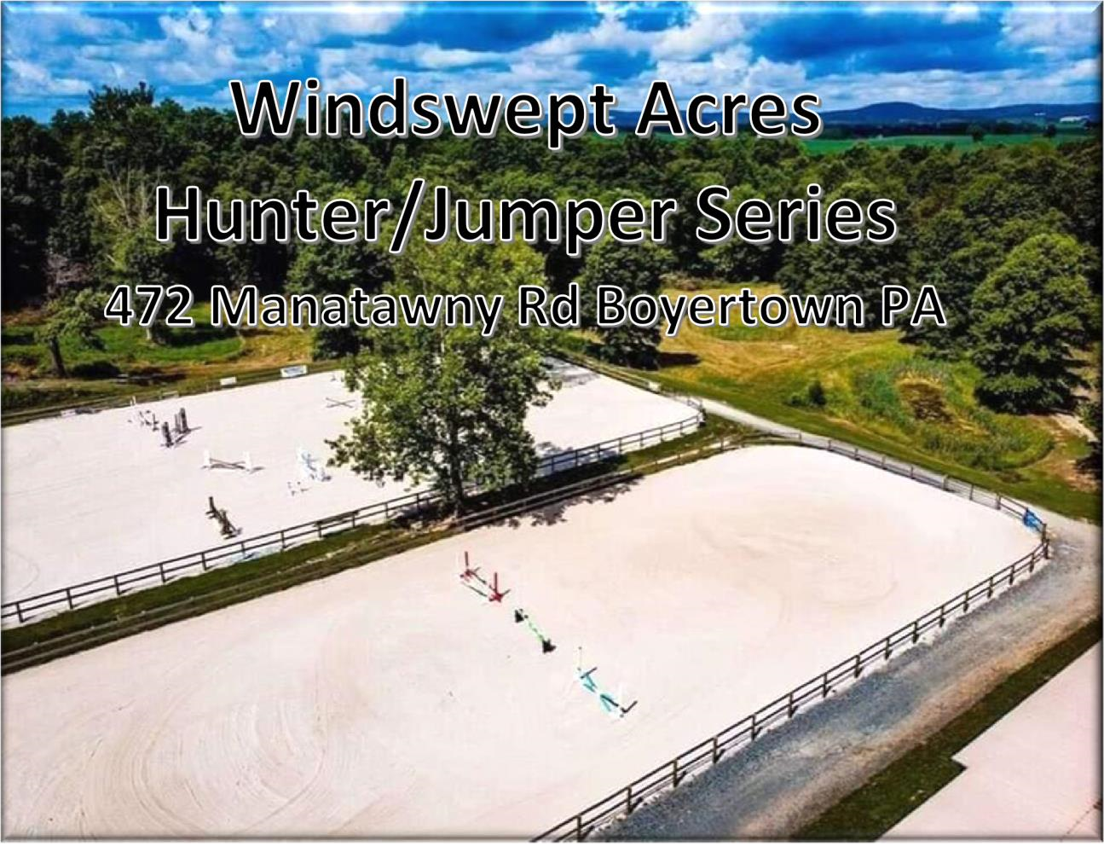
2026 SHOW DATES
May 9- Meghan Mendenhall Huf
June 6-Sara McCoy Graham
June 19**
July 18-Bradley Caine
July 31**
*August 29- ALL THOROUGHBRED*separate prize list*
October 24**
** JUMPERS ONLY ** Separate prize list
T.I.P Points
COLONIAL CLASSIC QUALIFIER SERIES!
Commonwealth Junior Amateur Invitational Qualifier

9 AM start
Jumpers not before 12:30- PLEASE check counts and updates on Facebook the day of the show

Leadline (under 7)
- Leadline Walk
- Leadline W/T
- Leadline off lead

Walk/Trot Division (beginners ONLY! May not cross enter into ANY cantering class. )
- Walk
- Walk/trot Equitation
- Walk/trot Pleasure

Short Stirrup Equitation (12 and under)
7.Walk/trot Equitation
- Walk/Trot/Canter Equitation
- Over Fences (4 crossrails)

Hunter on the Flat*
Walk/Trot
- Walk/Trot
- Walk/Trot/Halt
- Walk/Trot/Canter

Cross Rail Hunter-
- Walk/Trot
- Walk/Trot/Canter
- Over Fences (cross rails)

Beginner Rider (cross rails)
- Walk/Trot
- Walk/Trot/Canter
- Over Fences
_SCHOOLING BREAK

Modified Hunter (2’) Sponsored by Oley Valley
Feed
- Over Fences #1
- Over Fences #2
- Modified Hunter U/s

*****OPEN EQUITATION PONIES TO JUMP AFTER MODIFIED. ******
There will be a schooling break for 2’6 for open equitation, Thoroughbreds, and Open Hunter
AFTER all the ponies have jumped their 2’ courses

Open Equitation (Junior/Adult) Ponies 2’ Horses 2’3-2’6

Sponsored by Abbey’s Keepsakes
- Over Fences #1
- Over Fences #2
- Open Equitation U/s

Thoroughbred Hunter (All Ages) (2.3-2.6”) TIP points
25.Over Fences #1
26.Over Fences #2
27. TB Hunter U/S

Open Hunter (Choice 2’6 or 3’) Will split if entries warrant:
28 Over Fences #1
29.Over Fences #2
30. Open Hunter U/s
Jumpers NOT BEFORE 12:30 p.m.

NO SCHOOLING JUMPER FENCES
CROSS RAIL JUMPERS *
31. Cross Rail Jumpers- Table IV (Optimum time)
32.- Cross Rail Jumpers- Power and Speed
33.Table II Sec 2b

Itty Bitty Jumpers – 2’ – 2’3” Sponsored by Brookledge
Horse Transportation (.70m)
34.Itty Bitty Jumpers – Table II sec 2b
35.Itty Bitty Jumpers– Power and Speed
36 Itty Bitty Jumpers – Table IV (Optimum time)

Preliminary Jumpers/Thoroughbred Jumpers – 2’6” – 2’9” Sponsored by Brookledge Horse Transportation (.85m). Thoroughbred high point will be awarded and results reported to TIP for any Thoroughbred in this division.
*however will be pinned with Preliminary if not enough entries*
37.Preliminary/TB Jumpers – Table IV (Optimum time)
38.Preliminary/TB Jumpers – Power and Speed
39. Preliminary /TB Jumpers – Table II sec. 2b_

Children’s/Adults Jumpers

3’ – 3’3” Sponsored by Brookledge Horse Transportation
(1.0-1.05m)
40. Child/Adult Jumpers– Table II sec I. (speed)
41. Child/Adult Jumpers – Power and Speed
42. Child/Adult Jumpers – Table II sec. 2b

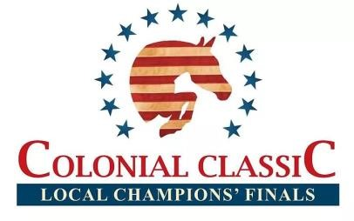
1. All horses must have a negative Coggins to be on show grounds. This applies for companion horses also.
  - All riders must wear protective ASTM/SEI approved head gear.
  - Windswept Acres₂ LLC, Ken Zimmerman, employees, etc. WILL NOT BE HELD RESPONSIBLE for any damage, injury, or loss to persons, horse/pony or property of exhibitor or spectator incurred on or off the show grounds. It shall be a condition of entrance to the grounds that this is agreed.
  - Windswept Acres reserves the right to cancel, combine or otherwise alter classes.
  - Show management reserves the right to excuse any horse that is visibly unsound or in ill health, as well as any rider who demonstrates unsportsmanlike behavior.
  - No martingales in under saddle classes.
  - No draw reins permitted in classes.
  - Schooling in ring available 7:45 AM-8:45 AM and as indicated in schedules. Schooling breaks are ten minutes only; there will be a warm up ring available.
  - Lunging in the INDOOR only.
  - Refreshments will be available on the grounds.
  - All dogs must be leashed.
  - Six ribbons will be awarded in each class; Champion and Reserve ribbons in each division.
  - Fence heights are approximate.
  - The decision of the judge is final.
  - There will be a $20 schooling fee for all horses not registered in a class
  - There will be a $15 EMT/ office fee.
  - Hunter on the flat does NOT count for Colonial Classic
  - TB Jumpers will be combined with Preliminary, however. Results will be reported to TIP and there will be a TB High point Jumper for the day.
  - For additional qualifying information/divisions- see final page
ADDRESS DAY OF THE SHOW:
472 Manatawny Road
Boyertown PA 19512
NOTE: do NOT send entries to farm address
When using a GPS do NOT take Spangsville Rd. There is a covered bridge and it cannot handle the weight of a trailer. windsweptacrespa@hotmail.com for any questions (note the PA at the end of windsweptacres ^ )

HUGE THANKS to our 2025 SHOW SPONSORSSPONSORS!

-Itty Bitty Jumpers, Preliminary Jumpers, and Children’s/Adults Jumpers sponsored by
Brookledge Horse Transportation
Jumping To Your Standards- For all Your Wood Working Needs- from Jumps to tack trunks!
-TIP awards for highest point TB jumper and TB hunter PRIZES from our sponsors!
My Charmed Pony- Bling for both pony AND rider!
Abby’s Keepsakes- your ones stop shop for all animal/Horse hair jewelry and memorabilia

SPONSORSHIP opportunities are always available! Don’t hesitate to ask ☺

PRE-ENTRIES MUST BE RECEIVED BY THE THURSDAY BEFORE THE SHOW, PRE-ENTRY
$20/CLASS. ENTRIES THE DAY OF SHOW $25/CLASS. ENTRIES MAY BE MAILED TO Cyndi
Gilbert 91 MEXICO ROAD; OLEY, PA; 19547 or EMAILED to windsweptacrespa@hotmail.com Checks made out to WINDSWEPT ACRES OR VENMO : @windsweptacrespa (make a note of the RIDER name in VENMO)

PLEASE ADD A $15 EMT/SECRETARY FEE TO YOUR ENTRY.

Rider: _________________________________________________ DOB (If under 18): _________

Name of Horse: ___________________________________________________________________

Address: _________________________________________________________________________

Phone: _______________________ E-mail: _______________________________________________

T.I.P. Number (if applicable) ____________________________________

Classes: _____________________________________________(PRE ENTRY $20 per class/ POST $25 per class/ $15 EMT/SECRETARY FEE)

Total $: ______________________

Paid: Y/N Check #: ______________ Coggins: Y/N

The undersigned agrees that Windswept Acres₂ LLC, Ken Zimmerman, employees, volunteers, etc. WILL NOT BE HELD RESPONSIBLE for any damage, injury, or loss to persons, horse/pony or property of exhibitor or spectator incurred on or off the show grounds. It shall be a condition of entrance to the grounds that this is agreed.

Signed (Rider): _______________________________________________________________

Signed (Parent/Guardian if under 18): _____________________________________________ Date: ________________

IF TRYING TO QUALIFY FOR COLONIAL OR COMMONWEALTH JUNIOR AMATEUR INVITATIONAL YOU NEED TO CIRCLE THE DIVISIONS YOU ARE TRYING TO QUALIFY FOR ON THE BACK OF THIS ENTRY!!

DIVISION SPECS
WINDSWEPT ACRES(WSA) | COLONIAL CLASSIC(CC) | COMMONWEALTH  (CW) | AGE(if applicable)
Leadline | Leadline | Leadline | 7 and under
Walk/Trot | Walk trot | Open Walk Trot | WSA-any age/no cross entering canter classes  CC- 8 and under CW-any age
Short Stirrup Eq | Short Stirrup Eq Pre-Short | Short Stirrup Mini Stirrup | WSA & CC=10 and under CW=?
Hunter on the flat | NONE | Open WTC? | N/A
Cross Rail Hunter | Cross Rail Hunter | Cross Rail Hunter | Open to anyone
Beginner Rider- X rails | Beginner Rider Long Stirrup | Beginner Rider Long Stirrup | CC- 10 & under, 11-17 for beginner rider  CC long stirrup- adults  CW- unsure on age
Modified- 2’ | Modified  Baby Green Pony  Low Children’s Pony  Baby Green  Children’s pony- sm/med | Modified  Baby Green  Low Child/Adult Hunter | CC- see website
Open Eq- 2’ pony 2’6 Horse | Junior Eq Adult Eq | Open Eq- could jump pony height | CC- Jr Eq- 13& under  CC-Jr Eq-14-17  CC-Adult Eq
TB Hunters- 2’3 | TB Hunters | None
Open Hunter 2’6 or 3’ | Adult Hunter-3’  Low Adult Hunter-2’6  Low Children’s Horse-2’6 Children’s Horse- 3’ | Child/Adult Hunter | cc- see website
Cross Rail Jumpers | NONE | Cross Rail Jumpers
Itty Bitty Jumpers-2-2’3 | Itty Bitty Jumpers | Itty Bitty Jumpers Modified Jumpers
Prelim Jumpers- 2’6-2’9 | Prelim Jumpers | Prelim Jumpers Hopeful Jumpers
TB Jumpers | TB Jumpers | Prelim Jumpers Hopeful Jumpers
Child/Adult Jumpers- 3’-  3’3 | Low Child/Adult Child/Adult | none

