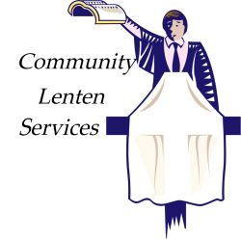

First Presbyterian Church
175 W. Main St. Clarksburg, WV 304-622-6831
Requested donation $5.00 for lunch, which includes soup, sandwich & dessert.
Lunch: 11:30 a.m (Take out available)
Worship Service 12:30 p.m. to 1:00 p.m.

Date Speaker Soup & Sandwich of the day

Feb. 18. 2026 Rev. James A Harris Italian Tomato Soup Pimento cheese, chicken salad or ham salad

Feb. 25, 2026 Rev. Chris Scott Vegetable Beef Soup
chicken or ham salad sandwiches

March 4, 2026 Father Casey Mahone Broccoli Cheese Soup
Chicken or ham salad or pimento cheese sandwiches

March 11, 2026 Elder Mary Beth Paletta Chicken Corn Noodle Soup with
ham sliders

March 18, 2026 Rev. Steve Elderbrook Chicken Rice Soup with pork barbecue sandwiches

March 25, 2026 Rev. Jason Woods Potato Soup with
egg salad sandwich

April 1, 2026 Rev. Jeff Hanlin Minestrone Soup with
grilled cheese sandwiches

