***First Presbyterian Press 2025***

***Publication of First Presbyterian church of***

***Clarksburg, Wv_________________***

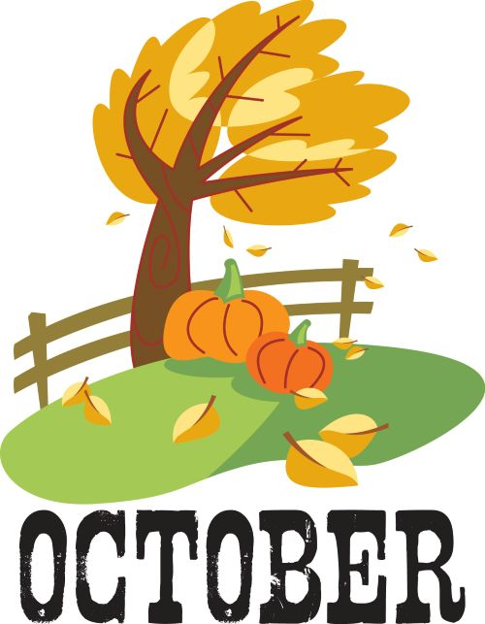

Quotes to Help You Celebrate the Glorious Month That Is October

1. "I'm so glad I live in a world where there are Octobers." - L.M. Montgomery
2. “You don't waste October sunshine. Soon the old autumn sun would bed down in cloud blankets, and there would be weeks of gray rain before it finally decided to snow.” — Katherine Arden
3. “I wish that every day was Saturday and every month was October.” — Charmaine J. Ford
4. “Ah, September! You are the doorway to the season that awakens my soul... but I must confess that I love you only because you are a prelude to my beloved October.” — Peggy Toney Horton
5. “There is no season when such pleasant and sunny spots may be lighted on, and produce so pleasant an effect on the feelings, as now in October.” — Nathaniel Hawthrone
6. “Listen! The wind is rising, and the air is wild with leaves, we have had our summer evenings, now for October eves!” — Humbert Wolfe
7. “In October, a maple tree before your window lights up your room like a great lamp. Even on cloudy days, its presence helps to dispel the gloom.” — John Burroughs
8. “Bittersweet October. The mellow, messy, leaf-kicking, perfect pause between the opposing miseries of summer and winter.” — Carol Bishop Hipps
9. “October is crisp days and cool nights, a time to curl up around the dancing flames and sink into a good book.” — John Sinor
10. "October is a symphony of permanence and change." — Bonaro W. Overstreet
11. "The clear light that belongs to October was making the landscape radiant." — Florence Bone
12. “Autumn carries more gold in its pocket than all the other seasons.” – Jim Bishop
13. “September is dressing herself in showy dahlias and splendid marigolds and starry zinnias. October, the extravagant sister, has ordered an immense amount of the most gorgeous forest tapestry for her grand reception.” — Oliver Wendell Holmes
14. “October, tuck tiny candy bars in my pockets and carve my smile into a thousand pumpkins…. Merry October!” — Rainbow Rowell
15. “October is the opal month of the year. It is the month of glory, of ripeness. It is the picture-month.” – Henry Ward Beecher





5th – Ginger Delawder Terra Burnett

12th – Josh White Mary Beth Paletta

19th – Pam Mitchell Beckie Alvaro

26th – Kandy Atkinson Pam Mitchell

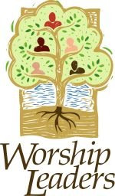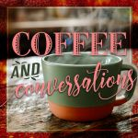

5th – Hank Lawrence Beth Allen

12th – Terra Burnett (Fall Festival) Mary Beth Paletta

19th – Jenna Bennett Steve Goff

26th – Ginger Delawder Beckie Alvaro

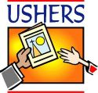

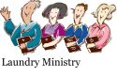

2nd – Beth & Steve 5th - Denver & Lance

9th – Wayne & Harriett 12th – Lance, Hank & Andrea

16th – Maria & Beckie 19th – Jason & Lance

23rd – Josh, Sally & Kierra 26th – David, Denver, & Lance

30th - Pam & Jeff

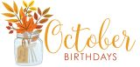

1st – Jennifer Wetzel

3rd – Karen Nickerson

8th – Braden Tustin

9th – Sally Ogden

12th – Kelsea Atkinson

19th – Jeanne Lynch

20th – Loria Cavallo

Matthew Strange

21st – Isabella Rinehart

Rebekah Rinehart

26th – Linda Faust

Brian Tustin

28th – Suzi Heger

29th – Sandi Nuzum



Sermons & Scriptures

5th – Preventing Pearl Harbor Habakkuk 1:1-4: 2: 1-4 Luke 17: 5-10

12th – Would You Rather 2 Timothy 2: 8-15 Psalm 111

19th – The Children’s Book Luke 18: 1-8 Psalm 121

26th – It’s a Good Thing Joel 2: 23-32 Psalm 65

We are now in the last quarter for the year 2025. Autumn is here. The leaves will start changing colors. The flowers that bloom in the fall are sowing their colors. The weather will be getting cooler. Hurricane season is upon us. We still have so much to be thankful for. School is back in session and we need to look out for our children. Let us take the time to thank God for his blessings. Let us use his blessings to help others. We are surrounded by Gods people and he wants us to love one another and to care for each other. During this last quarter in the year 2025 let us strive to make this a better world by doing good for each other and the strangers whom we come in contact with. God Bless and keep you in my prayers.

Pastor James

Pam Mitchell submitted these as she copied the following from a Facebook post. Pam said it reminded her of the laundry ministry of FPC.

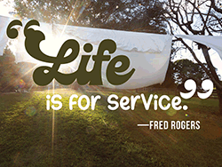

I’m 74. I don’t march in protests. Don’t argue politics online. But every Monday, I do something that keeps America human.

My name’s Walter. I’m 74 years old.

I don’t have much. A pension check, a rusty Ford, a one-bedroom walk-up that smells like radiator heat in the winter.

I don’t cook fancy meals. Don’t go golfing. Don’t even keep up with the news most days—it just makes my chest hurt.

But every Monday morning, I do one thing that, somehow, has rippled further than I ever imagined.

I pay for strangers’ laundry. Not all of it. I’m not rich. Just one or two loads at the laundromat on Main Street.

It started three winters ago. I’d gone in to wash my old flannels. Place was half-empty, the hum of machines steady like a tired heartbeat. That’s when I saw her—young, maybe twenty-five, baby on her hip. She dug in her purse, counting quarters, lips pressed tight. When she came up short, she bit her lip and pulled a onesie from the basket, like she was deciding which piece of clothing could stay dirty another week. I don’t know why I did it. I just stood, walked over, and slipped a quarter into the slot. “This one’s on me,” I said.

She froze. Blinked like I’d spoken a foreign language. Then whispered, “Thank you,” so soft I almost missed it.

That night, I kept thinking about her. About how heavy the world must feel when even clean clothes are a luxury. And I thought about how many times I’d felt invisible since I retired, like the world had already moved on without me.

So, the next Monday, I went back. Dropped a few quarters into a machine, taped a note to it:

Loads on me. Stay warm. Didn’t sign my name. Didn’t need to.

By the third week, someone had scribbled back on my note:

You saved me today. Bless you. I kept going.

Every Monday, I’d bring a little baggie of quarters. Sometimes I’d pay for one load. Sometimes two. I never waited around to see who used them. It wasn’t about that. It was about the moment someone realized they weren’t alone in the world.

Word spread. Not because of me—I kept quiet—but because people talked. One mom told another. A tired nurse on night shift posted on Facebook: “Someone paid for my scrubs tonight. Whoever you are, you kept me going.” The local paper called it “The Laundry Angel.” I hated that. I’m no angel. I’m just an old man with a pocket of coins. Then something happened I’ll never forget.

I walked in one Monday, and the machines already had tape notes on them. Different handwriting. Different words. “For the next one.” “We’re in this together. “I stood there, holding my quarters, tears blurring my eyes so bad I could barely read. It had spread. One evening, I came in late and saw a teenage boy—hood up, eyes tired—drop two quarters into a washer, then walk away without putting clothes in. I called after him, “Hey, you forgot your load.” He looked back and said, “No, sir. It’s not for me.” Then he left. That’s when I knew this wasn’t mine anymore. It belonged to the town. Now it’s every Monday across three laundromats. Folks bring jars of quarters. A church group leaves rolls of them taped to machines. Even the mayor stopped by, slipped a $20 into the change machine, and said, “Guess I’m on the Monday crew now. “And me? I still show up. Still tape my little note: Load’s on me. Stay warm.

Because here’s the thing.

We live in a country that argues about everything. Who deserves what. Who belongs where. Who gets to be seen.

But when someone pulls warm, clean clothes out of a washer they couldn’t afford five minutes ago? None of that matters. In that moment, they know one simple truth: somebody cared.

That’s all it takes. Not speeches. Not politics. Not endless shouting on TV. Just quarters. And a quiet message taped to a machine: I saw you. I know it’s hard. I’ve got you.

The world may stay divided. The noise may never stop.

But as long as the washers keep turning on Mondays, so does hope.

