FIRST PRESBYTERIAN PRESS 2025
PUBLICATION OF FIRST PRESBYTERIAN CHURCH OF CLARKSBURG, WV
November 2025

- All Saints' Day — November 1, 2025
- Daylight-Saving Time Ends — November 2, 2025
- Veterans Day — November 11, 2025
- Bible Sunday — November 23, 2025
- National Bible Week — November 23-29, 2025
- Christ the King Sunday — November 23, 2025
- Thanksgiving Day — November 27, 2025
- First Sunday of Advent — November 30, 2025

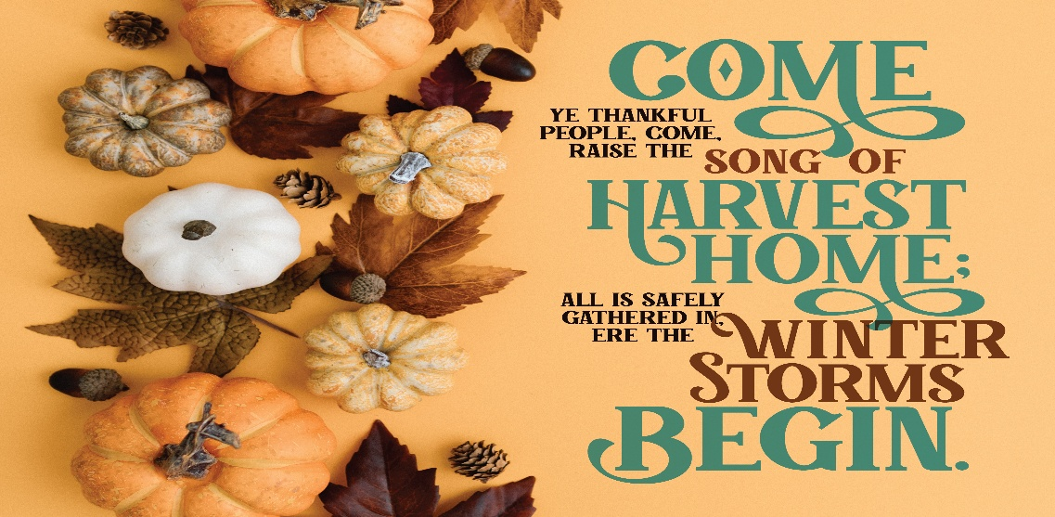


- Veterans Day is the day set aside to thank and honor ALL who have served, living or deceased, but in particular the living veterans among us.


Worship Leaders Greeters
2nd - Hank Lawrence Josh White
9th – Jenna Bennett Maria Morrison
16th – HarrietT Northey Betty brandli
23rd – Mary Beth Paletta Ginger Delawder
30th – Jenna Bennett Jane Simmerman

Coffee Hour Children’s Moments
2nd – Betty & Anne Rev. Harris
9th – Harriett
16th – Karen & Boys maria Morrison
23rd – Jenna Mary Beth Paletta
30th – Terra Terra & Children

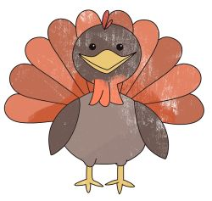
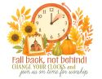

Remember to change your clock back on Saturday night the 1st!

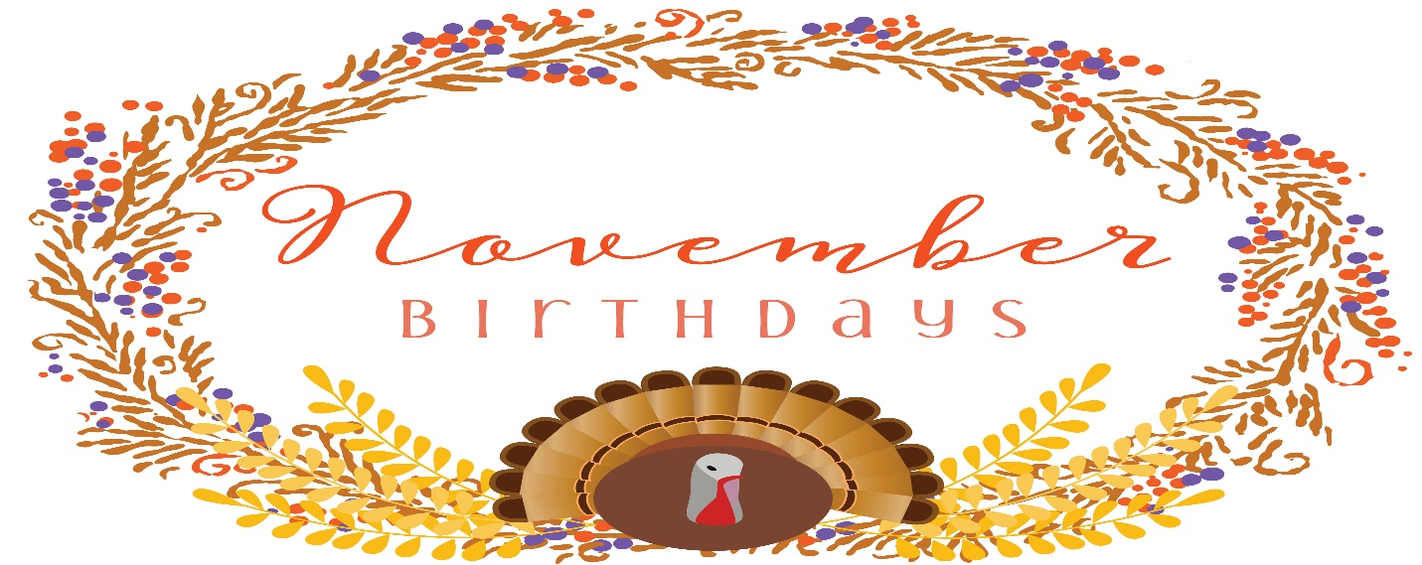
2nd – Cole Delawder
Michael Lonsinger
4th – Gary Nickerson
7th – Theresa Koerner
11th – Judy McQuaid
Jeff Strange
20th – Frank Simmerman
22nd – Gia Corsini

25th – Evie Corsini



The Pastor will be out of the office from November 25th to December 2nd.

Sermons & Scriptures
2nd – Gridiron Gospel Habakkuk 1:1-4, 2: 1-4 Luke 19:1-10
9th – Fresh Courage Take Haggai 1:15b-2-9 Luke 20:27-38
16th – Rethinking Old Age Isaiah 65:17-25 Luke 212: 5-19
23rd – Benedictus Luke 1:68-79 Psalm 46
30th – Mary Beth Paletta Pastor out of office

November is the eleventh month of the year, sixty-one days until we celebrate the New Year. We will celebrate Veterans Day and let us remember to thank a veteran for his sacrifice that he gave for the freedoms that we enjoy. We have some veterans in our congregation. They served in different branches of the military, so let’s thank them, not just on veterans day but every day that we are able to enjoy our freedom. We will celebrate Thanksgiving this month. We have so much to thank God for. We should thank God daily for our many blessings. Let’s make everyday a day of thanksgiving. Our lives are blessed because God loves us. So let us be a blessing to others, love one another and look after each other. God Bless and keep you – Pastor James

Please remember all the people who do not have families or are alone during thanksgiving. Sometimes they have a hard time during the holidays. Families may be too far away or maybe they don’t have a family.

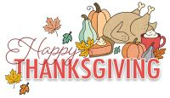

Heavenly Father, we gather with hearts full of gratitude for Your boundless blessings. Thank You for the gift of family and friends, for the love that binds us, and the joy we share. We are thankful for the food on our table, the roof over our heads, and for all the small and large ways You provide for us each day. Bless our time together, our conversations, and our laughter. We pray for those who are alone or suffering, that they may find comfort and peace. Help us to be a source of love and strength for one another, and to carry this spirit of gratitude with us throughout the year. Amen.

