FIRST PRESBYTERIAN PRESS 2025

Publication of First presbyterian church of Clarksburg



Did you know?

John Adams believed that July 2nd was the correct date on which to celebrate the birth of American independence, and would reportedly turn down invitations to appear at July 4th events in protest. Adams and Thomas Jefferson both died on July 4, 1826—the 50th anniversary of the adoption of the Declaration of Independence.

On July 2nd, the Continental Congress voted in favor of Lee’s resolution for independence in a near-unanimous vote (the New York delegation abstained, but later voted affirmatively). On that day, John Adams wrote to his wife Abigail that July 2 “will be celebrated, by succeeding Generations, as the great anniversary Festival” and that the celebration should include “Pomp and Parade…Games, Sports, Guns, Bells, Bonfires and Illuminations from one End of this Continent to the other.” On July 4th, the Continental Congress formally adopted the [Declaration of Independence](https://www.history.com/topics/american-revolution/declaration-of-independence), which had been written largely by Jefferson. Though the vote for actual independence took place on July 2nd, from then on, the 4th became the day that was celebrated as the birth of American independence.

No Meetings in July!



6th- Harriett Northey

13th – Mary Beth Paletta

20th – Pam Mitchell

27th – Amy Strange



6th – Harriett

13th – Suzi

20th –Andrea

27th -

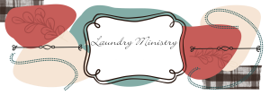

3rd – Kierra & Beth

10th – Wayne & Harriett

17th – Maria & Beckie

24th – Josh & Sally

31st - Jeff & Pam

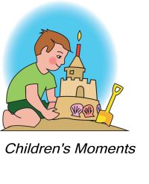 6th – Terra Burnett

13th – Mary Beth Paletta

20th – Beth Allen

27th – Maria Morrison



6th – Josh White

13th – Kandy Atkinson

20th – Maria Morrison

27th - Ginger Delawder

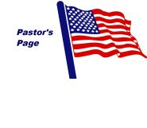**Sermons for July**

6th – Take Me to the River,

Scriptures: 2 Kings 5: 1-14, Luke 10: 1-11, 16-20

13th – The Bystander Effect

Scriptures: Luke 10: 25-37, Psalms 25: 1-10

20th – Jesus Versus Galactus Scriptures: Colossians 1: 15-28, Psalms 15

27th – The Happiest Place on Earth Scriptures: Luke 11: 1-13, Psalm 138

We have just passed the mid-year point of 2025. The fourth of July celebrations are exciting, the fireworks are great, and we enjoy the food. The reason for the holiday is really to remember the independence we received. The idea of a government for the people run by the people. We have a president and a congress to make our national laws. God has been good to us as a nation. We have had our struggles in practically every category, human, racially. Every state has been affected, through it all we can say we are a strong nation. God has blessed us and I pray that he will continue to bless us. Let’s have a wonderful month in July. Enjoy your vacations, the celebrations and most of all thank God for all the blessings he gives us. God Bless and keep you in my Prayers. Pastor James

**Rest in the Promise by Regina McIntosh**

Under the shadow of a maple tree, Green as summer, wistful and praising Like the peace blowing dandelion seeds Risking the rain’s rhythmic showers, Against blades of tempting July sprinkling Haphazardly against the wonders beyond Silent prayers, raised by last night’s Moon glowing against the glistening backdrop Stars listening for August’s trembling voice, Arriving on the dusty parched memories Colored precariously in the sensations breathing, Echoing in the noonday whispers, clouds Hoping to share their heartfelt sequence with Yesterday, before the summer discovers it’s answers Poured out in cerulean skies, lasting – enduring The temptation to just let go of her first glimpse of laughter Falling over the night, wishing for the pulsating Effervescent waves splashing melancholy Into the face of a breathless truth, the moment When hope meets faith and the promise of true love Stirs the chances, risking shame and humiliation, Stunning the source of her imagination, Awaking to the mists of passivity, still like a dream Drifting through the promises, pursued by the soul Who believes, always believes … muses Quivering, unsteady as the jolts of lightening against a sky Filled with glittery liquid, streaming and fading Wistful as the spirit who has been raided by oysters, And pearls who tempt the light into fading, Reassuring the evening, dusk brings a gentle grace, Soothing away the heat and making the heart a vow To begin once again, to begin to reveal the hope Who knows that every moment, each priceless twinkling Is the experience preparing joy to kiss away the doubting Caress the impression of God’s mercy rustling Through the profile of branches, feeling the breath, So subtle, erasing the past with its laughter, Healing the heart and calming the thoughts so forever Is only one breath from the moment when I smile Into the gaze of nostalgic moods, the reflection Who silences every shimmer of starlight, quiets Even the dark’s discontent with a forever that is alive, Eternity rides within the silhouette of the cross Where He left us with the imprint of His heaven sent promise Filled with a grace, abundant beyond our dreams, Grace that cannot deceive, grace that can never, ever leave!

**I’d Like to Make a Difference**

**God has given me a place on earth**  
**to be here for a while.**  
**I hope that as I’m passing through**  
**I can make somebody smile**  
**I want to make life easier**  
**For all the ones I meet**  
**I ask God for His blessings**  
**To the strangers on the street.**  
**I hope I’ll never fail a friend**  
**If I can help somehow.**  
**I want to be as generous**  
**As my resources will allow.**  
**And when my life on earth is done.**  
**It will be my final plea**  
**Let someone, somewhere think or say**  
**“You made a difference to me”**

-Helen 

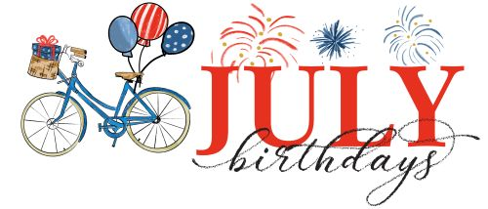

1st – Madison Stout 22nd – Elsa Davis

2 – Kris Burgess 26th – Carole Wilburn

4th – Jamie Atkinson 27th – Amanda Garrett

5th – Marla Gifford 31st – Larry Kennedy

6th – Anthony Paletta

7th – Anthony Corsini

11th – Kathy Lawrence

15th – Beth Allen

Britney Atkinson

George Clark

16th - Dick Ogden

17th – Morgan Caridi

17th – Anne Davis

19th – Robert Mitchell

Rebecca Simmerman