**FIRST PRESBYTERIAN PRESS 2025**

PUBLICATION OF FIRST PRESYTERIAN CHURCH OF CLARKSBURG

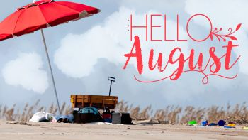

When it comes to loving you

When it comes to loving yourself, don’t put God’s gifts up on a shelf, use them all every day, as you have patience, persevere and pray.

Love yourself in all ways, by someone who surely always stays by others sides, be someone who’s open instead of someone who hides.

No matter where you are, know you can always go really far. Don’t put God’s gifts up or on a shelf, when it comes to loving yourself!

By Nicolas Constantino who recently graduated from Pennsylvania Western University.

It’s hard to believe school will be starting in about two weeks. Hate to see summer end, seems like we didn’t get much of it because of all the rain.

3rd – Ginger

10th – Andrea

17th – Karen & boys

24th – Pam

31st – Harriett

3rd – Josh Betty

10th – Jeff Pam

17th – Hannah

24th – Kandy

31st – Harriett

3rd – Pam

10th – Terra

17th – Beth

24th – Beckie

31st – Kandy

3rd – Denver, Lance

10th – Lance, Hank, Andrea

17th – Jason, Lance

24th – David, Denver, Lance

31st – Denver, Lance, David

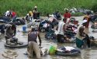Laundry Ministry

7th – Kierra & Beth

14th – Wayne & Harriett

21st – Maria & Beckie

28th – Josh &Sally

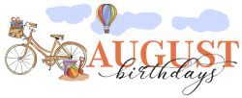

2nd – Wayne Northey 11th – Terra Burnett

6th – Ellen Merriott 23rd – Andrea Myerberg

Rev. James Harris 27th – Dawn Woodburn

7th – Hannah Burnett

Bryon Delawder

Susan Clark

10th – Phillip Bailey

Sermons & Scriptures for August

3rd – Seeking Things Above Colossians 3:1-11, Psalm 49: 1-12

10th –Look Busy Isaiah 1: 1 10-20, Luke 12: 32-40

17th – World Changing Ideas Isaiah 5: 1-7, Luke 12: 49-56

24th – Collision Course Jeremiah 1:4-10, Luke 13: 10-17

31st - The Gold Standard Luke 14: 1, 7-14, Psalm 112

We are entering the eighth month of the year. Our summer vacation is rapidly coming to an end. In a few weeks, school will begin once again, fall sports (football, soccer, cross country) to name a few will be in full force. Games weekly and practice daily. Our days will be busy: however, we must always remember our God who looks after us day and night as we carry out our busy schedule. Let’s remember the blessings that we have received from God. The blessing to be able to carry out our busy schedules, the blessing of living in a place that is not war torn. There are people starving all over the world, let us not only pray for them, but let us take some action to help the homeless, the hungry and the sick right here in our community. God has blessed us and has been good to us. Let’s pass our blessings on to others. As the summer comes to an end let us share our love with others.

God Bless and keep you in my prayers,

Pastor James

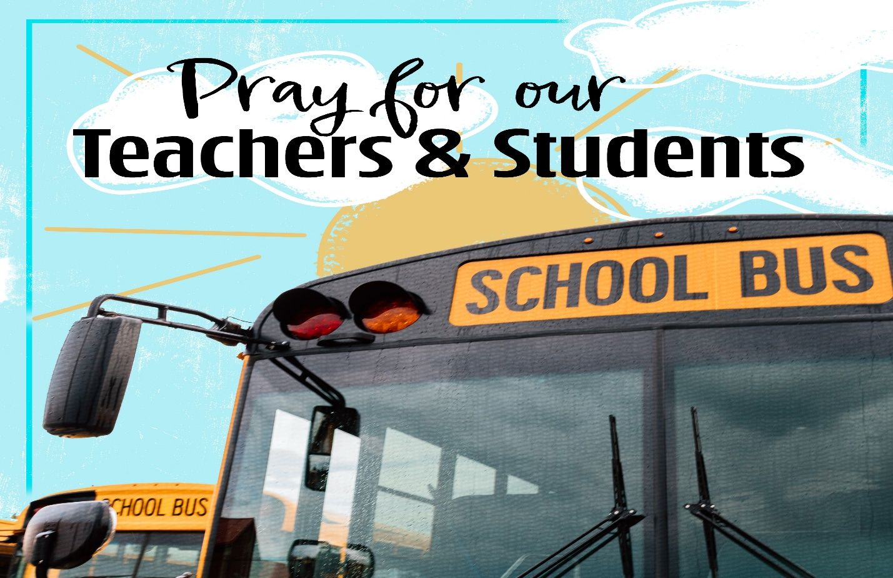Please remember school will be starting soon. Please be careful driving, watching out for the students who are excited to go back to school, the bus drivers, the parents and grandparents who are dropping off children, the educators, and teachers. Prayers for a safe and happy year!