FIRST PRESBYTERIAN PRESS 2026
PUBLICATION OF FIRST PRESBYTERIAN CHURCH OF CLARKSBURG, WV
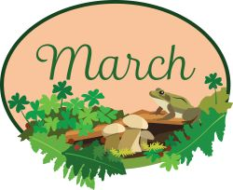

March Arrives
Poet: Catherine Pulsifer
In the realm where seasons weave their dance,
March arrives, bringing a hopeful chance.
Equinox whispers of celestial might,
Winter's grip fades, surrendering to light.
As the sun's rays caress the earthly floor,
Day and night harmonize like never before.
On this vernal equinox, nature aligns,
A tapestry of wonders, where magic intertwines.
In the Northern Hemisphere, spring awakes,
Awakening dormant life from slumber's embrace.
Budding blooms stretch toward the azure sky,
Embracing warmth with a joyful sigh.
And as we bid farewell to winter's cold,
Nature's canvas is painted with hues bold.
From gentle blossoms to vibrant leaves,
A symphony of colors, a joy that never leaves.

Worship Leaders Greeters
1st – Jenna Bennett Ginger Delawder
8th – Andrea Myerberg Joshua White
15th – Harriett Northey Sandi Nuzum
22nd – Mary Beth Paletta Kandy Atkinson
29th - Pam Mitchell

Children’s Moments Coffee Hour
1st – Beckie Alvario Ginger Delawder
8th – Terra Burnett Jenna Bennett
15th – Courtney Nuzum Beth Allen
22nd – Mary Beth Paletta Andrea Myerberg
29th – Palm Sunday CE Music/Worship
Lenten Happenings
Ushers

1st – Denver Atkinson, Lance Kuhens
8th – Lance Kuhens, Hank Lawrence, Andrea Myerberg
15th – Jason Burnett, Lance Kuhens
22nd – David Allman, Denver Atkinson, Lance Kuhens
29th – Denver Atkinson, Lance Kuhens, David Allman


2^{nd-} Kay Devono, Radetta McQuaid, Nanette Lafferty
4th – Amelia Harris
5th – Jeff Northey
7th- Connie Leuliette
8th – Hank Lawrence
14th – Ralph Graves
19th -Dakota Sabo
20th – Anderson Mitchell
21st – Missie Kaull, Rhonda Kim Sabo
22nd – Casey Nuzum, Mark Alvaro
26th – Joel Sabo
27th – Declan Wadsworth
30th – Jane Simmerman

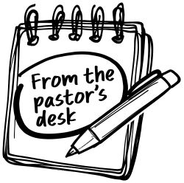

Sermons & Scriptures
1st – The Keeper Psalm 121, Mathew 17: 1-9
8th – Church Shopping John 4:5-42, Psalm 95
15th – Selection Sunday Samuel 16:1-13, John 9: 1-41
22nd – A Tomb with a View John 11: 1-45, Psalm 130
29th – Open the Gate Psalm 118: 1-2, 19-29, Matthew 21: 1-11

We are entering the third month of the year 2026. We are truly blessed. The lent season has started and we have had very good attendance so far. We are looking forward to having a successful lent season. I want to thank everyone for their help and support at this time. March 8th is the date that our clocks move ahead. Darkness will come a little later according to our clocks. Spring will begin on March 21st. Time to start cultivating the land and planting our flowers and other crops. We have enjoyed the snow but the wind and rain will be with us now.
Let us remember to thank the Lord for all of our blessings. Thank him for the sunshine, the rain, the snow, the cold and the heat that we receive from him. Let us continue to prepare ourselves for the great celebration Easter Sunday. God bless and keep you in my prayers.
Pastor James

