FIRST PRESBYTERIAN PRESS 2026
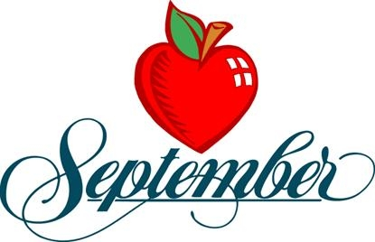
PUBLICATION OF FIRST PRESBYTERIAN CHURCH OF CLARKSBURG


Paul the Apostle gave a beautiful compliment to the believers in Corinth. He wrote:
“And you show that you are a letter from Christ delivered by us, written not with ink but with the Spirit of the living God, not on tablets of stone but on tablets of human hearts” (2 Corinthians 3:3, ESV).
What a meaningful picture. A letter carries a message, and Paul reminded the church that their lives were sharing the message of Christ with others.
The same is true for us today. Through our words, actions and faith, people can see evidence of God at work in our hearts. None of us is perfect, but living faithfully can point others toward Him.
What a wonderful goal for every Christian: to be known as “a letter from Christ.”

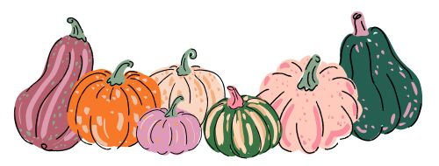

Fall is right around the corner; all the pumpkin flavors are back. Seems like everywhere you go they have something pumpkin. The weather is getting cooler; the trees are starting to change colors in the fall so it is always so nice to go leaf peeping. Enjoy each season to its fullest.

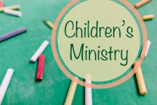

6th – Terra Burnett Maria Morrison
13th – Mary Beth Paletta Pam Mitchell
20th – Jeanne Harris Josh White
27th – Courtney Nuzum Courtney/Sandi Nuzum


Sunday School returns September 20th!
So glad it’s back!!!

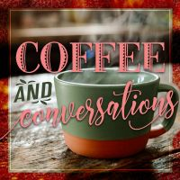


6th –Jeanne Harris Harriett Northey
13th – Sally Gray
20th – Youth & Rally Day Terra Burnett
27th – Harriett Northey


6th -Denver Atkinson, Lance Kuhens
13th – Lance Kuhens, Hank Lawrence, Andrea Myerberg
20th – Jason Burnett, Lance Kuhens
27th – David Allman, Denver Atkinson, Lance Kuhens

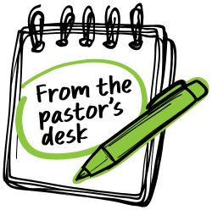
6th – “The Wearable Christ” Scriptures – Romans 13:8-14, Psalm 119: 33-40
13th – Mary Beth Paletta
20th – “What Is This Stuff” Exodus 16: 2-15, Matthew 20: 1-16
27th – “Success Is Not a Ladder” Philippians 2: 1-13, Psalms 25: 1-9

September is here. We will celebrate Labor Day. This is the last celebration of the summer. Autumn begins the 23rd and remember school is back in session. Look out for our little ones. As the seasons change our health is changing in many cases. Time for our fall and winter shots. Sports on every level is in full force right now. Let us keep the players, coaches, officials and the spectators in our prayers.
The hurricane season is upon us. We can prepare our homes and ourselves for the storms that may come. Remember, God is with us and he is watching over us at all times. Let’s rejoice and praise him and thank him for the blessings he has given us. Our families, our friends and our freedom to live in this land and to be able to serve him.
God Bless and keep you in my prayers.
Pastor James

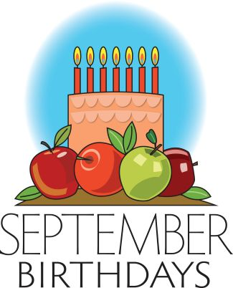
1st – Lisa Leibering, Jeep Wilson
2nd- Dave Allman
4th – Jackie Corsini

7th – Jason Burnett
10th – Ginger Delawder
13th – Sarah Mitchell
14th – April Leuliette
16th – Chip Corsini
18th – Courtney Nuzum
22nd -Jeff Mitchell, Brian Nickerson
25th – Treytin Tustin
27th – Beckie Alvaro

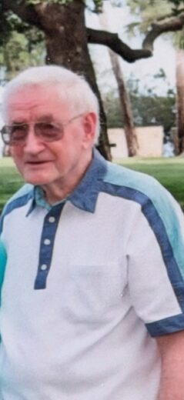
Willis Williams
Born July 27, 1934 in Corning, New York
Passed away August 14, 2026 in Melbourne, Florida
Willis Williams passed away after a brief illness on August 14, 2026, in Melbourne, Florida. Willis, who went by the name Bill, was born Willis Hunt Williams on July 27, 1934, in Corning, New York, the first of two children born to Ward and Florence Williams.
in 1996.
Bill was a faithful member of First Presbyterian Church, Clarksburg for over 50 years. He served several terms on Session and sang in the choir. Bill and Jan moved to Indian Harbour Beach, Florida in 2015, to be near one of their sons.
A memorial service is planned for family at a later date.
If anyone would like to send a card to his wife Jan Williams her address is Zon Beach Side 1894 South Patrick Dr. Rm 104, Indian Harbor Beach, Fl 32937. Her son said she really enjoys reading the newsletters from our church and loves getting mail.


Coffee Hour is still looking for sign-ups for 27th, and Worship Leader for the 13th. If you can help, please sign up on the bulletin board in Westminister Hall. Thank you!
We have openings for flowers for the reredos for the month of Sept.

