FIRST PRESBYTERIAN PRESS 2026 PUBLICATION OF FIRST PRESBYTERIAN CHURCH OF CLARKSBURG, WV
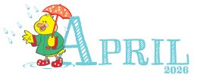

- Maundy Thursday — April 2, 2026
- Good Friday — April 3, 2026
- Easter — April 5, 2026
- Earth Day — April 22, 2026
- Administrative Professionals Day — April 22, 2026
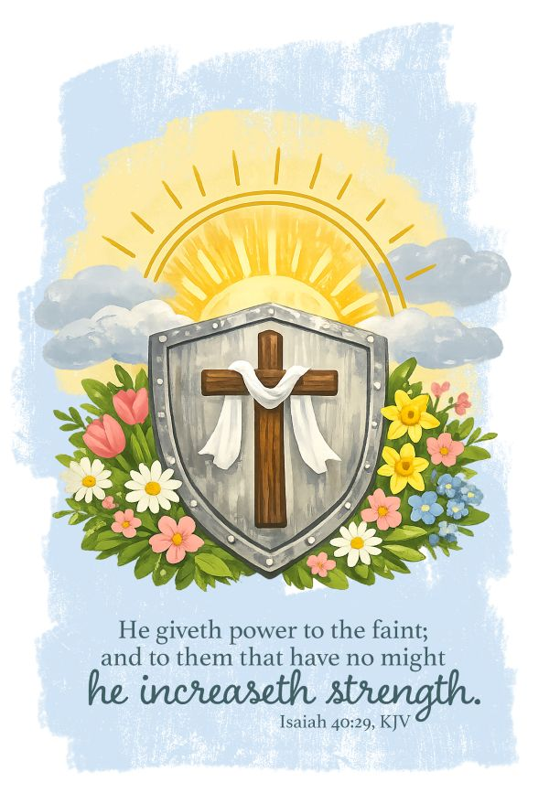

Worship Leaders Greeters
5th – Mary Virginia Sandi

12th – Suzi Kandy
19^{th-} Maria Ginger
26th – Jenna Ashleigh

Coffee Hour Children Moments
5th – Mary Beth Pastor Harris
12th – Jenna Pam
19th – Beckie
26th – Ginger Jeanne

Ushers
5th – Denver, and Lance
12th – Lance, Hank and Andrea
19th – Jason, and Lance
26th – David, Denver, and Lance



1st – Lily Sigmon 19th – Lynna Moen
3rd – Janet Wilson 20th – Mary Virginia Paletta
5th – Anna Corsini 22nd – Maria Moore
Helen Layfield Robert Sabatino
Maria Morrison 24th – JD Bailey
6th – Jenna Bennett 25th – Amy Strange
8th – Katy Clark 27th – Mary Beth Paletta
9th – Marcia Graves Amanda Wallace
Trey Simmerman 28th – Danielle Rinehart
10th – Kenneth Oldaker 29th – James Jarrett
11th – Phil Northey 30th – Parker Lawrence
12th – Chad Sigmon
14th – Paula Bomhoff
16th – Pat Woodburn
18th – Sylar Doty

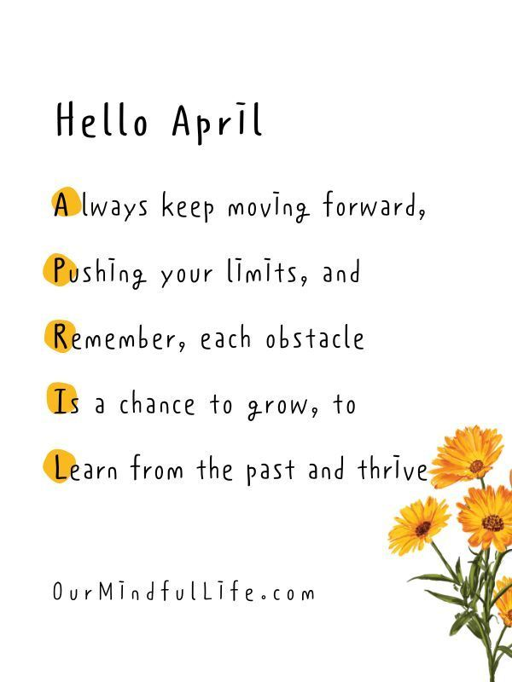


Scriptures & Sermons for April
5th – Easter Emojis Psalm 118: 1-2, 14-24, Matthew 28: 1-10
12th – But the Bible Says - Psalm 16, Acts 2:14a
19th – Traveling Companion – Psalm 34: 1-10, Luke 24:1335
26th – The Shepherd’s Voice – Psalm 100, John 10: 1-10

April has arrived. Lent season is over and we have celebrated Palm Sunday. We will celebrate Easter this Sunday. What joy fills our hearts in knowing that our Lord and Saviour lives, what a blessing. As the weather warms up let us keep ourselves in good shape for the future. We are getting closer to the time of the year for graduations from high school and college. Let us encourage each of them to go further and to be successful in their life encounters.
Let us remember to pray and to help one another. The last weekend in May is Memorial Day. Let us remember those who gave their lives for our freedom and give our blessings to those who are serving in our military today. Let us continue to pray for peace through out this world. Pray for an end to our government shut down and that we as a country may be united. God bless you and keep you.
Pastor James

