FIRST PRESBYTERIAN CHURCH
Clarksburg, Wv
REV. JAMES A HARRIS
Broadcast live on WPDX radio, 104.9 FM & 750 AM
Live stream at www.facebook.com/fpcclarksburg
May 10, 2026 Ten Forty-five



Sixth Sunday of Easter
Gathering Around the Word

Organ Prelude “Allegro” By Stanley and Bouree by Handel Kay Devono

Welcome
The Peace : The peace of our Lord Jesus Christ be with you all. And also, with you.

Announcements
Visitors, please fill out a visitor card and drop it in the collection plate.

Call to worship and prayer of the day
Leader: Voices raised in song,
All: We praise you.
Leader: Filled with rich joy,
All: We sing your glory.
Leader: Fathers hugging a child,
All: We share your love.
Leader: Mothers tending a wound,
All: We demonstrate your care.
Leader: Friends offering prayer,
All: We remember you.
Leader: Voices lifting a joyous refrain,
All: God, we praise you.

Opening prayer Appears in: The Real Story
Beloved Lord God, many of us have often called you mother as well as father. As a mother, O God, you nourish us with the food of life. Your love birthed in us, brings us healing and wholeness. Help us to face our pain and challenges honestly and in the knowledge of your compassionate love that we know in Jesus Christ. Let us run into your open and welcoming heart and never feel separated from you and your Holy Spirit. Amen.

History Jeanne Harris
Hymn # back page “Nothing but the Blood of Jesus”

*CALL TO CONFESSION Appears in: Have a Good Cry
From age to age is God's faithfulness. From day to day is our striving. Let us confess to our faithful God our failure and our stress.

Prayer of Confession Faithful God, patient Friend, you are as near to us as breath and as constant as the waves on the shore. Yet how often our lives fail to mirror your ways. We are sometimes absent from our children, giving into pressures at work or yielding to the lure of success and money. We are at times distant from one another, for though we are in the same place, our hearts and minds wander and stray. We choose not to listen, to only half-hear the words of another.
Faithful God, patient Friend, restore our sense of belonging to each other. Heal our relationships and encourage us to be caring fathers, strong mothers and wise friends. Teach us the way of love and the path of Jesus. Amen.
Declaration Of Pardon
Faithful God, patient Friend, restore our sense of belonging to each other. Heal our relationships and encourage us to be caring fathers, strong mothers and wise friends. Teach us the way of love and the path of Jesus. Amen

*CONGREGATIONAL RESPONSE - “Gloria Patri”

RECOGNIZE THE MOTHERS
Recognize the graduating seniors

Proclaiming the word
Hymn “Jesus Loves Me”(verse 1)
Children of the Church

Prayer for illumination (in unison) Appears in: Final Instructions
Let us pray together,
O Wisdom Divine, just as you inspired the mothers of our faith, grant us your knowledge and discernment so that we can learn how to be clever in our compassion and courageous in our faith, through Christ and in the Spirit. Amen

First Scripture Lesson Psalm 115
The word of the Lord.
Thanks be to God.

Second Scripture Lesson 1 Peter 3:13-22
The word of the Lord.
Thanks be to God.

Affirmation: I am a child of God. I believe in Jesus Christ as my Lord and Savior. I believe he has the power to change my life and your life.

Sermon: “God’s Stain Remover ” Rev. James A. Harris

Piano Interlude – Silent Prayer and Reflection

Responding to the Word
*The Creed Appears in: No Sun, No Moon, No Night
We believe in one God, Lord of heaven and Earth. We believe that the gift of our salvation is eternal life with Jesus Christ our Lord. We believe that God created heaven, that he lives and reigns there, and that we will live with him when he one day calls us home. We live by faith, believing that what is unseen will one day be revealed, to the glory of our one God, Lord of heaven and Earth.

*HYMN #388 “O Jesus I Have Promised”

Prayers of the People & The Lord’s Prayer
Gathering of Tithes and Offerings 
Gathering -electronic gifts may be made through our website www.clarksburgfpc.org
Offertory Anthem “Golden Land” by Hammer Kay Devono
* The Doxology
* Prayer of Dedication

SEALING THE WORD: THE HOLY MEAL
COMMUNION OF THE PEOPLE
Celebrants: Rev James a Harris Pastor
RE Suzi Heger
BEARING THE WORD INTO THE WORLD

*Hymn #298 “There’s a Wideness in God’s Mercy”
* Benediction
*Congregational response “First Song of Isaiah” (chorus only) 2x Surely it is God who saves me. I will trust in him and not be afraid for the lord is my stronghold and my sure defense. And he will be my Savior.
*Organ postlude “Abbot’s Leigh” Arr. By Hobby Kay Devono
Special Care Facilities: Doris Holt, Mark Freeman, Gary Mitchell,

Churches: Community Presbyterian Church, Arthurdale, Milton Presbyterian Church

Please join us for refreshments and fellowship in Westminster Hall following the service. Beckie & Beth are the hosts today.
Liturgists................................................The Congregation of First Presbyterian Church
Officiant and Preacher.....................................................................Rev. James A Harris
Worship Leader...............................................................................................Beth Allen
Minister of Music........................................................................................Jeanne Harris Organist.........................................................................................Dr. Mary Kay Devono
Children Moment.........................................................................................Terra Burnett
Greeter ........................................................................................................Donna Shiffra
Ushers ............................................. Lance Kuhens, Hank Lawrence, Andrea Myerberg

First Presbyterian Church - 175 West Main Street – Clarksburg, WV 26301 304-622-6831 / www.clarksburgfpc.org


Monday: 10:00 Prayer Group Zoom or in person
Tuesday: 5:30 pm Deacons Meeting
Wednesday: Bible Study 3:30 pm
Thursday: Laundry Ministry 4:30pm Wayne & Harriett
Saturday:12:00 pm Dave’s Memorial Service at the church

Birthdays this week Josh White’s birthday was April 27th and he didn’t let us know so we wanted to recognize it today.

2nd – Denver Atkinson 15th – Lance Kuhens
7th – Xochitl Leuliette Betty Bowles
Sarah Waters
8th – Dianne Keller
10th – Tammy Kennedy

Prayer List: Sean Keener, Mark Ferree, Jared Nuzum, Sandi Nuzum’s brother Greg, Doris Longwell, Janette Elliott, Karen Tyson’s nephew Jahlil family, Karie Lynch, Jackie Scott, Tyler Turner, Brooklyn’s family, Stephanie Shields and family, Renee, Jim McQuaid family, Heather Pillo, and Rob Murphy family, Tommy’s granddaughter, Sally Ogden, Donna Swann, Radetta’s great aunt, Annie, Tim Garcia, Lilley Joyce, Joni Anderson, Ellen Merriott, Stoney next door neighbor of Jeanne & James, Susan Sigmon, Bud Burnett and wife, Burnett and Mitchell family, Kristi McKinney, and Daylin Russell, Jim & Nancy Gallo, Scott Harper and his sister, Pastor Harris sister Minnie, and brother Johnie, David Yazvac, Greg Palmer, Sharon Vandenberghe, Melanie Simmons, Janet Pinti, Luke Roselli, Jane Post, Brenda DeGarmo, Donna & Everett Shiffra, Glenn Thompson, Keith Cumberledge, Carol Watson Sears and family, Jeff Mitchell’s brother-in-law Doug, Jo Tetrick, Judy Pinti, Charla Koerner, Harriett Northey, Marlana Tetrick, family of Dave Nuzum, Justin Davis.

Happy Mother’s Day. Hope you have a great day.



Hannah Burnett is the daughter of Jason and Terra Burnett and the granddaughter of Jeffrey and Pamela Mitchell and H.D. “Bud” and Barbara Burnett. She is a 2026 honors graduate of Robert C. Byrd High School. At RCB, she was a member of the National Honor Society, 4-year member of the soccer team (served as a captain and recognized as part of the all-county team her Senior year), 4-year member of the marching band (featured twirler and section leader) and concert band, 4-year member of the theater department, 3-year member of the choir and show choir. She has also danced at In Step Dance and Fitness since she was three years old and has been a student assistant in the twirling classes for 3 years. During her Senior year, she was a dual enrollment student at RCB and Pierpont Community and Technical College. She will be attending Fairmont State University to pursue a degree in Elementary Education. She is active at the First Presbyterian Church, serving as an acolyte, worship leader, member of the bell choir and assisting with the children's programs. She also volunteers her time with special projects and activities at church. Hannah has worked part time at Harrison County Parks and Recreation for the summer parks programs and enjoys spending time with her friends and family, dancing, camping, and boating. Her summer plans include a graduation celebration on a family cruise vacation, working, and attending summer school to begin her educational journey. Hannah would like to thank her family and church family for their love and support over the years.
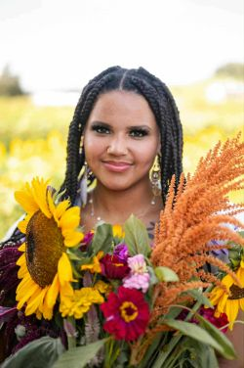
Kierra Mae Harris is the daughter of Terri Hines and Errick Harris and the granddaughter of Jeanne and James Harris, and Terry Wyckoff. She is a 2026 graduate of Robert C. Byrd High School and plans to go to Pierpont Tech.
She loves fishing, hiking, waterfall chasing, and anything to do with animals. She is a mechanic’s helper and works part-time at BLI Solutions and at Camp Cupcake Dog Kennel. She would like to work as a mechanic and eventually open an animal boarding business. Summer plans include working, hiking, fishing, and vacationing. Her words of inspiration are, “All of our dreams can come true if we have the courage to pursue them.” Walt Disney.: . . .

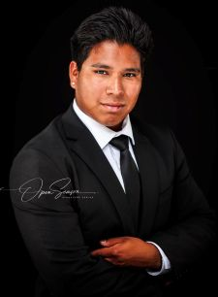
Anderson Mitchell is the son of Robbie (Sarah) Mitchell and Lindsey (Mark) Harrison and the grandson of Jeffrey and Pamela Mitchell and Charles and Paulette Bierer. He is a 2026 honors graduate of Bridgeport High School. At Bridgeport, he was a 4-year member of the swim team, qualifying for the state swim meet all 4 years and winning states his junior year. In the offseason, he also participated in club swim team. During his Senior year, he was a dual enrollment student at Bridgeport High School and Pierpont Community and Technical College. At Pierpont, he completed 15 hours in Aviation Maintenance Technology program and will continue pursuing that degree upon graduation. Anderson has worked part- time at The Bridge as a lifeguard and enjoys collecting vintage CDs, cassettes, and albums. His summer plans include a graduation celebration on a family cruise vacation swimming, working, and attending summer school to continue his educational journey. Anderson would like to thank his family and church family for their love and support over the years.

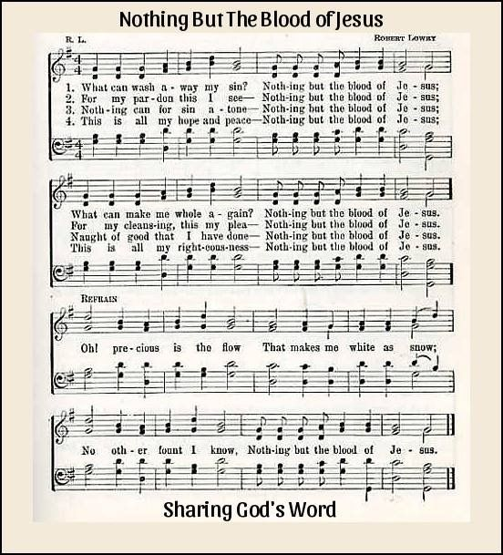
Congratulations to all our Seniors!!!

