 presbyterian PRESS 2025

**PUBLICATION OF FIRST PRESBYTERIAN CHURCH OF CLARKSBURG**

**SPECIAL DAYS IN MARCH**

* Transfiguration Sunday — March 2, 2025
* Ash Wednesday — March 5, 2025
* World Day of Prayer — March 7, 2025
* Daylight-Saving Time begins — March 9, 2025
* St. Patrick's Day — March 17, 2025
* First Day of Spring — March 20, 2025

**IT LOOKS LIKE WINTER MAY BE OVER SOON – FIRST DAY OF SPRING MARCH 20TH -----**





2nd – Maria Morrison

9th – Dick Ogden

16th – Pam Mitchell

23rd – Beth Allen

30th - Terra Burnett

2nd – Ginger Delawder

9th – Kandy Atkinson

16th – Josh White

23rd – Ashleigh Burnett

30th – Maria Morrison

 

2nd – Amy Strange Harriett Northey

9th – Anthony Paletta Beth Allen

16th – Kandy Atkinson Ginger Delawder

23rd – Harriett Northey Suzi Heger

30th – Jenna Bennett Terra Burnett

Laundry Ministry 6th – Beth & Kierra

13th – Wayne & Harriett

20th – Beckie & Maria

27th – Josh & Sally/Suzi

The deacons are collecting snacks and candy treats for the VA nursing home. If you would like to donate, please drop off your donations by the 16th as they will be packaging up the treats to deliver on the 17th.

The Lenten lunches will be starting on the 5th of March (Ash Wednesday)

**Date Speaker Soup & Sandwich of the day**

March 5th Rev. James A Harris Italian Tomato Soup with pimento  First Presbyterian Church cheese, chicken salad sandwiches

March 12th Rev. Linda Muhly Vegetable Beef Soup with chicken. St. Mark’s Lutheran Church or ham salad sandwiches

March 19th Father Casey Mahone Chili and grilled cheese Immaculate Conception Parish sandwiches

March 26th Rev. Evan Walker Potato Soup & egg salad,

First Presbyterian – Fairmont chicken salad sandwiches

April 2nd Rev. Steve Elderbrock Chicken & Rice Soup with pork First Presbyterian – Bridgeport barbecue and pimento cheese sandwich

April 9th Rev Jeff Hanlin Broccoli Cheese Soup with Central Christian Church pimento cheese, chicken and ham salad sandwiches

April 16th Rev Chris Scott Minestrone Soup with Grilled Christ Church & St. Barnabas Chapel ham and cheese sandwich

Terra has a volunteer sign -up in the bulletin if you would like to donate a cake or help in any way with the lunches. All help is appreciated.

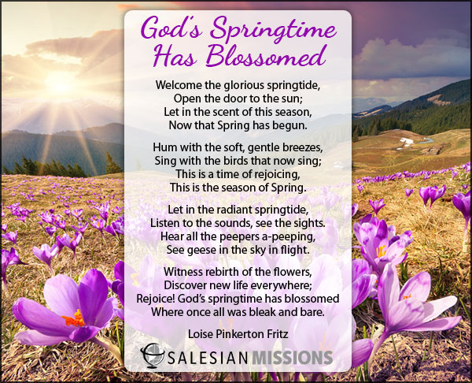Sermons for month of March:

2nd - “Lord, I Hear You” Scriptures: Psalm 99, Luke 9:28-36 (37-43)

9th - “Giving, Not Giving Up” Scriptures: Luke 4: 1-13, Deuteronomy 26: 1-11

16th - Dick Ogden speaking - Pastor out of town

23rd – “My Treasure Good or Bad” Scriptures: Luke 13: 1-9, Isaiah 55: 1-9

30th – “Storm Has Passed” Scriptures: 2 Corithians 5: 16-21, Joshua 5: 9-12



As March begins, we ask the question where did February go so fast. We had a rough month in February, plenty of snow along with the rain. Some areas in our state were flooded. We have to keep the ones who suffered losses in our prayers. We must continue to pray for peace in this world. Pray for our leaders on every level in our government to make decisions that will help us and not harm or destroy us. Remember to turn our clocks forward one hour on the 9th of March. Spring begins the 20th of March. Our Lenten services and lunches begin on the 5th of March which is Ash Wednesday. Let us prepare our hearts and minds for the season to grow spiritually. Let love take over our feelings and hateful thoughts and deeds will leave us. God bless and keep you in my prayers.



It’s time to start thinking about our orders for the Easter Lilies.

We will need to have our order by the end of March and I talked to the florist today and she said they will be the same price as last year. I will put the notice in the bulletin in a couple of weeks but I am just letting you know in advance.

I’m so excited that spring will be here shortly. Time for vacations, fun times with children, grandchildren, friends and family. Beaches, amusement parks, mountains, fishing, gardening whatever your interest may be. Fun times ahead.