FIRST PRESBYTERIAN PRESS 2026
PUBLICATION OF FIRST PRESBYTERIAN CHURCH OF CLARKSBURG, WV
November 2026
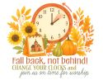
- All Saints' Day — November 1, 2026
- Daylight-Saving Time Ends — November 1, 2026
- Veterans Day — November 11, 2026
- Bible Sunday — November 15, 2026
- National Bible Week — November 23-27, 2026
- Christ the King Sunday — November 22, 2026
- Thanksgiving Day — November 26, 2026
- First Sunday of Advent — November 29, 2026

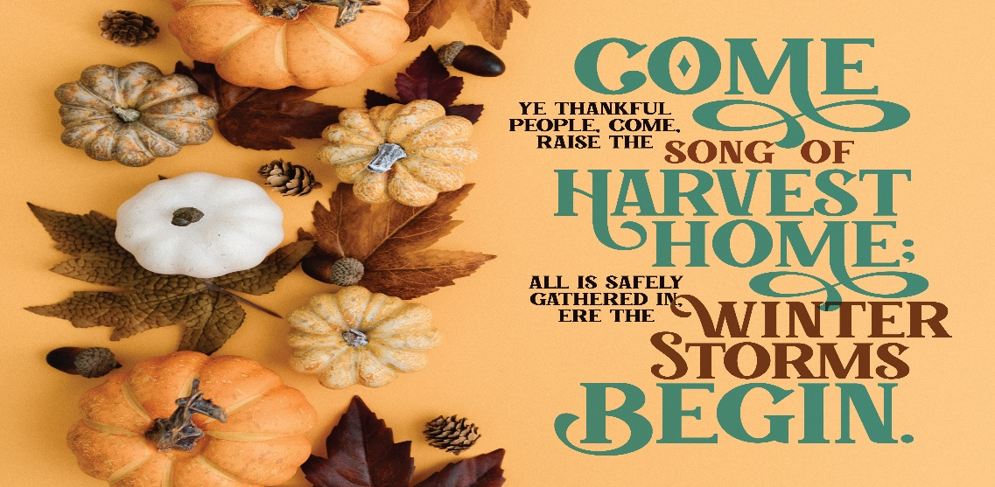


- Veterans Day is the day set aside to thank and honor ALL who have served, living or deceased, but in particular the living veterans among us.
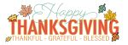

Worship Leaders Greeters
1st - Maria Morrison Sandy/courtney
8th –Beth Allen Kandy Atkinson
15th –Suzi Heger Donna Shiffra
22rd – Jeanne Harris
29th –Youth Pam Mitchell

Coffee Hour Children’s Moments
1st – Suzi Heger Beth Allen
8th – Karen & boys Jeff Mitchell
15th –Beth Allen Kandy Atkinson
22^{nf}– Andrea myerberg Jeanne Harris
29th – Terra Burnett Terra Burnett
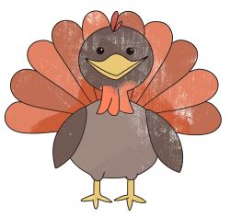



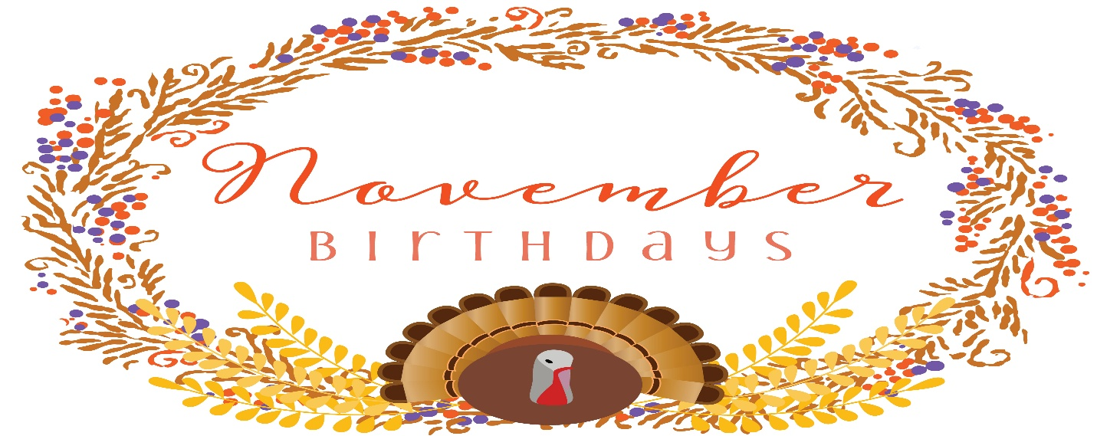
2nd – Cole Delawder
Michael Lonsinger
4th – Gary Nickerson, Rev. John Koerner
7th – Theresa Koerner
8th – Kevin Corsini
11th – Judy McQuaid
Jeff Strange
20th – Frank Simmerman
22nd – Gia Corsini
25th – Evie Corsini

Remember to change your clock back on Saturday night the 31st!


The Pastor will be out of the office from November 23rd to December 1st.
Sermons & Scriptures
1st – Christian Leadership Psalm 43, Matthew 23: 1-12
8th – The Wise Can Wait Psalm 70, Matthew 25: 1-13
15th – Unexpected Angels 1 Thessalonians 5: 1-11, Judges 4: 1-7
22nd– The View from the Tower Psalm 100, Ephesians 1: 15-23
29th –Pastor out of office. Children doing the service.
We thank you Lord for blessing us to see November 2026. We will celebrate Veterans Day and Thanksgiving this month. To all of the men and women who served in our armed forces we thank you for your service. We shall always remember and respect those who sacrificed their lives for our freedom. We celebrate and are very thankful to be able to thank God for the privilege to say thank you Lord for all of the blessing you have given us. We will have national and local elections this month. Let’s all go to the polls and vote. The busy time for Christmas shopping draws near. Let us remember the true meaning of Christmas. The birth of our Lord and Saviour. God bless you.
Pastor James

Please remember all the people who do not have families or are alone during thanksgiving. Sometimes they have a hard time during the holidays. Families may be too far away or maybe they don’t have a family.

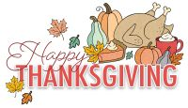
Heavenly Father, we gather with hearts full of gratitude for Your boundless blessings. Thank You for the gift of family and friends, for the love that binds us, and the joy we share. We are thankful for the food on our table, the roof over our heads, and for all the small and large ways You provide for us each day. Bless our time together, our conversations, and our laughter. We pray for those who are alone or suffering, that they may find comfort and peace. Help us to be a source of love and strength for one another, and to carry this spirit of gratitude with us throughout the year. Amen.

