THE CROWN POST

WELCOMES YOU TO OUR 14TH CENTURY RESTAURANT… The Crown post was named as it boasts one of the finest surviving early examples of its namesake. This is clearly shown in all its glory, together with the grand vaulted ceiling in one of the upstairs dining rooms. The building was originally thought to herald from the 16th century, however after further investigation it was found that the main and original structure actually dates back to early 14th century. It was thought to have been a small guildhall, which was later re-modelled into a house in the 16th century. These additions were experimental and somewhat innovative for its time and is a testament to the early craftsmanship. The building has been brought back to life with much care and attention please enjoy your visit and be welcomed to take time to look round at the many early features we have.

57 CHURCH STREET
HARWICH
01255 553131

Food service times:
MONDAY: closed
TUESDAY 12-00pm – 2:00pm
6-00pm - 9:00pm
WEDNESDAY: 12:00pm – 2:00pm
6:00pm – 9:00pm
THURSDAY: 12:00pm – 2:00pm
6:00pm – 9:00pm
FRIDAY: 12:00pm – 2:00pm
6:00pm – 9:00pm
SATURDAY: 12:00pm – 2:00pm
6:00pm – 9:30pm
SUNDAY: 12:00PM – 6:00pm

[V] Suitable for vegetarians. Our food is prepared in a kitchen where nuts, gluten and other allergens are present if you have a food allergy or intolerance please feel free to consult a member of staff about your requirements. Fish dishes may contain small bones.

WHILE YOU DECIDE
Pot of seasoned mixed olives [V] £3.00 Fresh Bread and Oils [V]
£3.25 Whole baked camembert [V] whole wheel of French cheese soft oven baked served with crisp toasted baguette and a spiced onion chutney £7.95

Starters
Soup of the day
served with fresh sourdough bread.
£4.25
Deep fried breaded whitebait
sourdough roll & tartare sauce
£4.95
Garlic Field Mushroom [V]
baked in a stilton crust served with dressed salad and balsamic glaze.
£5.25
Teriyaki Beef
strips of sirloin steak seared in teriyaki sauce served on little gem lettuce accompanied with Asian vegetables and topped with sesame seeds.
£5.95

Classic Prawn Cocktail
Greenland prawns in marie rose sauce served on shredded little gem lettuce accompanied with lemon and fresh bread and butter.
£6.75
Sweet & sticky chicken skewers
salad & sweet chilli dip £5.25

Salt and Pepper Calamari
chunky pieces of squid deep fried in a crisp salt and pepper batter served with dressed salad and chipotle mayonnaise
£5.75

Please see our specials boards for a range of chef’s daily specials

MAIN COURSES

Crown Post fish and Chips £9.75 Local fillet of the day in crispy homemade batter accompanied by chunky chips, minted garden peas & tartar sauce.
Oven roasted lemon sole £11.50
Sauté potatoes, asparagus tips & prawn beurre blanc
Homemade Chicken Kiev £10.25
tender 8oz chicken breast stuffed with garlic and herb butter and roasted in a crispy crumb served with chunky chips, house dressed salad & homemade creamy cauliflower cheese.

Pan Fried Lambs Liver £9.25
slices of lamb’s liver seared with smoked back bacon and onions served on a bed of creamed mash potatoes and rich red wine gravy accompanied with seasonal vegetables.
Grilled seabass fillets £10.95
New potatoes, curly kale & prawn butter

VEGETARIAN OPTIONS
Red Pepper penne pasta £9.25
Creamy penne pasta with spinach & garlic bread
Sweet potato gratin £9.75 Sweet potato & goats cheese with red pepper & spinach, skinny fries & salad

FROM THE CHARGRILL
Steaks
8oz Rump £13.95
8oz Sirloin £14.95
8oz Rib-eye £14.95
8oz English steak cooked to your preference served with roasted tomatoes, field mushroom and crispy fried onion rings accompanied with skinny fries
steak sauces, mushroom, stilton or garlic butter £1.50
Cajun Chicken Burger £9.75
tender chicken grilled in a blend of Cajun spices & breadcrumbs, served in a brioche roll accompanied with skinny fries and house dressed mixed salad.
Gammon steak £9.25
Local sourced gammon steak, topped with a fried egg, spicy pineapple and chilli chutney, served with chunky chips and garden peas
8oz Beef Burger £9.75
served in a toasted brioche bun topped with bacon, pepper jack cheese, lettuce, tomato & gherkin accompanied with skinny fries.

EXTRAS
All at £2.75
Garlic bread
Chunky chips
Creamy cauliflower cheese
Crispy fried onion rings
Skinny fries
Seasonal vegetables
Dressed house salad

DESSERTS
all at £4.50

Chefs cheesecake
please ask your server for the cheesecake of the day
Apple crumble
Hot apple crumble with custard
Chocolate brownie
served warm with vanilla ice cream and a rich chocolate sauce

Rich dark chocolate tart
chocolate sauce & vanilla ice cream

Trio of ice creams or sorbet
please ask staff for flavours

Selection of fine cheeses
served with savoury biscuits and a sweet onion chutney £6.50
Hot drinks
Cappuccino £2.80
Latte £2.80
Mochaccino £2.80
Hot chocolate £2.80
Pot of tea £2.25
Espresso £2.15
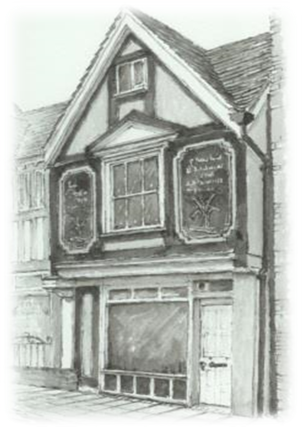

KIDS MENU
Homemade fish or chicken goujons
served with skinny fries and garden peas

Burger & skinny fries
salad

Homemade lasagne
garlic bread & salad

All at £5.25

LIGHT BITES

JACKET POTATOES
Freshly baked jacket potato accompanied with house dressed salad garnish and a choice of topping £5.25
Cheese, beans, tuna, coleslaw, creamy garlic mushrooms

BAGUETTES
Freshly prepared and made to order accompanied with house dressed salad garnish and a choice of filling £5.25

Cheese & pickle
Tuna mayonnaise
Prawn and Mary rose sauce
Ham and grain mustard
BLT – Bacon, lettuce and tomato
Add skinny fries or chunky chips for just £1.00 extra

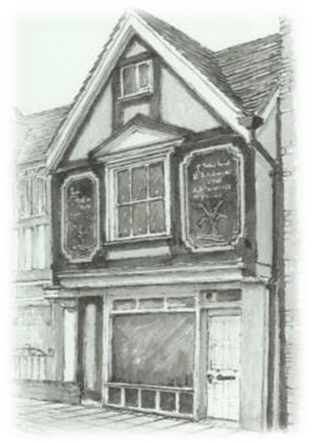
PLOUGHMAN’S LUNCH
Delicious ploughman’s lunch with dressed salad, crispy baguette & butter, dill pickle, baby pickled onions
Cheddar £5.95 Gammon Ham £5.95
Cheddar, Brie & Stilton £7.25
Cheddar & Gammon Ham £6.95

Thank you for visiting the Crown Post we hope you have enjoyed your visit we welcome any feedback so please feel free to review us on TripAdvisor Facebook

