




2026-2027
Woodlawn PRESCHOOL
Family Handbook

TABLE OF CONTENTS

GENERAL INFORMATION
Mission/Philosophy
Program Overview
Clothing and Footwear Policy
Non-Discrimination Policy
Cultural Competency Plan
Licensing Notebook Notification
Program Evaluation
Curriculum
Assessment
Screening/Referrals
Special Needs Plan
Confidentiality
Recruitment Policy
Enrollment Policy/Fee Policy
Withdrawal/Exclusion Policy
Attendance Policy
Discipline/Conflict Resolution Policy
Rest Time Policy
Injury/Illness/Incident
Medication Policy
Health Policy
Nutrition Policy
Abuse and Neglect Policy

PROGRAM SPECIFIC INFORMATION
Program Philosophy
Daily Routine
Calendar of Year
Grievance Policy
Volunteer Policy
Transportation Policy
Weather Policy
Emergency Policy
Kindergarten Transition Policy
Parent Signature Page

MISSION STATEMENT
Mission- All children will be safe, healthy, prepared, and eager to succeed in school and life.
PHILOSOPHY
Woodlawn preschool Program is committed to giving every child a great start in order to be successful in school and in life.

We believe that school readiness begins by supporting children’s health and development across all domains. This is achieved through the following areas:

- A learning environment that fosters independence, creates an inviting space and provides open-ended, multi-faceted materials that reflect children’s interests and experiences.

- Relationships built on mutual respect and trust, that support child initiative and problem solving, encourage identifying and managing emotions and promote adult scaffolding of children’s learning. Social relationships are encouraged through learning conflict resolution, working cooperatively in small and large group settings and exhibiting a respect and appreciation for all people.

- A curriculum that promotes active learning and responsive teaching for various learning styles. Assessment tools that use observation and documentation to record children’s current strengths while planning for children’s growth, share progress reports and gather family input on child’s individual development and outcome goals and provide data to use as a tool for planning staff and administration professional developments.

- Family involvement includes various forms of open, respectful, two-way communication, volunteer opportunities in and out of the program setting, events or activities supporting family growth and understanding of identified concepts that are relevant to them and opportunities to have their voices and opinions heard, such as through advisory committees and program evaluations. Family home life and cultures are reflected and celebrated through materials and interactions.

PROGRAM OVERVIEW
The Great Start Readiness Program (GSRP) is operated by a grant received from the State of Michigan. This is a program for four-year old children with factors which may place them at risk of educational failure. The children are in attendance either Monday-Thursday for either a school day or part day, or Monday-Friday school-day depending on the program. The adult-child ratio in every classroom is 1 teacher for every 10 children and a cap is set at 20 children.

Clothing and Footwear Policy
Clothing and Footwear Policy: Children should arrive dressed for active play and the weather. Please send your child in shoes that fit securely and are safe for walking, running, and outdoor play. Send a change of clothes labeled with your child’s name. If your child needs different footwear for a medical or developmental reason, please speak with the program director.

NON-DISCRIMINATION POLICY
Woodlawn preschool great Start Readiness Program shall not discriminate in its policies and practices because of age, race, color, national origin, marital status, disability, physical characteristic, gender, religious beliefs, cultural identity, socioeconomic status, familial status and genetic information.

CULTURAL COMPETENCY PLAN
Woodlawn preschool Great Start Readiness Program recognizes and respects all children’s home cultures. This includes but is not limited to the religion, language, race, celebrations, socio-economic status, education level of family members, child-rearing practices and family structure in each home. We strive to reflect this through the policies and procedures including having translators and forms in various other languages, our verbal and non-verbal language, events that include all members of the family, materials in our classrooms, the Parent Advisory Committee, conferences and home visits. We encourage families to share information, skills, materials and knowledge from their home culture throughout the year. We have a strong commitment to handle any information about or interaction with a family with respect and confidentiality (see Confidentiality Policy). Our staff will have opportunities annually for professional development, discussions, and exchanging of ideas to further their understanding of this topic.

HOME VISITS/CONFERENCES
Partnership between families and the school is a key component of a child's success in this program and beyond. Families can expect to participate in four family meetings each year, including two home visits and two parent-teacher conferences.
Home visits take place at the beginning and end of the school year and are approximately 45 minutes long. Parent-teacher conferences are held during the middle of the school year and are approximately 30 minutes long.
During these meetings, teachers and families will discuss your child's development, progress, strengths, and any family needs. Together, families and teachers will create goals and strategies to support your child's learning and growth both at school and at home.

LICENSING NOTEBOOK
This program is licensed under DHS and follows all licensing guidelines and rules. A copy of these rules and guidelines is available on the information board in or near the classroom as well as online at https://www.michigan.gov/mileap/early-childhood-education/cclb. Each site shall maintain a licensing notebook that contains information about renewal inspections, addendums, corrective action plans, any special investigation reports and product recalls. All families will be given notification on the contents and location of this notebook. Families are welcome to review this notebook any time during the program’s operating hours.

PROGRAM EVALUATION
All GSRP programs are required to work with the Michigan Department of Lifelong Education, Advancement and Potential to measure the effect of the state-wide GSRP program. Information is sometimes collected about GSRP staff, enrolled children, and their families. Program staff or a representative from MiLEAP might:
- Ask parents questions about their child and family.
- Observe children in the classroom.
- Measure what children know about letters, words, and numbers, etc.
- Ask teachers how children are learning and growing.
Information from you and about your child will not be shared with others in any way that you or your child could be identified. It is protected by law.

If you have questions please contact:

Calhoun Intermediate School District
- 269-660-1606
- 475 E Roosevelt Ave, Battle Creek, Mi 49017

Michigan Department of Lifelong Education, Advancement and Potential
- 517-241-7004
- 105 W Allegan Street, Lansing, MI 48933

CURRICULUM
Woodlawn preschool great Start Readiness Programs have the option to use the HighScope Curriculum or Creative Curriculum. Both curriculums are research based and validated to provide a comprehensive early childhood framework for classrooms.

HighScope
Researchers have tested the HighScope approach and the effectiveness of the curriculum. Studies found that children from a high-quality classroom using a HighScope Curriculum:
- showed higher social responsibilities
- demonstrated higher employment rates and annual earnings
- had higher educational achievements
- took more responsibility with their families
HighScope is built upon the idea that children construct knowledge through active learning and supportive adult-child interactions. In an active learning setting children choose materials to explore, search for answers, and problem solve obstacles they encounter with adult support and guidance. Positive relationships develop through shared control and responsive encouragement. Teachers provide a consistent daily routine and child-friendly learning environment. Small and large group activities are planned based on children’s interests and developmental needs. Children’s developmental growth is documented through the use of HighScope’s Child Observation Record (COR). HighScope’s curriculum follows the key developmental indicators (KDIs), found on the following page of this handbook.

HIGHSCOPE PRESCHOOL CURRICULUM CONTENT
KEY DEVELOPMENTAL INDICATORS (KDIs)

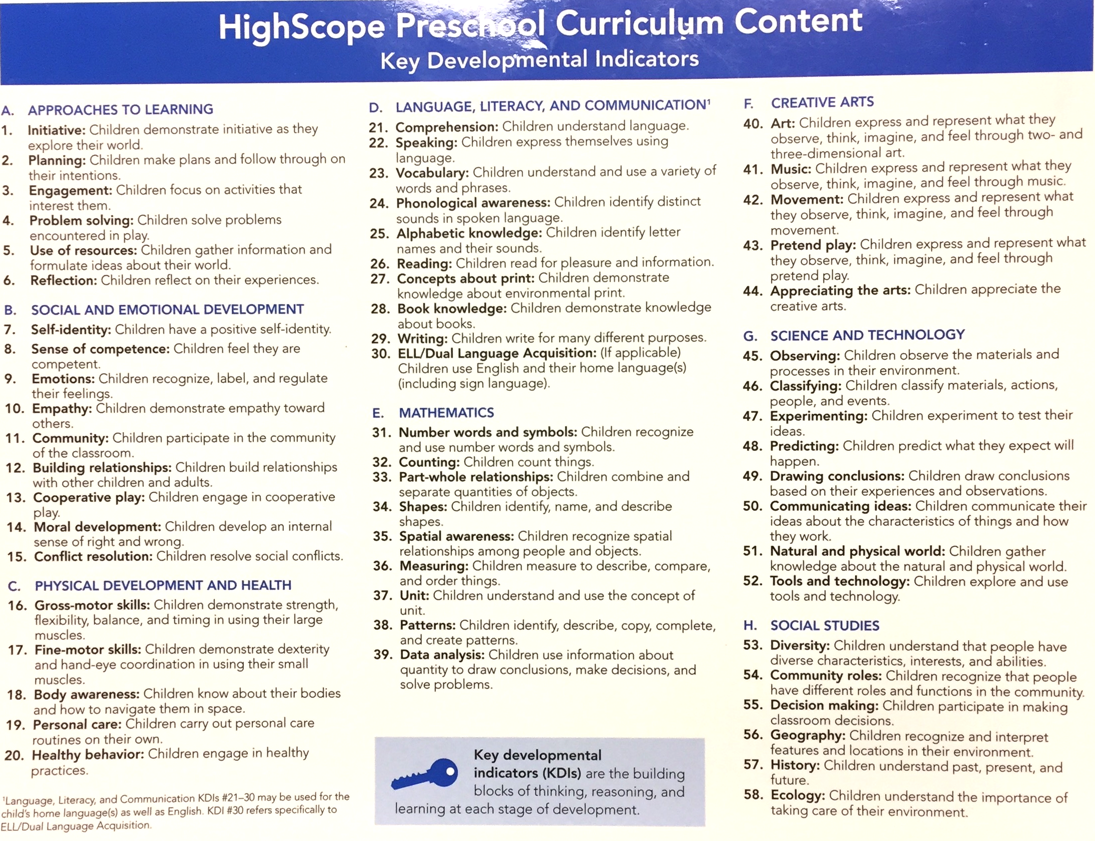

SCREENING
Teachers will facilitate family access to ASQ Online. Families will complete the Ages & Stages Questionnaires, Third Edition (ASQ-3) and the Ages & Stages Questionnaires: Social-Emotional, Second Edition (ASQ:SE-2) within two weeks of the program start date.
The ASQ-3 is a developmental screening tool that helps identify a child's strengths and areas where additional support may be beneficial. It looks at five key areas of development: communication, gross motor, fine motor, problem-solving, and personal-social skills.
The ASQ:SE-2 is a social-emotional screening tool that focuses on a child's social and emotional development, including self-regulation, communication, independence, interactions with others, and behavior. It helps identify children who may benefit from additional support in developing healthy social-emotional skills.
The information gathered from these screenings will be compiled and used to develop individualized strategies to support each child's growth both at home and at school. Families will be asked to provide information about their child's abilities and any areas of concern they may have. All screening results will be shared and discussed with individual families in a confidential manner. If additional screenings are recommended during the school year, families will be contacted, informed of the reason for the screening, and asked to provide written permission before any further screenings are conducted.

REFERRAL PLAN
Any concerns for a child’s development or social and emotional wellbeing will be discussed between the teacher and family. Teachers will first seek support through their Early Childhood Specialist. The Early Childhood Specialist, program staff and family will work together to create a plan and strategies for support. If concerns persist, an outside referral might be necessary to seek additional support. Outside referrals (Birth to Six and/or Social and Emotional Support) can only be made with family approval and signature. The teacher will submit the signed referral form to the Early Childhood Specialist. Families will be included on all steps of this process.

Additionally, there may be times when a family is experiencing needs that could be alleviated by a referral to a community resource. If this does occur, then the family will be directed to Help Me Grow Calhoun to be connected to resources in our community.

SPECIAL NEEDS PLAN
Woodlawn Preschool Great Start Readiness Program is committed to the concept of inclusion. Staff will make accommodations to include all children in the learning environment and daily routine. Families and staff work together to meet the individual needs of each child. Communication is two-way and ongoing while respecting confidentiality. Staff will receive annual training on various strategies and information on working with families and children with special needs.

CONFIDENTIALITY
Student health/medical records and identifying information is kept confidential. Please be assured that information you share with the teacher will be kept in the strictest confidence. Occasionally, information such as allergies, IEP goals, behavior plans, demographics, etc. may need to be shared with individuals working with the child (substitute teacher, principal/director, and support services staff such as special education personnel). Family Education Rights and Privacy Act (FERPA) gives parents and guardians the following rights:
- The right to inspect student records maintained by a school district.
- The right to prevent disclosure of educational records to a third party without their consent, except in certain limited situations.
- The right to request a correction of any part of the student records which you believe to be inaccurate, misleading or violates your right.
- The right to protest to the Family Educational Rights and Privacy Office Department of Education, 400 Maryland Avenue, SW, Washington DC 20202, concerning the program’s failure to comply with FERPA.
During your child’s enrollment, you may learn about other families and children, and confidentiality must be maintained.

RECRUITMENT POLICY
GSRP funding is provided through a grant from the State of Michigan and distributed by the Calhoun Intermediate School District (CISD). All families must qualify for this program by meeting requirements set by GSRP. Eligibility and selection is determined by using the GSRP prioritization guidelines. GSRP works in cooperation with Head Start and Early Childhood Connections to ensure accurate placement of families. Families that are Head Start eligible must be referred to Head Start.

ENROLLMENT POLICY
Step 1 Parents can access the application at https://helpmegrowcalhoun.org/ This application is completed and submitted online to be considered for enrollment in a Great Start Readiness Program classroom. If there is no internet accessibility, parents can obtain an application by calling the Early Childhood Office at 269-660-1606.
Step 2 Beginning March 15th of every year, Calhoun ISD Early Childhood Services staff will mail a letter to parents acknowledging the receipt of a Birth-to-Five application for their 4 year old child.
Step 3 Within 10 days of the requested agency’s receipt of the application, parents will be notified by the agency that their application has been received, and will be notified if additional information/documentation is needed to complete the eligibility phase and where/when these documents should be delivered.
Step 4 Acceptance eligibility is determined from lowest income to highest income. Those
Step 5 Agencies will notify families of their child’s acceptance as soon as eligibility has been confirmed. This process will occur throughout the summer.

Children must not be denied enrollment or excluded from GSRP programming based on challenging behavior, developmental delays or identified disabilities (e.g., toileting needs, speech, motor function, aggressive behaviors, and cognitive delays).

FEE POLICY
The Great Start Readiness Program is a state-funded preschool program through the Michigan Department of Education. There is no cost or fee for students meeting the required criteria.

WITHDRAWAL/EXCLUSION POLICY

“Children must not be excluded or expelled because of the need for additional medical or behavioral support, assistance with toileting, or staff attitudes and/or apprehensions.” (GSRP Implementation Manual, Classroom Requirements)

- Withdrawal of child by family: It is requested that families give notification of withdrawal to the program as soon as possible. The program will follow up with the family to determine the cause of withdrawal.

- Exclusion:
- Should a short-term injury or contagious illness occur, a child may be excluded from the program until a doctor gives permission to return to school.

- A child without an immunization record, medical waiver, or certified, non-medical waiver on file may be excluded after families are notified about this requirement, unless student is in a dose waiting period.

- Withdrawal from program- in rare, extreme cases where it is determined that, after exhausting all strategies and supports (i.e. asking for a behavior consultant, referring for psychiatric visits, consulting with child’s pediatrician, working with special education providers, inviting in a social worker), the child’s needs can be better met in another setting. Children will not be excluded because of the need for additional medical or behavioral support, assistance with toileting, or other issues that can be supported through professional development of staff, providing resources to families, changes in the learning environment or daily routine, etc. (See Attendance Policy and Discipline Policy)

ATTENDANCE POLICY
Please notify the program when your child will not be in attendance.

Consistent attendance is one of the most important things you can do to help your child. Research shows that regular attendance might be the biggest influencing factor on school success. Family attitude toward school is very powerful. These early experiences will lay the groundwork for future habits.

Children who attend school on a regular basis:
-Have higher reading and math scores
-Demonstrate larger vocabulary and better social skills
-Feel part of a school community and learn how to be a better citizen
-Learn that school is a priority.

You can help by:
-Planning ahead to reduce absences
-Preparing for school the night before and getting a good night’s sleep
-Maintain your child’s health with annual visits to a doctor.
-Ask for help! Transportation is often an issue that prohibits attendance. The program staff can brainstorm some ideas that could work for your family.
-Show your child you are interested in the school experience
-Visit www.attendanceworks.org

Staff is committed to having all children in school daily. Teachers will try many strategies to encourage attendance and follow up with families where attendance becomes infrequent. After multiple strategies over an extended period of time with no results, the family may be notified of the child’s withdrawal from the program if the slot is needed for families on the waiting list.

DISCIPLINE/CONFLICT RESOLUTION POLICY
Positive guidance techniques will be used to:
- help children become aware of their behavior and the consequences
- develop rules to protect the safety of children, protect property or help children learn to respect the rights and feelings of others
- develop consequences that are natural or logical
- make accommodations to the learning environment or daily routine that will help each child to be successful within the GSRP classroom.

The following are prohibited forms of discipline:
- Spanking/hitting, shaking, biting, pinching or any form of corporal punishment
- Exclusion from outside, gross motor time or daily learning experiences
- Restricting a child’s movement by binding or tying
- Inflicting mental or emotional punishment (humiliating, shaming, threatening)
- Confining a child in an enclosed area such as a closet, locked room, box or similar cubicle

Conflict Resolution will be handled in the following manner:
- approach social conflicts calmly, stopping all hurtful actions
- acknowledge the feelings of children involved in the conflict
- gather information from children on the problem
- restate the problem so that all parties understand
- ask children for ideas and solutions, encouraging them to choose one together
- give follow up support as children act on their decisions

REST TIME POLICY (where applicable)
Programs that operate 5 or more hours must have quiet/rest time. This rest time will be a period of at least 45 minutes and no longer than one hour, while accommodating for the individual needs of children. Other quiet activities will be provided for children who do not sleep. Children will assist with setting up and cleaning up as their abilities allow. Soft music will be played, the lights will be turned off and staff will provide a comforting, supervising presence while children rest. Children may bring their own blanket and stuffed animal to assist them in resting. Each child will be provided one mat or cot to rest on. Mats/cots will be sanitized in accordance with licensing rules.

INJURIES/ILLNESS/INCIDENT POLICY
A Child Information Card giving permission for emergency treatment must be kept on file.

Injuries:
- minor cuts and scrapes will be treated with band-aids, ice packs and staff monitoring. Family notification will be made by face-to-face or written notification at the end of day.
- more critical injuries will be attended to with first aid care. Family notification will be made immediately by phone or email following the occurrence of an injury that occurs to the head.
- serious accidents requiring removal to an emergency room or for paramedics to be called require immediate notification of family and/or emergency contacts by phone. Notification must also be made to the Bureau of Children and Adult Licensing.

Illness:
Families will be notified of the name of the disease and the symptoms when a staff member, volunteer or child in care has contracted a contagious illness. When a child is showing signs of being ill at the program, notifications will be made in order of preference as listed on child information card. The ill child will be provided a spot to rest away from the other children until he/she can be picked up. See Health Policy.

Incidents:
Incidents include but are not limited to: a child left unsupervised, a fire, physical discipline of a child by staff or volunteer, or alleged sexual contact. Incidents require an immediate notification of parent/guardian, administrator of program and a verbal report to DHS within 24 hours.

MEDICATION POLICY
Medication should be administered by a parent or guardian before the child comes to school or the child should be kept home until well enough to attend without needing medication.
In the case of emergency treatment medications (allergies, asthma, etc.), a permission form will need to be on file with the program. All medicines must be in their original container with the label from the pharmacy (child’s name, doctor’s name, dosage, etc.)
The date, time and amount of medication will be documented by program staff.

HEALTH POLICY
Physical and Immunization:
Each child is required to have a current physical form on file within 30 days of a child beginning the program and a current immunization record or waiver on file.

Head Lice
The American Academy of Pediatrics states “A child or adolescent should not be restricted from school attendance because of head lice”. Caregivers will be notified and the family will be connected to resources and information to assist the family.

When to keep your child home:
Vomiting and/or diarrhea within the past 24 hours.
Fever of 100 degrees within the past 24 hours.
Strep throat, Scabies, Scarlet Fever, Conjunctivitis (“pink eye”), Meningitis and/or other communicable diseases: Ask your physician for his/her recommendation. Children must have 24 hours of medicinal treatment prior to returning.
Chicken Pox: Children can return after the sores have dried up (scabs are no longer oozing).
Colds, influenza and/or other viral infections: Ask your physician and/or use your best judgment. Consider the following:
- Is your child feeling up to attending?
- Will his/her being there present any danger of spreading infection to others?
- Will being there cause his/her illness to get worse?
Blood/Bodily Fluids
We have special policies to follow when a child has been bleeding or has any bodily fluids on his/her clothing. **Bodily fluids are vomit, diarrhea, urine and blood. Michigan law requires that a child that has bodily fluids on his/her clothing cannot be exposed to other children.

Our procedure for handling blood and bodily fluids is a follows:
Gloves are put on before making contact with bodily fluids during care and all cleaning procedures. Additionally, masks may be worn.
- Disposable gloves will be discarded after a single use in accordance with disposal procedures.
- Hands will be washed in soap and water after handling fluids and contaminated articles even though gloves are worn.
- Discarded items, including disposable gloves, paper towels, sanitary napkins/tampons, used bandages and dressings will be placed in a plastic trash container which is kept closed and is discarded daily.
- Disposable items will be used to handle body fluids whenever possible or practical.
- Paper towels will be used to pick up and discard any solid waste materials, e.g., vomit, feces.

Children & Staff Hand Washing:
The hands of children and staff shall be thoroughly washed at arrival time, prior to handling food and before eating, after toileting, after coughing into hands or blowing nose. Procedures for hand washing shall be posted in food preparation areas and toilet rooms according to Child Care Center Licensing Rule R 400.8134.

Our hand washing procedure is as follows:
- Use soap and warm running water. Soap suspends easily removable soil and microorganisms, allowing them to be washed off.
- Rub hands together for approximately 20 seconds to work up a lather.
- Scrub between fingers, knuckles, backs of hands, and nails.
- Rinse hands under warm running water. Running water is necessary to carry away debris and dirt.
- Use paper towels to thoroughly dry hands. Discard paper towels.
Coughing & Sneezing:
Children are taught ways to cough/sneeze to avoid the spread of germs:
- Cough into a tissue and throw it away.
- Cough into your upper sleeve or elbow.
Cough into a tissue, throw it away and wash your hands. If no tissue is available, cough into a sleeve (at the elbow). Using either of these methods, can reduce the spread of germs and help stop the spread of infectious illnesses/diseases.

Controlling Infection, Including Universal Precautions:
All staff will receive BloodBorne Pathogens training within 6 months of being hired. Emergency rules and procedures, as well as CPR and First Aid will be reviewed annually by all staff.

Sanitizing Equipment:
All tableware, utensils, food contact surfaces, and food service equipment shall be thoroughly washed, rinsed, and sanitized after each use with an approved sanitizing solution. Children’s toys and equipment will be sanitized regularly to adhere to Child Care Center Licensing Rules and Regulations.
GSRP ensures that all toys are sanitized using the 3-Step Sanitizing Process (outlined below) a minimum of 1 time every three weeks. When a child mouths a toy, or touches a toy after coughing or sneezing, the toy is put into a Dirty Toy bucket. All toys in the bucket are sanitized at the end of the day and returned to the classroom.
In addition to the tri-weekly complete sanitizing process, toys are sprayed with an approved sanitizing solution and allowed to air dry at the end of every day.
Three Step Sanitizing Process:
Step 1 – Soapy Water (Using soapy water, wash surface vigorously)
(Must be dumped and refilled daily)
Step 2 – Clear Water (Rinse surface with clear water and wipe with paper towel)
(Must be dumped and refilled daily)
Step 3 – Sanitize with sanitizing solution. Allow to air dry when possible.
(Must be dumped and refilled daily)

Physical Activity
Children will be provided a minimum of 30 minutes of physical activity per day. This will be outside whenever weather permits so please dress your child appropriately (tennis shoes, snowsuit and boots in winter, hat with brim if sensitive to sun)

NUTRITION POLICY
GSRP classrooms adhere to Child and Adult Care Food Program nutritional guidelines and DHS Bureau of Children and Adult Licensing rules. Menus will be planned in advance and posted for families to see. Food substitutions will be noted on the classroom menu on the date of occurrence. Children with food allergies will be provided with substitute snack/meal foods upon receipt of written notification from a licensed physician. A list of allergies will be posted in the room.

Meals and snacks served follow the USDA’s nutritional standards outlined below

Breakfast | Lunch & Supper | Snack  Serve 2 of the 5 groups below
Milk  Fruit and or vegetable  Grain | Milk  Meat or meat alternate  Fruit  Vegetable  Grain | Milk  Meat or meat alternate  Fruit  Vegetable  Grain

Meals and snacks are provided to children in a family style way to encourage child independence in passing, serving themselves. Meaningful conversations take place between adults and children while table manners are modeled during family style meals.

ABUSE AND NEGLECT POLICY
If abuse or neglect of a child is suspected, staff are mandated to:
- make an oral report to Children’s Protective Services
- notify immediate supervisor
- File a written report within 72 hours of the oral report

In accordance with Section 3(a) of MCL 722.623 – the Child Protection Law – teachers, school counselors, and school administrators are required to report suspected child abuse and/or neglect as mandated reporters. The Mandated Reporters’ Resource Guide states: The Child Protection Law requires mandated reporters who have reasonable cause to suspect child abuse or neglect to make an immediate oral report to the Michigan Department of Health and Human Services (MDHHS) – Centralized Intake (855-444-3911), followed by a written report within 72 hours OR create a report through the Michigan Online Reporting System (MORS). A written report is not required if MORS was utilized to address the alleged abuse/neglect. The reporter is not expected to investigate the matter, know the legal definitions of child abuse and neglect, or even know the name of the perpetrator. The Child Protection Law is intended to make reporting simple and places responsibility for determining appropriate action with the
Children’s Protective Services (CPS) division of MDHHS.

(Section 722.622) Definitions:
Child abuse means harm or threatened harm to a child’s health or welfare that occurs through non-accidental physical or mental injury, sexual abuse, sexual exploitations, or maltreatment by a parent, a legal guardian, or any other person responsible for the child’s health or welfare or by a teacher, aide or a member of the clergy.
Child neglect means harm or threatened harm to a child’s health or welfare by a parent, legal guardian, or any other person responsible for the child’s health or welfare that occurs through either of the following:
-negligent treatment, including the failure to provide adequate food, clothing, shelter or medical care
-placing a child at an unreasonable risk to the child’s health or welfare by failure of the parent, legal guardian, or other person responsible for the child’s health or welfare to intervene to eliminate that risk when that person is able to do so and has, or should have, knowledge of the risk.

WRITTEN INFORMATION PACKET DOCUMENTATION

Child(ren)’s Name(s) (Last, First) | Center Name

A written information packet has been provided at the time of enrollment. The packet included all the following information:
GSRP Handbook which includes many of the following topics –
- Criteria for admission and withdrawal
- Schedule of operation, denoting hours, days, and holidays during which the center is open and services are provided
- Fee policy
- Discipline policy
- Food service program
- Program philosophy
- Typical daily routine
- Parent notification plan for accidents, injuries, incidents, illnesses
- Exclusion policy for child illnesses
- Notice of the availability of the center’s licensing notebook
- The licensing notebook contains all the licensing inspection and special investigation reports and related corrective action plans since May 28, 2010
- The licensing notebook is available to parents during regular business hours
- Licensing inspection and special investigation reports from at least the past two years are available on the child care licensing website at www.michigan.gov/michildcare.
- Other _________________________________________________________________________

I certify that I received and understand all of the above items

___________________________________________ _________________________________
Parent/Guardian Signature Date

Note: A single form may be used for all children in the same family

PHILOSOPHY
Every child is a unique and special individual. The High-Scope Curriculum is an educational approach based largely on the interactional theory of child development. This curriculum aims to promote active learning by providing many opportunities for children to initiate their own activities and take responsibility for completing them. Capable, nurturing staff provides a caring environment facilitating each child’s social, emotional, and intellectual health and development. Success in these areas directly affects each child’s self-esteem and future educational success

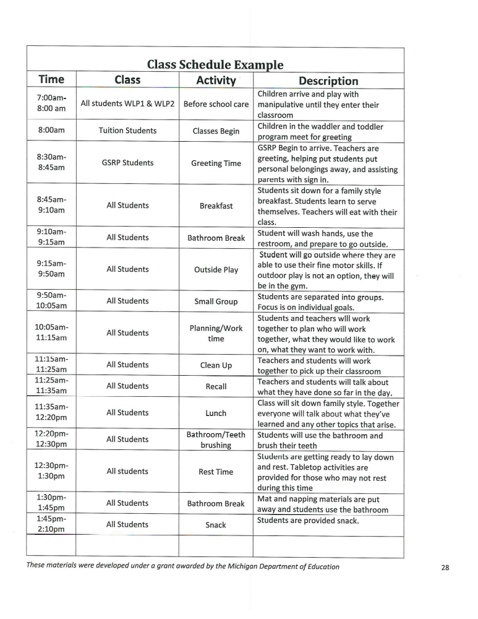
DAILY ROUTINE

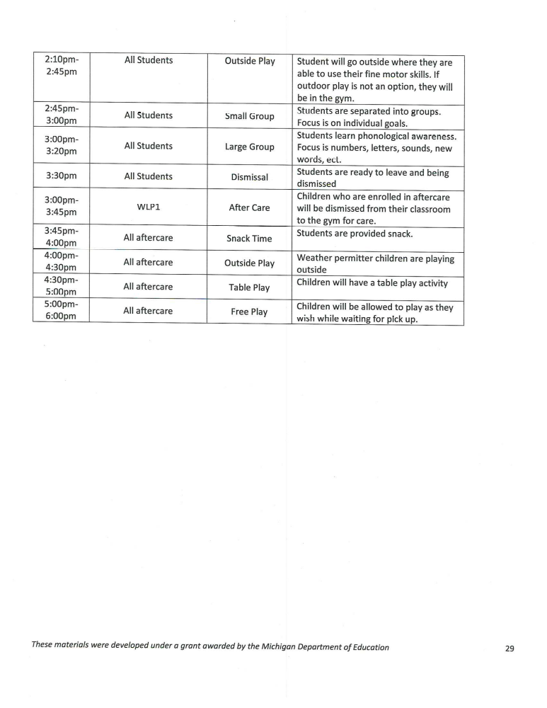


PARENT NOTICE OF PROGRAM MEASUREMENT
Woodlawn preschool is required to work with the Michigan Department of Education (MDE) to measure the effect of the state-wide Great Start Readiness Program (GSRP). Information is sometimes collected about GSRP staff, enrolled children, and their families. Program staff or a representative from MDE might:
- Ask parents questions about their child and family.
- Observe children in the classroom.
- Measure what children know about letters, words, and numbers, etc.
- Ask teachers how children are learning and growing.
Information from you and about your child will not be shared with others in any way that you or your child could be identified. It is protected by law.
Questions? Contact: mde-gsrp@michigan.gov or 517-373-8483
Or MDE, Office of Great Start, 608 W. Allegan, P.O. Box 30008, Lansing, MI 48909

GRIEVANCE POLICY
Woodlawn Preschool GSRP strives to provide a positive environment for all. However, at times, concerns may arise. Families that have grievances with some part of the GSRP should follow these steps:
- Bring concerns to the attention of lead teacher
- Follow up with the director/administrator that oversees the program. This person is Jeanette Davis and can be reached 269-963-7334 jeanette@wlpreschool.org
- If the concern is not resolved through these channels, the next person in line to contact is the Assistant Superintendent of Early Childhood Services and can be contacted at (269) 660-1606.
If the concern relates to a licensing regulation, reports may be made to the Department of Human Services, Office of Children and Adult Licensing, at (866) 685-0006 or www.michigan.gov/michildcare

VOLUNTEER POLICY
Woodlawn Preschool welcomes volunteers as an important part of our program. Volunteers may include parents/guardians, family members, community members, college students, and other approved individuals. Volunteers provide valuable support to staff and children while helping to enrich the learning environment.
Supervision of Volunteers
To ensure the safety and well-being of all children:
- All volunteers will be supervised by a Woodlawn Preschool employee at all times while they are interacting with children.
- Volunteers, including parents or guardians volunteering in the classroom or during program activities, will not be left alone with children and will not have unsupervised contact with any child unless they have met all state licensing requirements and have been specifically authorized by the Program Director.
- Volunteers are not counted in staff-to-child ratios and may not assume responsibility for the supervision or care of children.
- Volunteers may assist with classroom activities, reading stories, preparing materials, special events, playground activities, and field trips under the direct supervision of staff.
- Volunteers must follow all Woodlawn Preschool policies, including confidentiality, health and safety procedures, child guidance practices, and emergency procedures.
- Any volunteer who violates program policies or whose behavior is determined to be inappropriate may be asked to leave and may no longer be permitted to volunteer.
Parent Volunteers
Parents and guardians are encouraged to participate in classroom activities and special events. Parent volunteers are also required to remain under the supervision of Woodlawn Preschool staff and may not supervise or discipline children other than their own.
Child Release
Children will only be released to individuals listed on the child's Emergency Information Card or to another person with written authorization from the parent or guardian.
- If the individual picking up a child is unknown to staff, a valid government-issued photo ID will be required before the child is released.
- Staff reserve the right to refuse release of a child if proper authorization or identification cannot be verified.
- Children will never be permitted to walk home alone unless written authorization is provided by the parent/guardian and allowed by program policy and applicable licensing regulations.
Sign-In and Sign-Out
Parents, guardians, or other authorized adults are responsible for signing children in upon arrival and signing them out when leaving each day. Staff will verify that the individual picking up the child is authorized before releasing the child.

WEATHER POLICY
Weather and Emergency Closure Policy
The safety of our children, families, volunteers, and staff is our highest priority. Woodlawn Preschool closely monitors weather conditions and emergency situations to make decisions regarding outdoor play, delayed openings, early dismissals, evacuations, or program closures.
Outdoor Temperature Guidelines
Children will go outside daily whenever weather conditions are safe.
- Outdoor play will generally occur when the temperature or wind chill is 20°F or above.
- Outdoor time may be shortened during very hot or very cold weather.
- Outdoor play will be canceled when:
  - The wind chill is below 20°F.
  - The heat index reaches 90°F or higher.
  - There is lightning, heavy rain, poor air quality, or other hazardous weather conditions.
Families are encouraged to dress children appropriately for the weather, including coats, hats, gloves, boots, sunscreen, and lightweight clothing during warm weather.
Severe Weather Procedures
Tornado Warning
- Children and staff will immediately move to the designated tornado shelter area within the building.
- Attendance will be taken to ensure all children and staff are accounted for.
- Children will remain sheltered until local emergency officials declare it is safe.
Severe Thunderstorms or Lightning
- All outdoor activities will stop immediately.
- Children and staff will remain indoors until at least 30 minutes after the last clap of thunder or lightning strike.
Winter Weather
The Preschool Director will monitor weather forecasts and road conditions. Delays or closures may occur due to:
- Heavy snowfall
- Ice-covered roads
- Dangerous wind chills
- Other hazardous travel conditions
School Closings or Delays
If Woodlawn Preschool must delay opening or close due to severe weather or another emergency, families will be notified as early as possible through:
- ClassDojo
- Text message
- Phone call (if necessary)
- Woodlawn Preschool Facebook page
- Email (when appropriate)
Families should ensure the preschool always has current phone numbers and emergency contact information.
Emergency Evacuation
If the preschool must evacuate because of fire, gas leak, power outage, flooding, or another emergency:
- Children will be safely relocated to our designated emergency evacuation site.
- Families will be notified immediately by phone, text message, and/or ClassDojo with instructions on where and when to pick up their child.
- Children will only be released to individuals authorized on the child's emergency contact form and who present valid photo identification if requested.
Emergency Program Closure
If the preschool cannot safely remain open due to an emergency, families will be notified immediately with information regarding:
- The reason for the closure
- Child pick-up procedures
- When available, information about reopening
Woodlawn Preschool is committed to making timely decisions that protect the health and safety of every child while keeping families informed throughout any emergency situation.

EMERGENCY POLICY
Woodlawn Preschool is committed to providing a safe and secure environment for all children, staff, and families. Written emergency procedures for fire, tornado/severe weather, lockdown, shelter-in-place, and evacuation are posted in every classroom and throughout the building.
In the event of an emergency, families will be notified as soon as it is safe to do so through ClassDojo, text message, phone call, email, and/or the program's emergency notification system. Families will receive information regarding the nature of the emergency, the status of the program, and any instructions for reunification.
If evacuation is necessary, families will be directed to the designated reunification site. Children will only be released to individuals listed on the child's emergency contact form with valid identification.
Reasonable accommodations will be made for children with special needs. Individual emergency plans will be developed as needed to ensure each child's safety during emergencies.
Fire and tornado evacuation plans are posted in every classroom. Required emergency drills will be conducted and documented as follows:
- Fire Drills: Four (4) times each year, with at least one drill conducted during each season.
- Tornado Drills: Two (2) times each year.
A written drill log will be maintained and available for review.
Pest Management Notification Policy
Woodlawn Preschool uses Integrated Pest Management (IPM) practices to maintain a safe and healthy environment. Families will receive annual written notification of the program's pest management practices. If pesticide applications are scheduled, families will be notified in advance as required by Michigan law, unless the application is made in response to an emergency situation.

KINDERGARTEN TRANSITION PLAN
Woodlawn Preschool is committed to providing a smooth and successful transition from preschool to kindergarten. Our goal is to help children feel confident and prepared while supporting families through the transition process. We work collaboratively with families, local school districts, and community partners to ensure every child enters kindergarten ready to learn and succeed.
Guiding Principles
Woodlawn Preschool will:
- Respect and value each family's culture, experiences, and goals.
- Support children's social, emotional, physical, and academic readiness.
- Partner with families throughout the transition process.
- Communicate regularly with families about kindergarten expectations and enrollment.
- Collaborate with local elementary schools whenever possible.
Transition Plan
1. Family Information and Support
Beginning in the spring prior to kindergarten, families will receive information about:
- Kindergarten enrollment and registration deadlines.
- Required health forms, immunizations, and school documentation.
- Local school district contact information.
- Kindergarten readiness expectations.
- Tips and activities families can do at home to prepare their child.
Families will be encouraged to ask questions and share any concerns throughout the transition process.
2. Kindergarten Readiness Activities
Teachers will provide activities throughout the school year that promote kindergarten readiness, including:
- Early literacy and language development.
- Math and problem-solving skills.
- Social-emotional learning.
- Independence and self-help skills.
- Classroom routines such as following directions, taking turns, and working independently.
3. Transition Meetings
Teachers will meet with each family before the end of the school year to:
- Review the child's developmental progress.
- Discuss kindergarten readiness.
- Celebrate the child's strengths and accomplishments.
- Develop strategies to support any areas where additional practice may be beneficial.
- Answer family questions about the transition to kindergarten.
4. Child Transition Portfolio
With written parent permission, a transition portfolio may be shared with the child's receiving kindergarten teacher. The portfolio may include:
- Developmental assessment information.
- Samples of the child's work.
- Teacher observations.
- Information about the child's interests, strengths, and learning style.
- Any additional information the family chooses to share.
5. School Visits and Community Partnerships
When available, Woodlawn Preschool will encourage participation in local kindergarten orientation events, school open houses, classroom visits, or other transition activities offered by the receiving school district.
Whenever possible, local kindergarten teachers or school representatives may be invited to share information with families.
6. Preparing Children Emotionally
Teachers will help children become excited and confident about kindergarten by:
- Reading books about starting kindergarten.
- Talking positively about the transition.
- Encouraging independence and confidence.
- Providing opportunities for children to ask questions and express their feelings.
7. Family Communication
Families will continue to receive support throughout the transition process through newsletters, conferences, classroom communication, and individual conversations. Staff will work with families to ensure they know who to contact if additional assistance is needed.
Commitment
Woodlawn Preschool believes that successful transitions occur when children, families, preschool staff, and elementary schools work together. By providing information, encouragement, and individualized support, we strive to make every child's transition to kindergarten a positive and successful experience.

3. Family Engagement and Decision-Making
Woodlawn Preschool believes that families are valued partners in their child's education. Family input is encouraged throughout the school year and is used to improve our program, strengthen transitions, and support children's success.
Family Participation
Families have opportunities to provide feedback and participate in program decisions through:
- Home visits
- Parent-teacher conferences
- Family surveys
- Open House events
- Kindergarten transition meetings
- Daily communication with teachers through ClassDojo, phone calls, emails, and in-person conversations
- Informal discussions with the Program Director and teaching staff
Family feedback is reviewed and considered when planning family engagement activities, transition events, communication practices, and program improvements.
Transition Information for Families
Woodlawn Preschool provides families with information to help prepare for the transition to kindergarten, including:
- What to expect during the preschool and kindergarten transition
- A timeline of important transition activities and events
- Kindergarten readiness information
- Parent roles and rights during the transition process
- Information about how child records are shared with parental consent
- Community resources that support school readiness
Suggested Questions Families May Ask
Families are encouraged to ask questions such as:
- What does a typical kindergarten day look like?
- How will I know if my child is ready for kindergarten?
- What behaviors are common during the transition to kindergarten?
- How will my child's information be shared with the kindergarten teacher?
- What can we do at home to prepare for kindergarten?
- How will the school communicate with our family?
Family Surveys
Throughout the year, Woodlawn Preschool may ask families to complete surveys to help improve our program and transition practices. Survey topics may include:
- Satisfaction with communication
- Transition activities and events
- School readiness information
- Family engagement opportunities
- Suggestions for future improvements
- Cultural or language supports needed by families
Feedback from families is reviewed by the Program Director and staff and is used to strengthen our preschool program and better support children and families during important transitions.

4. Child Information/Data Transition
Woodlawn Preschool is committed to supporting a smooth and successful transition for every child entering kindergarten. With written parent/guardian consent, information that supports the child's learning and well-being may be shared with the receiving school.
Information That May Be Shared
With parent/guardian authorization, the following information may be securely shared with the receiving school:
- Developmental screening results (e.g., ASQ-3 and ASQ:SE-2)
- Assessment information (e.g., GOLD or other program assessments, if applicable)
- Child strengths, interests, and learning styles
- Health information, including allergies, medical needs, and emergency care plans
- Individual support plans, behavior support plans, or accommodations, when applicable
- Family's preferred methods of communication
- Home language and cultural considerations that support the child's success
- Attendance information, when appropriate
- Teacher recommendations and strategies that have been successful in supporting the child
Transition Conference
When appropriate and with family permission, preschool staff may:
- Meet with the receiving kindergarten teacher or school staff to discuss the child's strengths and support needs.
- Review successful teaching strategies and accommodations.
- Answer questions regarding the child's learning and development.
- Ensure continuity of services for children with identified needs.
Transition Summary
A Transition Summary may be prepared for each child and may include:
- Child's strengths and interests
- Social-emotional development
- Communication and language skills
- Early literacy and math skills
- Physical development
- Learning approaches and classroom participation
- Strategies that help the child be successful
- Family goals or concerns shared during conferences
Confidentiality
All child records remain confidential and are handled in accordance with applicable state and federal privacy laws. No information will be released to a receiving school without written parent/guardian consent unless otherwise required by law.
Family Participation
Families are valued partners in the transition process. Parents/guardians will:
- Review and approve information before it is shared.
- Have opportunities to ask questions and discuss transition plans.
- Receive copies of any transition summaries or reports shared with the receiving school upon request.
- Be encouraged to communicate directly with the receiving school regarding their child's needs and strengths.

Family Resource
^{Dear Parents and Guardians,}
We understand how important it is to have access to the right support when raising young children. Below is a list of helpful local resources available to families in the Battle Creek area. These services can assist with food, medical care, dental needs, mental health, and early childhood development.

^{🍼 Early Childhood Services}
^{Help Me Grow Calhoun}
- Referrals to child care, preschool, home visits, parenting groups
- Early On services for children with developmental delays (ages 0–3)
^{📞 Call or Text: 269-223-9694}
^{🌐 www.helpmegrowcalhoun.org}
^{Early On Michigan}
- Free evaluations and support for children birth to age 3 who may have developmental delays
📞 1-800-Early-On (1-800-327-5966)
^{🌐 www.1800earlyon.org}

^{🩺 Medical & Dental Care}
Family Health Center of Battle Creek
- Affordable medical, dental, vision, and behavioral health care
📍 181 W Emmett St, Battle Creek, MI
^{📞 269-965-8866}
^{🌐 www.fhcbc.org}
^{Grace Health}
- Offers pediatrics, women’s health, dental, behavioral health, and WIC
📍 181 W Emmett St, Battle Creek, MI
^{📞 269-965-8866}
^{🌐 www.gracehealthmi.org}

^{🧠 Mental Health Support}
^{Summit Pointe}
- Mental health, substance use, family therapy, youth behavioral services
📍 140 W Michigan Ave, Battle Creek, MI
📞 1-800-632-5449 (24/7 crisis line)
^{🌐 www.summitpointe.org}
^{Family & Children Services}
- Parent coaching, counseling, and in-home support for families
📍 778 W Columbia Ave, Battle Creek, MI
^{📞 269-965-3247}
^{🌐 www.fcsource.org}

^{🥕 Food Assistance}
^{South Michigan Food Bank}
- Mobile food pantries and grocery support
^{📞 269-964-3663}
^{🌐 www.smfoodbank.org}
WIC Program (Women, Infants, and Children)
- Provides healthy food, nutrition education, and breastfeeding support
📍 Grace Health – 181 W Emmett St
^{📞 269-969-6450}
^{2-1-1 Helpline}
- Call or text 2-1-1 for help finding local food pantries, hot meals, and more

If you need help connecting to any of these programs, feel free to reach out to us at Woodlawn Preschool or call Help Me Grow Calhoun. We’re here to support you and your family every step of the way.
^{Warmly,}
^{Jeanette Davis}
Dear Woodlawn Preschool Families,
At Woodlawn Preschool, we are committed to helping children grow healthy and strong! A big part of that is providing nutritious meals and snacks every day that support learning, energy, and overall well-being.
We follow the USDA Child and Adult Care Food Program (CACFP) guidelines to make sure every child receives healthy, balanced meals. Our meals include:
- Fruits and Vegetables: Fresh, canned (in juice), or frozen options served daily
- Whole Grains: Items like whole wheat bread, brown rice, oatmeal, and whole grain pasta
- Protein: Options such as turkey, chicken, cheese, beans, or eggs
- Dairy: Milk is served with every meal, and yogurt or cheese is offered as snacks
- Limited Sugar and Salt: We avoid sugary drinks, candy, and salty packaged snacks
Water is always available throughout the day, and juice is limited to special occasions only. We do not serve soda, candy, or chips.
🔴 Please note: For the safety of all children, outside food is not allowed. This helps us prevent allergic reactions and follow food safety guidelines. If your child has special dietary needs, please let us know so we can make the necessary accommodations.
Thank you for partnering with us in helping your child build healthy eating habits that last a lifetime!
If you have any questions or would like to see a sample menu, feel free to contact us.
Sincerely,
Jeanette Davis

Woodlawn Preschool Board of Directors
Susan Taylor- 269-425-5640, Autumn Hawkins 269-275-5252, Tonette Fountaine, and Jessica Main
Email for board Adnin@Wlprescvhool.org

Woodlawn Preschool is led by
Jeanette Davis
Masters Early Childhood Education

Thank you for choosing Woodlawn Preschool.

I have read and understand the policy as written in this Family Handbook

Parent notification of the Licensing Notebook:
I am aware there is a Parent Licensing Notebook in the office for my review during business hours.

*I understand that if a peanut allergy is identified, no peanut products will be allowed.

I verify that I have read and understand all of the above information:

Signature: ________________________________________

Date: ______________________

Print: _________________

