


Windlesham Village Fete
Classic Cars & Motorbikes
At 1pm on Saturday June 20th 2026
Windlesham Field of Remembrance, Kennel Ln, Windlesham GU20 6AA
Owners Name _____________________________

Car/Motor bike Make _______________________

Model _____________________________

Contact Phone number_______________________

Email Address____________________________
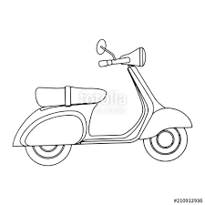


Please fill in the form and email to Kevin at either address below. Please include a phone number and email address, if possible, in case of any changes or cancellation due to wet conditions. Please arrive before 12.30pm the fete starts promptly at 1.00pm Bring a copy of this form so the people on the gate know where to direct you.


Contact details: Kevin Lloyd-Bisley 07785 282858
kevin@lloyd-bisley.com Kevinbisley@gmail.com
WWW.WindleshamFete.com


