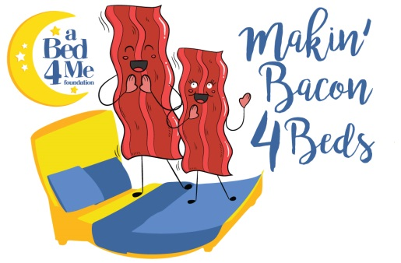
Makin’ Bacon 4 Beds Sponsor Opportunities

King sponsor (contest sponsor) -$1,000 – 1 Available SOLD
- Sponsor exclusive for the game – to include booth with game and sponsor material
- Sponsor name and logo on all social media posts
- Sponsor name mentioned when qualifying participants
- Sponsor name included in all event signage (if committed when printed)
- Sponsor name, logo and link included on B4Me website
- 4 VIP tent tickets

Queen Sponsor (t shirt sponsor) - $500 – 1 Available SOLD
- Exclusive sponsor logo on event t-shirts, in addition to charity and location sponsor logo
- Sponsor name and logo on all social media posts
- Sponsor name, logo and link included on B4Me website
- 2 VIP tickets

Headboard Sponsor - $300 – 5 available SOLD OUT
- Sponsor name and logo displayed on signage with one custom painted headboard
- Sponsor name on all social media posts
- Sponsor name and link included on B4Me website

Pillow Toss Sponsor - $200
- Sponsor name listed on signage at pillow toss at event
- Sponsor name and link included on B4Me website
Twin Sponsor - $100
- Sponsor name listed on signage at bed display at event
- Sponsor name and link included on B4Me website

Sleep Tight Sponsor - $20
- Sponsor name listed on pillow display at event

To become a sponsor, or for more info on how you can support kids in our community, please contact Diane Freeman at (850)240-0778 or diane@abed4me.org

