Makin’ Bacon 4 Beds
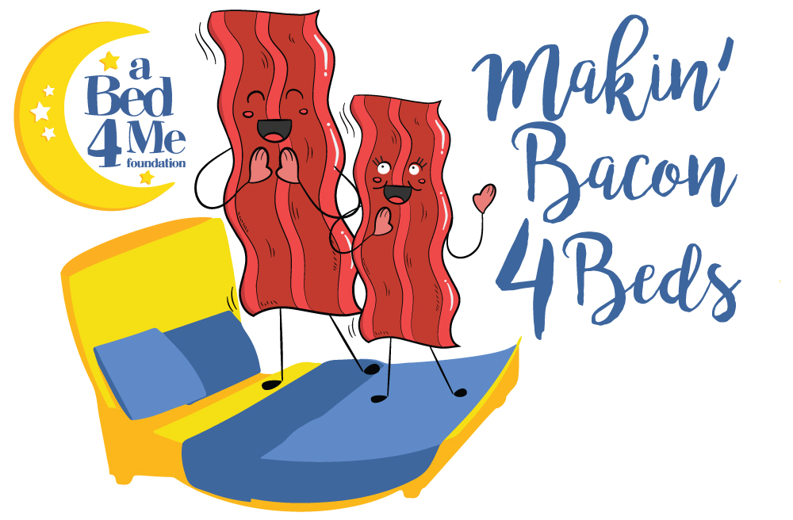
Vendor Application
Saturday September 7, 2019, noon – 4:00 p.m.
Destin Commons
4100 Legendary Drive
Destin, Florida 32541

APPLICATIONS ARE ACCEPTED ON A FIRST-COME, FIRST-SERVED BASIS
NO APPLICATIONS WILL BE ACCEPTED AFTER August 1, 2019

Name of Business: _____________________________________Contact Name: ____________________________
Address: ________________________________________________City: _________________ Postal: _____________
Phone Number: ______________________ Email Address: _____________________________________________
Date of Birth: ______/________/_________ (DD/MM/YYYY)
“Makin’ Bacon 4 Beds” Vendors are to apply directly at everythingscandydesign@gmail.com
Describe Merchandise or Food: ____________________________________________________________________
Makin’ Bacon 4 Beds Logo Use: YES NO If yes, please describe how it will be used:
___________________________________________________________________________________________________
Please describle in detail your display/set up. Include photos if avaialable.
___________________________________________________________________________________________________

Type of Space Requested: | REGULAR FEE: | Space (s) Requested:
Merchandise Vendor (Per location) (10 by 20 ft space, 2 tables, 2 chairs) vendors must provide tablecloths and displays | $100.00
Mobile Food Premise – Food Vendor (Health Inspection Required) (Insurance Required)(10 by 20 ft space) * Must complete MLHU Form with application. Vendors must provide 1000 1-3 ounce samples* | waived | 1
Beverage vendors * must provide 1000 1-3 ounce samples*  (Health Inspection Required) (10 by 10 ft space) * Must complete MLHU Form with application | waived | 1

IMPORTANT INFORMATON:
PAYMENT: send checks to A Bed 4 Me Foundation, Makin’ Bacon 4 Beds, 1221 N Bayshore Dr, Valparaiso, FL 32580
FOOD & BEVERAGE VENDORS: You must provide detail of the product or service that you will be serving. Vendors are not permitted to sell food at Makin’ Bacon 4 Beds unless approved by the committee. All Hazardous Food Vendors must provide proof of $1 million in liability insurance.
ALL FOOD & BEVERAGE VENDORS MUST PROVIDE A BACON DISH FOR TASTING.
TRADEMARKS: The Makin’ Bacon 4 Beds logo is not to be used without the express permission of the Makin’ Bacon 4 Beds Festival. Please indicate on the line above if you wish to use the name or logo, how it will be used, and how many items are being created. You will be contacted if the logo use is approved.
PARKING: Parking for all vendors is free of charge; however you will be asked to park off-site. Please be prepared to unload your vehicle and move it off site.
SET-UP: You will be assigned a setup time based on your location. Setup begins at 9a.m. on Saturday September 7, 2019. We will allot space as applications are received.
HYDRO/WATER: Are not supplied, you must bring your own. Gas generators may be used, but must be quiet (Honda Style) and have enough amperage to service your booth.
THIS EVENT IS RAIN OR SHINE – NO REFUNDS.

QUESTIONS? Please contact either of the following.
Angela Arnett, Vendor Chair
(850) 259-1669 or everythingscandydesign@gmail.com

Diane Freeman, A Bed 4 Me Foundation
(850) 240-0778 or diane@abed4me.org

Thank you for helping support kids in our local community!
Sleep Tight, Dream Bright
Vendor Agreement 2019:
The undersigned parties: the concession operator, hereinafter referred to as the VENDOR, and the ‘Makin’ Bacon 4 Beds Festival”, hereinafter referred to as the BACONFEST, do agree as follows:
1. That the BACONFEST is in charge of the site and the festivities within.
2. All electrical requirements must be provided by the VENDOR. Gas generators must be quiet (Honda Style) and have enough amperage for service for your booth. VENDORS with food trucks must have the trucks CSA certified and have a valid inspection report.
3. The VENDOR shall procure and provide at his own expense, the necessary insurance, and all other licenses for the purposes of carrying out the provisions of this contract.
4. Vendors minimum hours of operation are 12:00pm-4:00 pm on Saturday September 7, 2019 and agree to stay for the full time of the show. Vendors are required to begin setting up at 9:00am on this date. You will receive a form with setup, parking and location information once your application is received and approved. All vehicles and trailers must be unloaded and cleared from the area and all roads must be clear no later than 10:00am.
5. The VENDOR releases the AB4M of all liability of any and all bodily injury which may be sustained by the VENDOR or any of its workers. All HAZARDOUS FOOD VENDORS must provide to the BACONFEST a certificate of insurance.
6. POWER AND WATER ARE LIMITED ON SITE. QUIET GAS GENERATORS ARE ALLOWED.
7. Vendors can begin breakdown at 4:30pm. No vehicles can be on the roads before then.
8. FOOD & BEVERAGE VENDORS are required to remove all debris at the end of the day. All restaurants must provide a solid, non-slip liner mat in their space – no aerated mats, as grease and other materials can seep through to the ground.
9. Compliance with both Provincial and Federal Sales Tax Regulations is the responsibility of the individual VENDOR.
10. FOOD VENDORS: At least one person on site must have completed and hold a valid ‘Safe Food Handlers Course’
11. All vendors are required to provide one 5 lb fire extinguisher for their booth, and are responsible for complying with local building, fire, health codes, regulations and licensing. Food truck vendors must have had their fire equipment inspected within the last 12 months and must have a proper fire suppression system if needed and proper K class extinguisher.
12. The VENDOR will obtain prior approval from the BACONFEST for all items that they intend to sell. Any permits relating to the item you are selling are the responsibility of the VENDOR. The BACONFEST reserves the right to fix the location from which the VENDOR shall operate.
13. The FOOD VENDORS shall complete a ‘Special Events Food Vendor Form’ from the MLHU and submit it with this agreement.
14. The deadline for this form is AUGUST 1, 2019. Spaces are reserved on a first-come, first-served basis.
15. VENDOR will provide:
  - 1000 1-3 ounce samples
  - All products needed for the tasting
  - Required sources of heating and cooking
  - Sterno chafing dishes for warming
  - Propane for frying, grilling, sautéing, etc.
  - Sample utensils, if needed, for dish
  - Destin Commons will provide power to the light pole outlets and will provide a dual headed plug to the ground. It is the vendor’s responsibility to supply their own extension cord for their individualized power needs. All Destin Commons power sources are 20 amp circuits. Vendors are required to use only electrical items that can utilize less than 15 amps.
  - Electrical outlets at Destin Commons are designed for small scale, complimentary lighting and aesthetics. They are not adequate for cooking or heating purposes.

I have read the rules and responsibilities and I agree to comply with same.

_____________________________________ __________________
VENDOR SIGNATURE: DATE:

