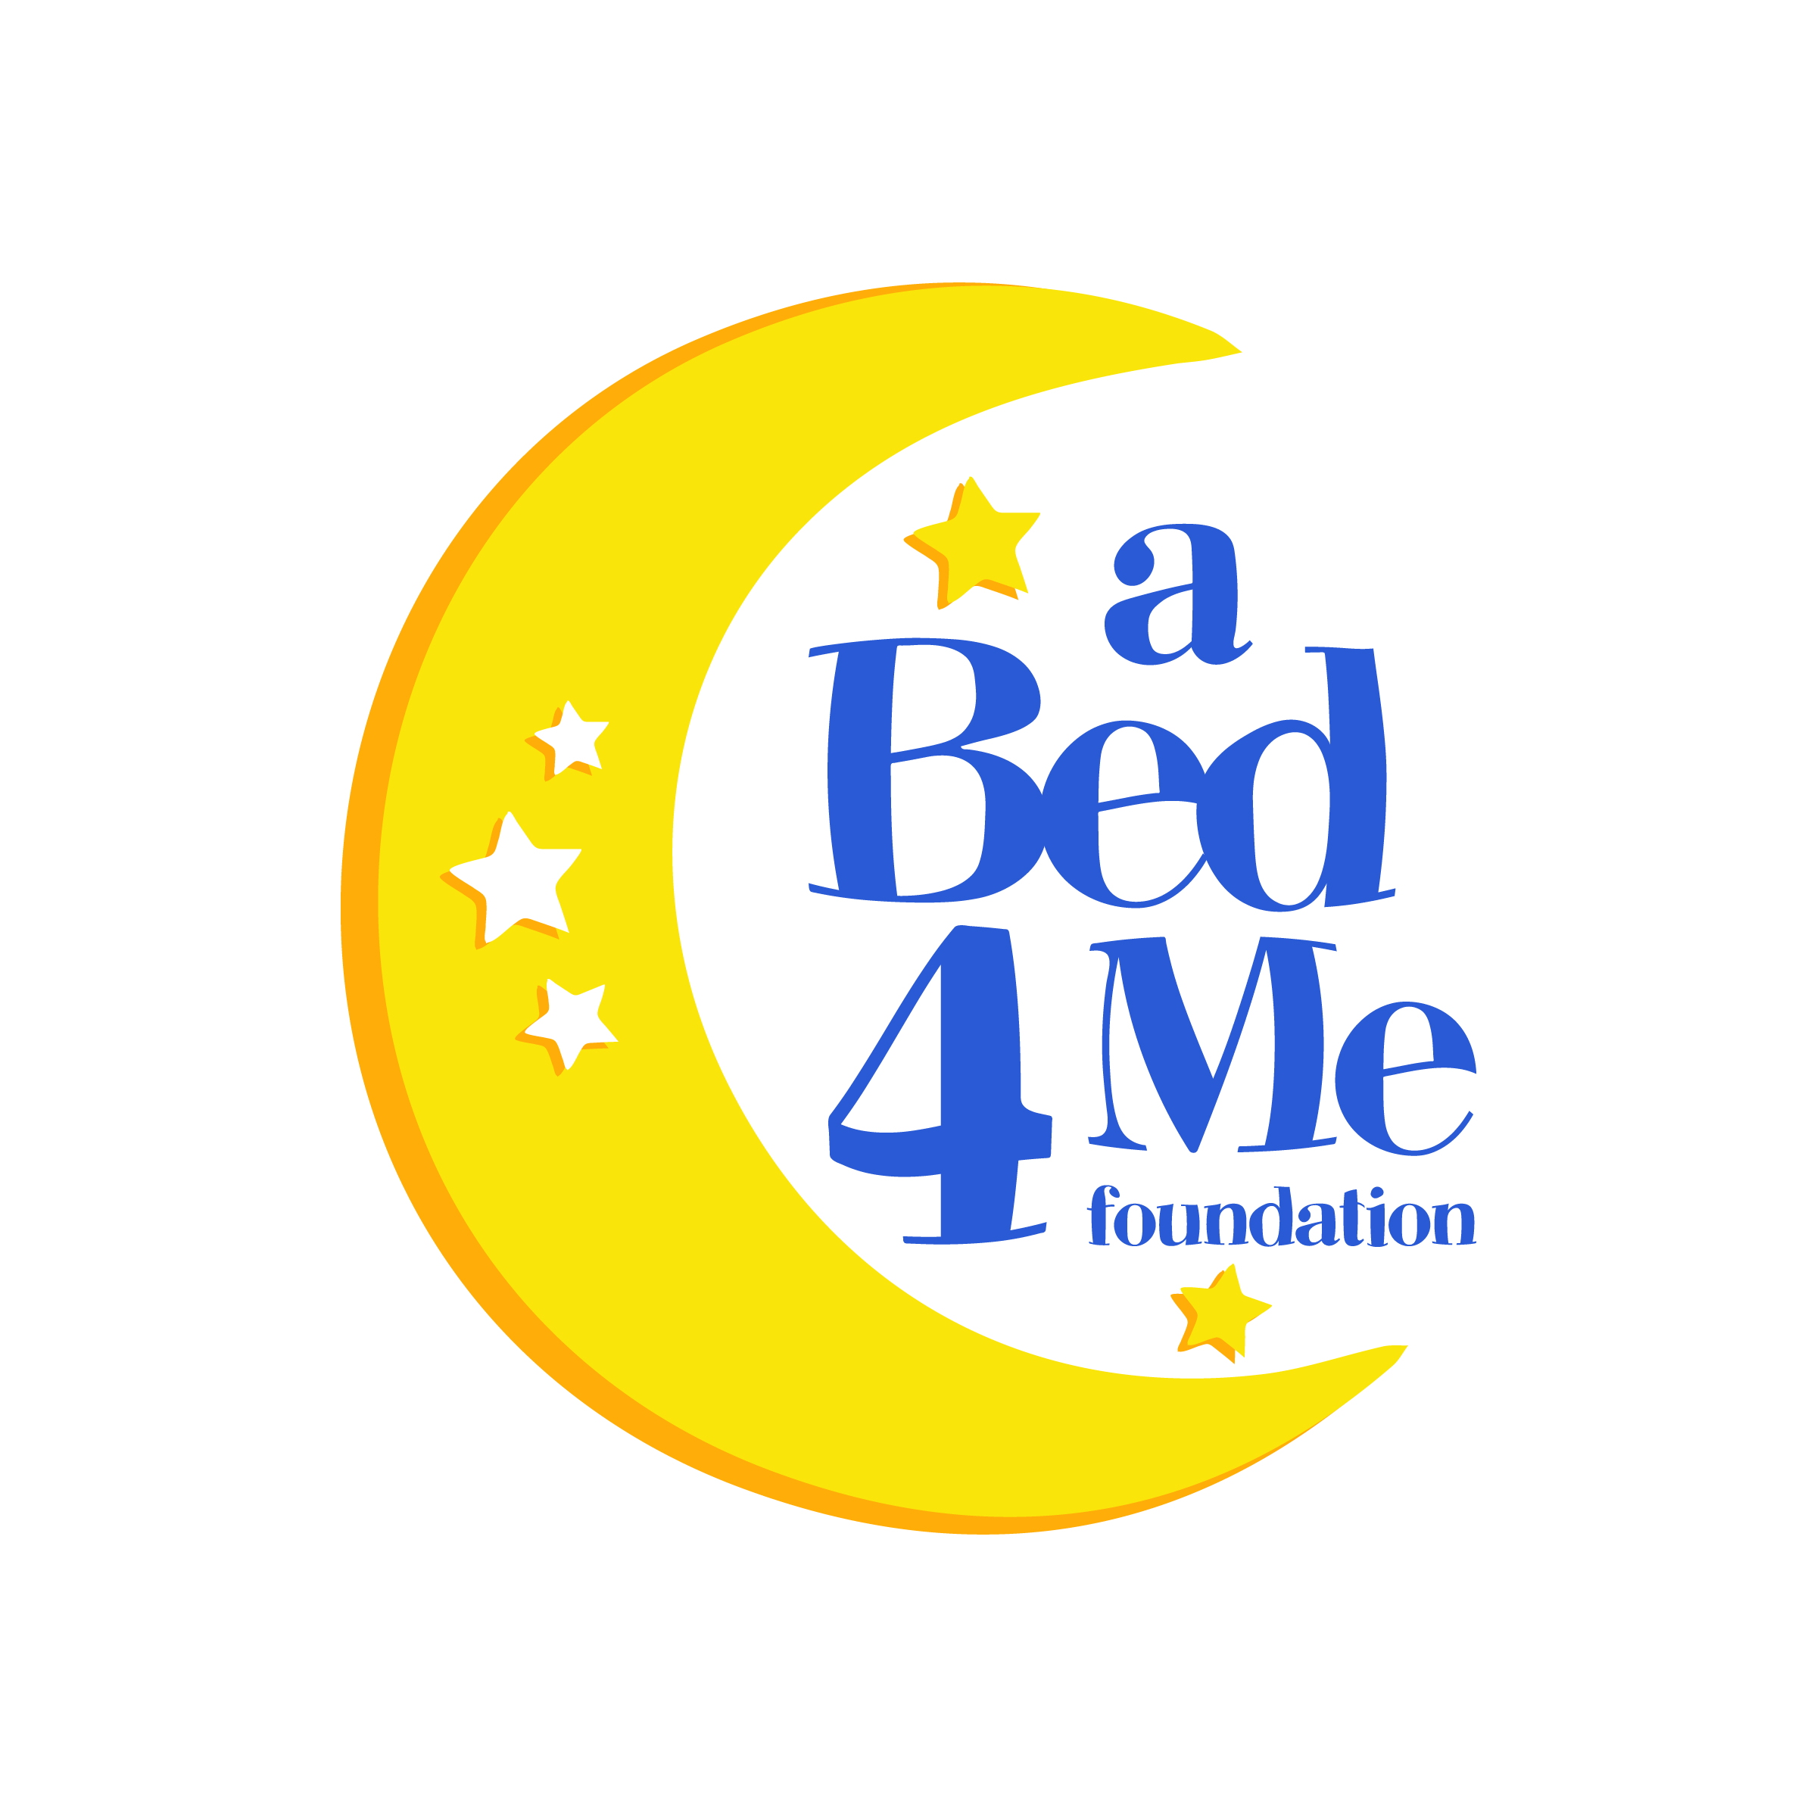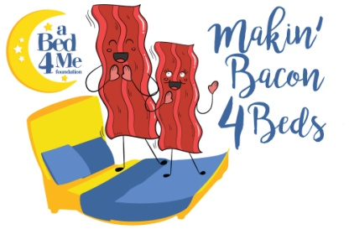
Greetings!
A Bed 4 Me Foundation is a nonprofit organization providing beds to children and teens that would otherwise be sleeping on the floor or other inadequate bedding. A Bed 4 Me qualifies this need and provides a new bed to children ages two to 18 from low to middle income families within Okaloosa County. We have found children sleeping on sofas, recliners, floor pallets or crammed into beds with siblings or parents. We know sleep is a crucial part of a child’s life. Lack of sleep affects academic performance, physical health and overall emotional state of all children. Can you imagine bed time without a bed? Something as simple as a bed can be the one small thing that gives a child hope, a space to call their own and the platform to dream.
To support the continuing efforts to place the many children on our waiting list into a bed of their own, the first ever Makin’ Bacon 4 Beds Festival will be held at Destin Commons on Saturday September 7, 2019. This event will include food and beverage vendors showcasing a bacon themed item for patrons to sample and local entertainment will perform throughout the entire event. There will also be craft vendors, a pillow toss contest and a chance competition with the opportunity to win $10,000.00. We are also hosting an auction of different size headboards that have been re-purposed and fashioned by local artists. All to raise funds to provide beds to children in Okaloosa County that are without one of their own. Our hope is to make this an annual event and give local businesses and groups not only advertisement, but to also let the community know that all involved care about children in our area.
Attached are sponsorship opportunities for businesses, organizations or individuals. Please consider contributing even a small amount to support not only the debut of this very unique event to our area but to also help put another child in a bed of their own. Dream with us!
Let us know if you have any questions. Thank you!

Diane Freeman
A Bed 4 Me Foundation
Executive Director
850.240.0778

abed4me.org @abed4mefoundation @abed4me @abed4me

