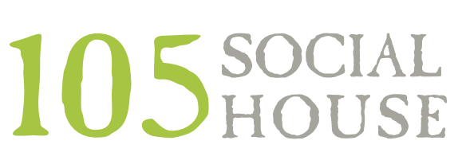
Wine
RED
Cabernet 8/30
Merlot 8/30
Malbec 8/30
Red Blend 8/30
Pinot Noir 8/30
White
Pinot Grigio 8/30
Chardonnay 8/30
Sauvignon Blanc 8/30
Rose’ 8/30
Prosecco 8/3
Mimosas
Traditional Mimosa OJ 7
Fruit Mimosa Strawberry, Mango, Cranberry or Pineapple 8

Beer/Seltzer
Draft
Jaks Brown Ale 6
West Bound & Down IPA 7
Jaks Pilsner 6
Jaks Irish Red 6
Ace Mango Cider 6
Elevation Horchata Porter 6
Boxing Brother Earl Grey Cider 6
Can/Bottle
Bud 4
Bud Light 4
Bud Light Black Cherry Seltzer 5
Call to Arms Lager 5
Ranch Water Seltzer spicy 5

Starters & Small Plates
Bang Bang Shrimp tempura fried shrimp with bang bang sauce 11
Bacon Wrapped Dates blue cheese, almond, maple balsalmic drizzle 12
Mushroom Fries with ranch 9
Wings bbq, buffalo, teriyaki, mango habanero 12
Brisket Queso brisket, pico, beer cheese sauce and grilled naan 12.00
Salads/Soup
Spinach Salad mixed berries, walnuts, onion, goat cheese, white balsamic 7/10
House Salad cucumber, tomatoes, carrots 6/9
Soup Du Jour 6
add chicken 5, shrimp 7, salmon 14
Sandwiches/Tacos
Grilled Chicken BLT grilled chicken, tomato, bacon, lettuce, garlic aioli, wheat bread 15*
Brisket French Dip roasted onions, cheese, hoagie roll, au jus 15*
Cheeseburger ½ pound burger,cheese, lettuce, tomato, onion, brioche bun 16*
Add Honey Cured Bacon 2
Prime Rib Cheesesteak sliced prime rib, cheese, peppers, onions, mushrooms, hoagie roll 15
Mahi Tacos pico, cabbage lime slaw, mango habanero aioli 15

Entrees
Asparagus & Artichoke Ravioli sun dried tomatoes, goat cheese, parmesan, lemon zest 18
Gnocchi carrots, caramelized onion, mushrooms, brie cream , basil pesto topper18
Salmon sauteed green beans, crispy sushi rice, miso glaze 26
add chicken 5, shrimp 7, salmon 14

***DRINKS FOR THE KITCHEN STAFF $6***
(IF YOU ENJOYED YOUR FOOD THEN PLEASE SHOW YOUR APPRECIATION BY BUYING THEM A ROUND OF BEERS….THEY WILL LOVE YOU FOREVER)
* A 20% gratuity may be added to parties of six or more
*Consuming raw or undercooked meats, poultry, seafood, shellfish, or eggs
may increase your risk of food borne illness

