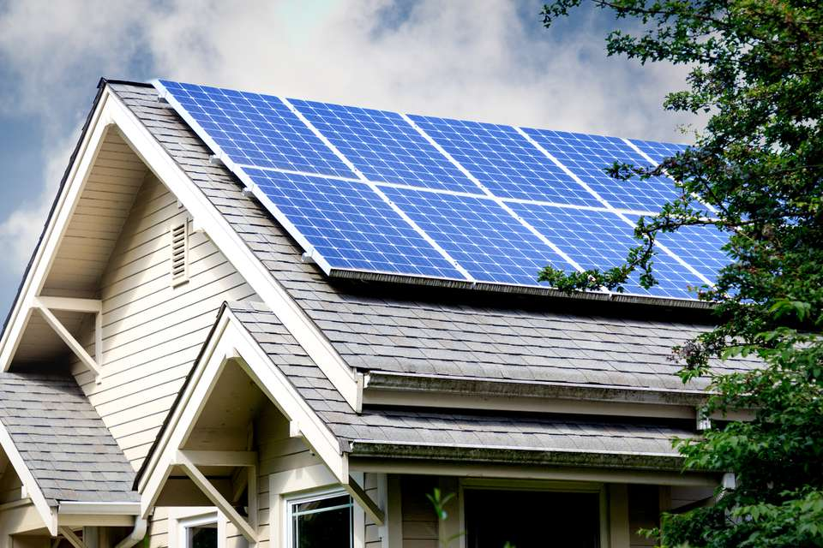

Installing Solar in 2021

2018

Richard Barbella
P: 386.965.6429
sales@sailfishsolar.com

Guide to installing residential solar systems in South Florida.
February 8, 2021

Sailfish Solar is affiliated with certified solar contractors throughout Florida.

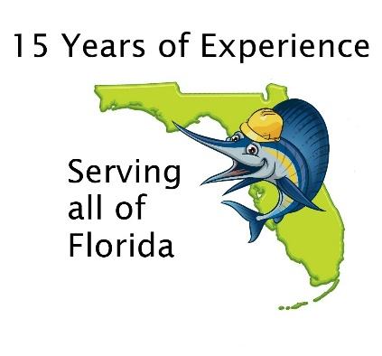

Why Solar Today?

An investment worth making soon.
- In Florida, an average 10kW solar electric system will generate about $200 per month in savings.
- Each solar system has several unique variables affecting average system returns, which can range from between a 7 and 9 year return on investment and an average annual rate of return between 9% and 11%.
- The federal government offers a 26% investment tax credit which is eligible through the end of 2022. It is important to note that this is a tax credit, not a tax deduction. A tax credit comes directly off of your total taxes owed, while a tax deduction only reduces your taxable income. Ask your tax advisor how this affects you.
- The levelized cost electricity that results in a predictable solar system can serve as an effective hedge against rising energy cost.
- Solar systems have proven to have a significant impact on the resale value of a home. Average solar systems add a minimum of $15,000 to $18,000 to a home’s resale value, with larger systems and battery systems adding much more to the resale value.

The bottom line is that you are paying for electricity either way – you might as well invest in stable return and a short ROI/long warranty at the same time.
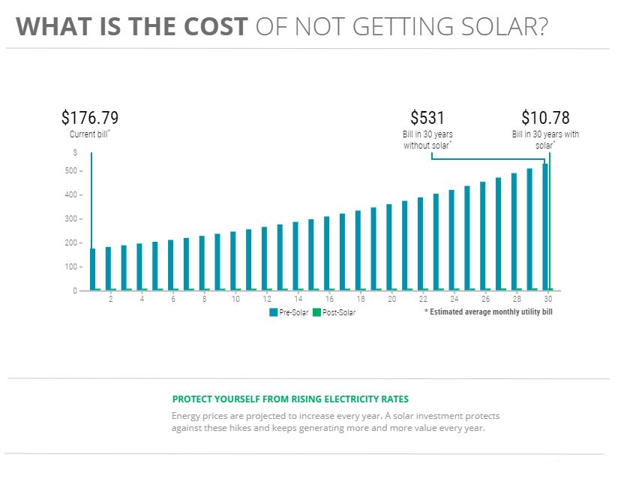

What is installed?
Only the highest-possible quality products.

. PV Panels:

- We use only Tier 1 solar panels. Our general philosophy is to use panels that have only the strongest warranties. Our primary recommendation are QCells panels, which have excellent energy density and are backed by massive international company, Hanwha (50B revenues, 145B assets) so the 25-year power output warranty and 12-year full warranty should be able to be serviced for the life of the warranty. Our secondary panel options are manufactured by Mission Solar and our premium line is manufactured by LG. We recommend using panels that are backed by corporations with multiple top of class manufacturing lines, giving added stability to manufacturers warranties.
- All designs are to local codes and using installation crews with vast experience in the 180MPH HVHZ area (High velocity hurricane zone).
- Designs can be installed over standing seam, tile, flat and shingle roofs.

Invertors:

- For micro-invertors, we typically recommend using the Enphase IQ7 product line.
- Using this technology, each individual panel has it’s own micro-inverter, assuring that if one panel has an issue, it won’t affect the entire system.
- Using the Enlighten monitoring service, system owners can easily monitor data on each individual panel as well as the overall system from their smartphone or computer.

- When using string invertors, we recommend the industry’s leading Secure Power Supply, which allows you to plug directly in to the solar system in the event of a grid outage, providing up to 2000 watts and 12 amps of power.
- We are currently recommending SMA inverters with 2-3 MPPTs (Tracking points) each for maximum power production, others available as needed.
- Through the Sunny Portal and using your internet connection, a solar homeowner can monitor their solar energy production and health of their system using the included software.
- High performance, flexible design and an innovative feature set make the Sunny Boy TL-US series the first choice among professionals.

Batteries:
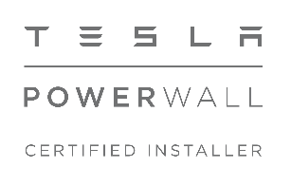
- Using two or more Tesla Powerwalls or Enphase Encharge batteries, a self-powered home combines solar energy and batteries to independently power your home day and night. During the day, solar panels may produce more energy than your home uses. Batteries stores that excess solar energy and makes it available on demand, even after the sun has set.
- Batteries can detect an outage, disconnect from the grid, and automatically restore power to your home in a fraction of a second. You will not even notice that the power went out. Your lights and appliances will continue to run without interruption.
- If you have solar and batteries, then solar energy will continue to power your home and recharge batteries. It is important to note that without batteries or an SPV invertors, solar will shut down during an outage.
- We also offer standard battery backup installation using deep cycle batteries.

Roof Installations:

Existing Tile Roofs - we use the top roofers in our area to remove the tile in the area of the solar, we then install the supports then the roofer returns and flashes around each support with commercial roofing material and replaces the tile using the preferred foam down method to assure a long roof life. (Compare this to breaking a small hole in the roof and using some roofing tar to seal the roof. This method will leak in a couple years, our method is good for the life of the roof.)

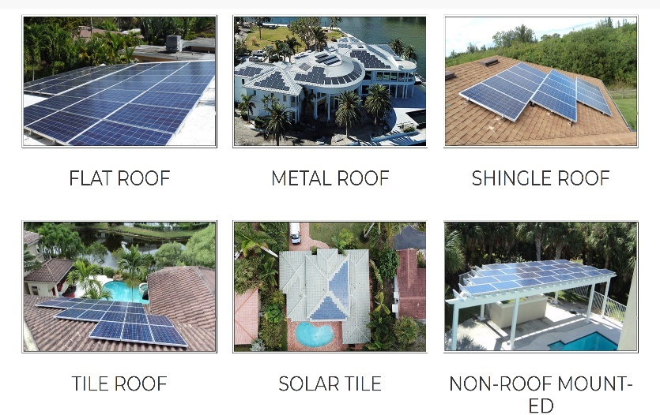
Flat Roofs - we use one CHEMCURBS (2-part sealer with rubber curbs) to seal all roof penetrations vs pitch pans. Pitch pans require maintenance every few years but chem curbs give a seal that will outlast most roofs.

Metal Standing Seam Roofs - we use the S-5 system reengineered for the hurricane winds where in most cases, the system can be secured without any penetrations in the roof.

Shingle Roofs - we use a customized self-flashing support engineered to outlast the roof system.

New Tile Roofs - we can either work with your roofer to install integrated solar tiles or put down traditional supports during the roofing process.

3 steps to solar
1st step: Create your system profile and calculate your power consumption.
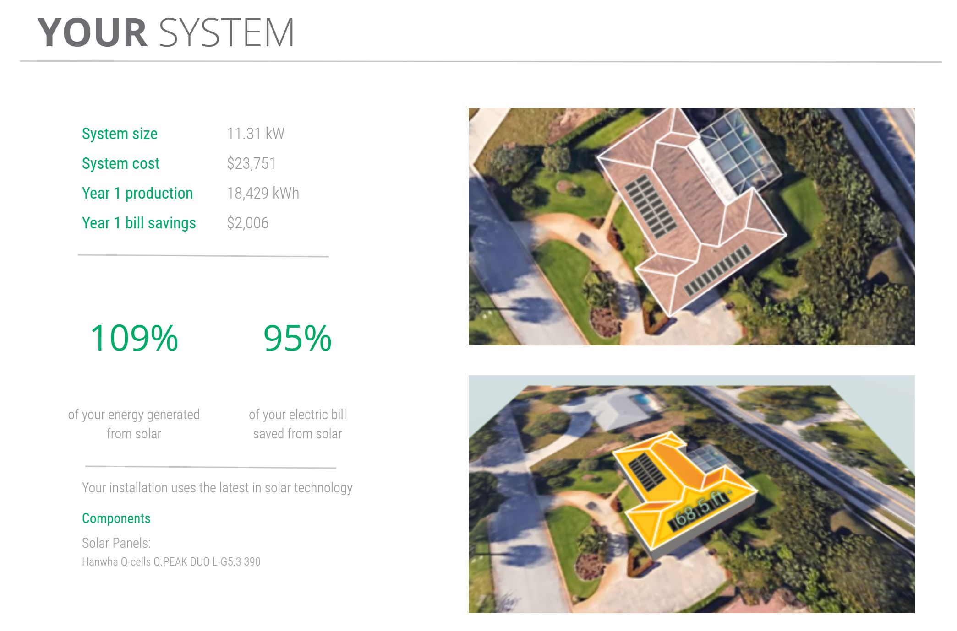

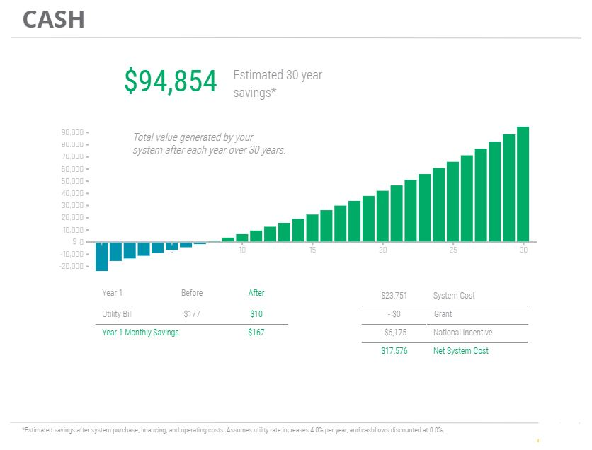
2nd Step: Calculate savings, return on investment and cashflow projections.
3: Installation process

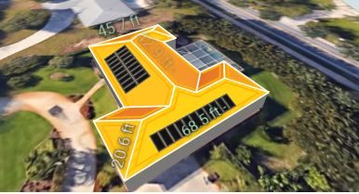
Assessment Phase – 2 days to 10 days
- Generate solar feasibility study
- Create system design layout
- Arrange necessary financing
- Contract agreement
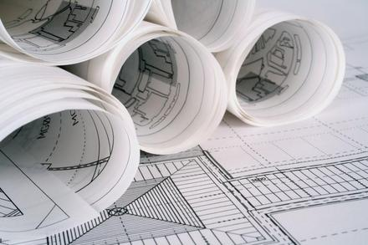
This Photo by Unknown Author is licensed under CC BY-NC-ND
Engineering and Design Phase – 1 to 2 weeks
- Finalize project design
- Project engineering
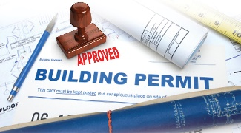
- Permit Application

Permitting and Procurement Phase – 2 to 5 weeks
- Obtain all necessary permits
- Procure equipment and components
- Timeline can very per city
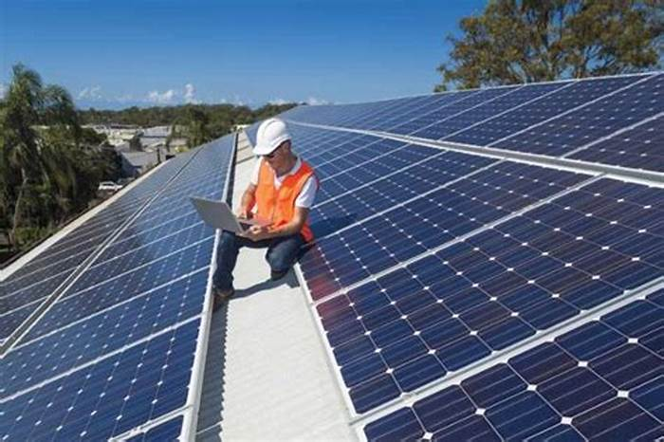
Construction Phase – 1 to 3 weeks
- Variables include roof type, location of electric panels, number of stories and accessibility.

Completion Phase – 1 to 3 weeks
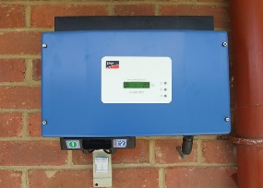
- Interconnection
This Photo by Unknown Author is licensed under CC BY-ND
- Project completion
- Warranty issuance
- Utility paperwork and net metering application
- Turn on system

Frequently Asked Questions

Q: What is the average payback for a solar installation?
A: An average payback for residential PV systems in Florida is 7 to 9 years, depending on your roof type and utility company.

Q: What is net-metering?
A: Net-metering is program through which solar systems that produce excess electricity can receive a retail credit on their power bill for the amount of excess electricity they produce and send to the power grid.

Q: Will my HOA allow solar?
A: Yes. Florida state laws mandate that HOAs are required to allow solar systems.

Q: Can I go “off-grid”?
A: Technically, no. Although a solar system can offset virtually all of your electric bill, you are still required to have a utility connection in Florida. A grid-connected system that is net-zero is actually “greener” than going off-grid. (Ask us how!)

Q: What about batteries?
A: Batteries make sense in some cases, but not all. They can add a significant price increase to the cost of a solar system. Battery requirements need to be assessed on a case by case basis. Contact us for more details.

Q: Will my solar system require maintenance?
A: Solar PV is virtually maintenance free. The frequent rainfall in Florida is enough to wash the dust and small debris from solar panels.

Q: What size solar system is right for me?
A: The right size solar system will depend on your monthly electricity consumption (power bill), your available roof space, and what is affordable for you. An average residential system is between 10kW and 20kW.

Q: Will a solar system work with my existing electrical panel?
A: Almost all of our solar installs have integrated easily into home's existing electrical service.

Q: What if I need a new roof?
A: Solar panels have a power production warranty for 25 years. We prefer to install solar on roofs that have at least 15 years left in their lifetime to avoid unwanted costs in the future.

Q: Can I get financing for a solar installation?
A: Yes. We can help you arrange financing through a variety of methods, including the Solar Energy Loan Fund (SELF), PACE financing, national solar lending institutions and local banks who specialize in solar loans.
About us:

Our principal, Mike Antheil, relies on his 15 years of experience in the solar industry to expertly guide the solar design, installation and financing process from beginning to end. Mike has spent the past decade developing and financing renewable energy and energy efficiency projects all over the United States. Mike serves on several boards of Florida and US based non-profits dedicated to the responsible advancement of renewable energy in the United States and he has been a key leader in statewide initiatives to bring clean energy to scale in Florida.

Sailfish Solar is a registered trade name of Energy Finance Group, LLC, an official partner of installation contractor WindMar Group.

The WindMar Group has been pioneering solar installations since 2002, with extensive project development in the U.S. and Puerto Rico. With over 250 employees, and more than 20,000 solar installations, WindMar is a best-in-class installer providing turn-key solar energy solutions to homeowners and businesses in Florida.
There is a reason our business grows almost exclusively by word of mouth. Contact us today to learn why.

Call us: 386.965.6429
sales@sailfishsolar.com
www.SailfishSolar.com

