MEMBER SPOTLIGHT – JIM HALL

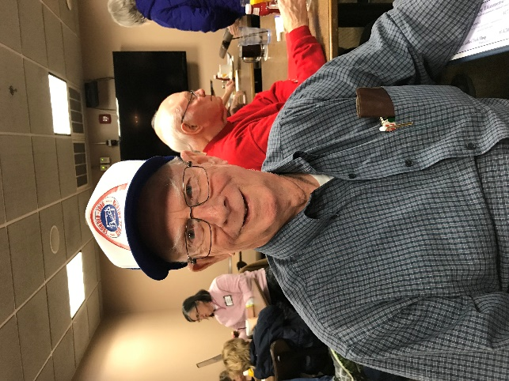

As the Gateway Chapter Buick Club nears its 40th anniversary year, together in Buick camaraderie, this month’s spotlight features Jim Hall, a founding member. Jim attended the first meeting held at Mallory Buick on Natural Bridge and Goodfellow in 1978 along with Bob Loudon, Bob Huff and Jeff Watkins.

Jim was born and raised the early part of his life in South St. Louis before his family moved north to a new home in Berkeley. He graduated from Berkeley High School and then in 1963 did a stint in the US Army stationed at Fort Carson, Colorado. After returning, Jim met his wife Doris through the gentle persuasion of a neighbor “fixing him up” with their daughter. The marriage is now nearing the 50 year mark. Doris and Jim have two daughters and two grandchildren.

Jim’s first old car was a 1929 Buick bought in 1960. Living in an apartment during its restoration, parts that Jim was working on were stored under the bed. Jim custom remade many of the wooden parts on this model such as wheel spokes and roof framing that were rotted with age.

Jim and Doris moved into a newly built house in St. Charles in 1972 with the architectural plans being drawn up by Doris’ father. There, Jim expanded his fleet of classics throughout the years to include a ‘54 Special, ’69 LeSabre (Jim’s favorite in which he replaced the transmission all by himself), ’69 Electra convertible (sadly totaled in a crash just around in the neighborhood), ’73 LeSabre and ’72 Boattail Riviera. Jim needed lots of lead additive back in the day. Paring down his collection in recent time, Jim’s daily driver today is his mother-in-law’s ’99 Century, with mileage at 109K and still a roadworthy product of GM.

Jim worked for 40 years at GM spending many years at the old St. Louis plant on Natural Bridge. He was on the Corvette, Corvair lines and was the last person to leave the factory when it shut down production and closed its doors. At that time, the plant gave Jim his personal work toolbox engraved with “Chevrolet”-- tools included as a keepsake. He treasures his bypass punch. Moving on to GM Wentzville, Jim worked in the Company Store. Here he was the supply man to see when a worker needed a specific tool such as a flashlight, hammer or forklift. Jim would then keep inventory and log the cost of the tool similar to a cashier. He remembers one request for a robotic welder, and when he looked the price up, it was one million dollars!

Jim’s hobbies include model car collecting from every decade up in to the 50’s. He once caused a commotion at one of our club meetings by bringing in his Tucker models to show. Jim never held any offices in our club, just enjoyed the company of fellow Buick nuts and their restoration adventures. Jim is an original, like the BCA logo on his hat he is never without. The Gateway Chapter tips its hat to him.