**MEMBER SPOTLIGHT – PAT PINKSTON**

New member, Pat Pinkston, introduced himself and his stellar 1957 Super 56R to the club at this spring’s Oil Spill at Pur Performance. Club members were in awe as he rolled the car up to the shop’s lift.

The son of a military man, Pat moved often to various cities across the country

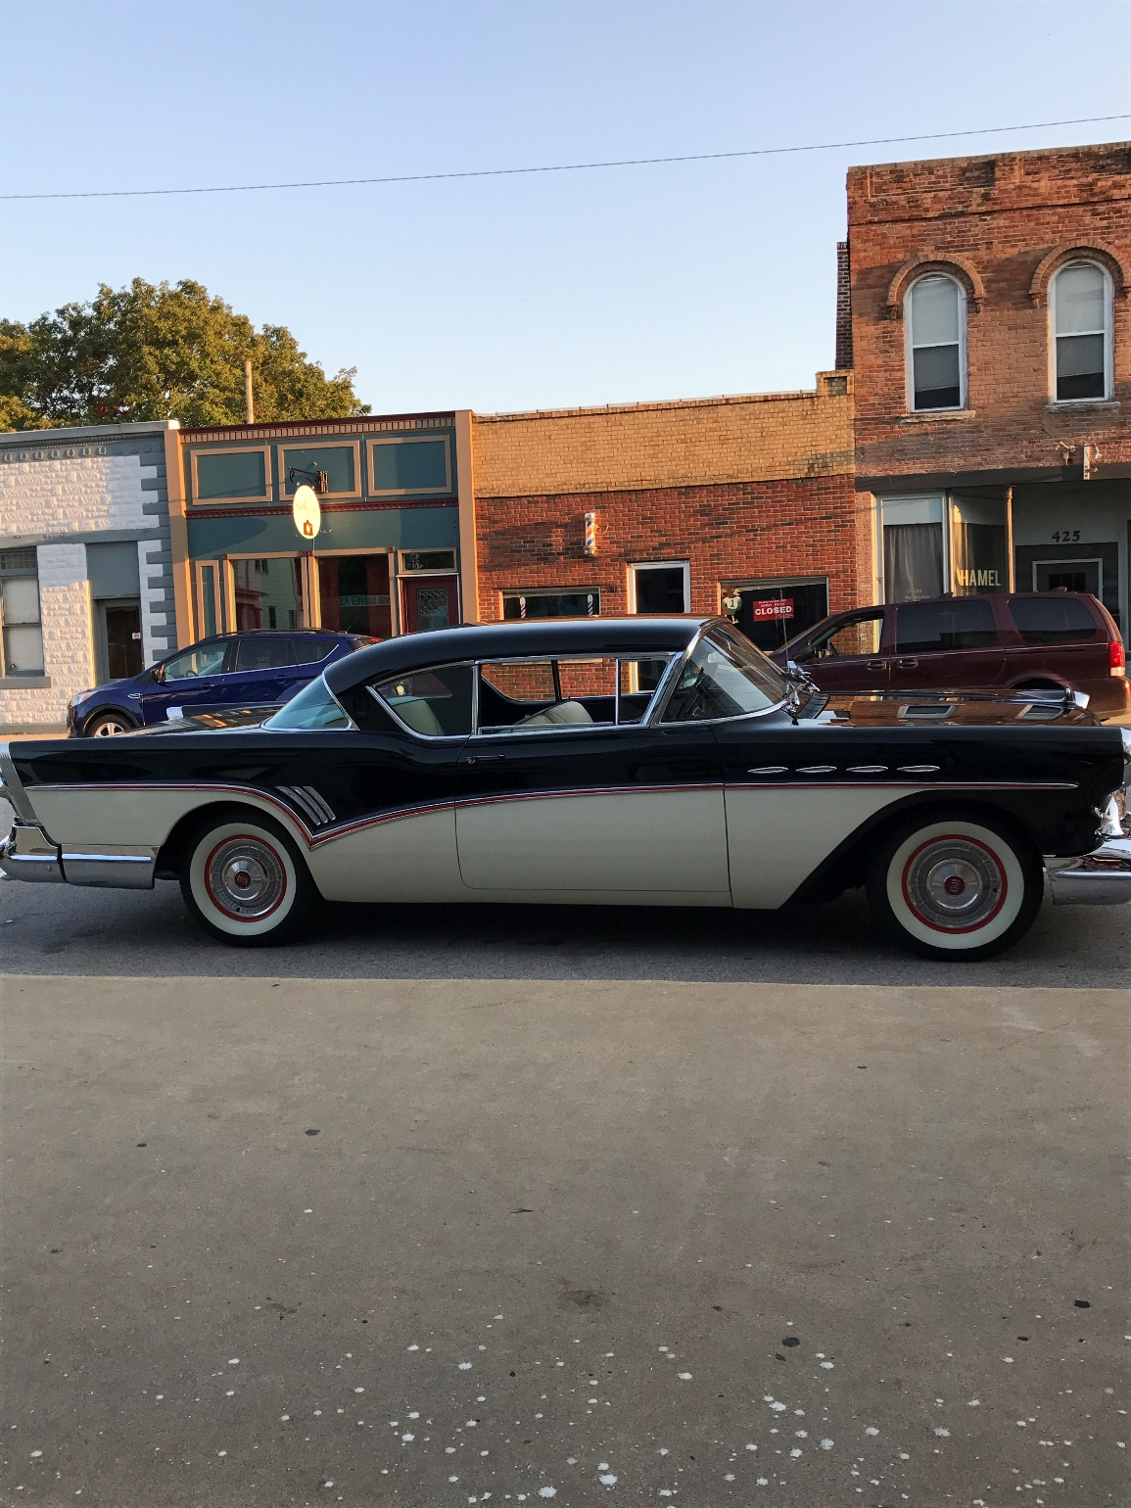

and even lived in Germany. His father first generated a love for the family car in him by purchasing an unforgettable 1957 Buick Special. As a child, Pat has fond memories of this car, sleeping across the back seat on a trip and then waking to stand on the transmission hump to see his mother driving it at 90 mph. Growing up in the ‘60s and 70’s, the prevalent muscle cars of yore further fueled his interest in automobiles.

Settled in Iowa for high school and college years, Pat met his wife and they were high school sweethearts. He attained a mechanical engineering degree in college and was involved with drive train design, operations and corporate administration for John Deere as a career. He also holds a private pilot’s license to fly Cessna planes.

Nancy and Pat have a family of three, Michelle and twins Sarah and Steven. Upon running the family car through a car wash after church one day, Pat spied a totally restored ’54 Buick Roadmaster and remembered his dad’s ’57 Special. The spirit of loving old Buicks was rekindled. He expressed his desire to find a ’57 Buick just like his dad’s to own and drive again in 2010. Nancy gave her approval.

After a brief Internet search, Pat found his ’57 Super 56R in nice shape and complete in Arkansas, as close to his father’s model as possible. After the purchase, while residing in LeClaire, Iowa, Pat began a four year total restoration of the car. Body and frame were done at Sterling Restoration in Sterling, Illinois; engine and transmission rebuilds were completed by a shop in Dubuque, Iowa.

Retiring from John Deere two years ago, Pat and Nancy moved to Carrolton, Illinois to be close to their children and grandchildren. They now have time to join car clubs and participate in events. Pat is also a member of the Cool Cruisers and White Hall Drag-o-Ways. He once owned a highly collectible 2002 Pontiac Firehawk but recently sold it with 8700 miles in favor of a 2017 Camaro SS. Sometimes pure power beckons one’s attention! We look forward to seeing Pat and Nancy at future events of the Gateway Chapter Buick Club.

