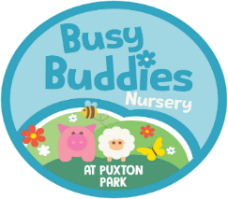Enrolment Enquiry
Dear Parent/Carer
Thank you for you enquiry, if you would like to complete the information below and email to busybuddiesdaycare@btinternet.com we will look to accommodate your requirements and will be in touch to discuss arrangements for full enrolment.
The Nursery is currently under construction and should be ready during March for the first children to enjoy in April 2020.
- Parent’s Name:
- Contact phone number:
- E-mail address:
- Child’s name
- Childs date of Birth (dd/mm/yyyy)
- Does your child have any special educational needs: Yes☐/No ☐?
If so, please provide details
- Sessions to start from date:
- Is the care required for term time only or all year around?
- Are you looking to use 15- or 30-hour Government funding?
- Will your child be attending any other setting (e.g. nursery, childminder) during the weeks with us Yes ☐/No☐?
If so, please provide details:
Please tick as required | Monday | Tuesday | Wednesday | Thursday | Friday
Full week 8am - 6pm
All day 8am - 6 pm
Short Day 8am – 4pm
Short day 9am-5pm
Morning 8am-1pm
Afternoon 1pm-6pm
Early start (between 7and 8 am)
After hours collection
Between 6 and 7 pm
Collection / drop off
In the meantime, please contact us if you have any questions alternatively please visit the website at busybuddiesdaycare.co.uk
Thank you
Busy Buddies

