Mountain Bike Centre of Scotland –

Primary School Children

Poster Competition Entry Form 2018

Please answer all questions in order for your submission to be eligible. The deadline is midnight on 4th November. We will contact you by email to confirm receipt.

Full competition details and forms can be found here: <https://mtbcos.co.uk/>

You can submit online:

sending all documents and media to mtb@napier.ac.uk with 'POSTER COMPETITION' in the subject line.

|  |  |
| --- | --- |
| Contact name: |  |
| Email address (parent/guardians if under 16): |  |
| Mobile/telephone number (parent/guardians if under 16): |  |
| Age and school year (as at 21 May 2018): |  |
| School Name and Address: |  |

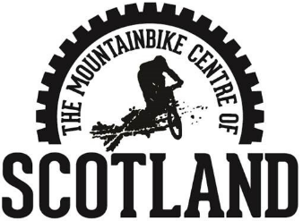

Mountain Bike Centre of Scotland

Peel Tower, Glentress Forest, PEEBLES EH45 8NB

Declaration – read and sign

• I confirm that I have read the competition terms and conditions and agree to them

• I confirm that the contacted named person on this form owns the rights to the material

• I confirm that the information I have given is true and accurate

Signed:

Print name

Date

For contact named person under 16 years of age

Consent Signed by Parent / Guardian

Print name

Date

Please submit this form online by email or post to:

Mountain Bike Centre of Scotland

Peel Tower,

Glentress Forest,

PEEBLES

EH45 8NB