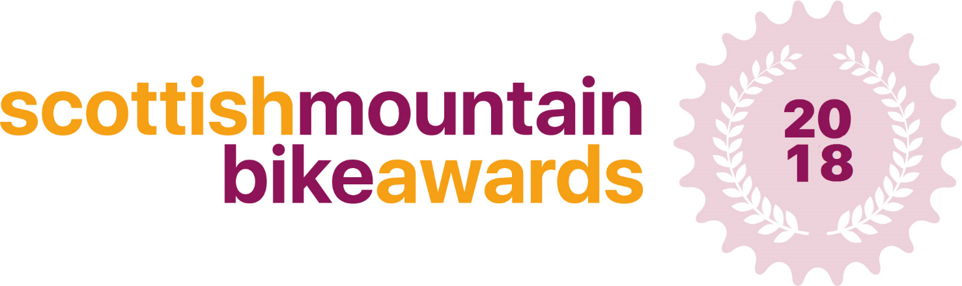
Scottish MTB Service Provider Application Form

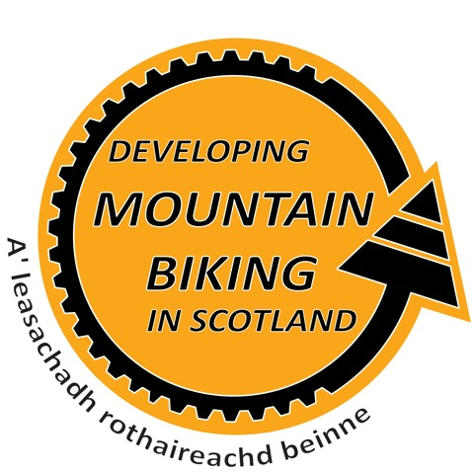
This form is designed to capture details of mountain bike tour operators, guides, coaches or skills instructors for consideration to become the 2018 Scottish MTB Provider of the Year.

The winner will be announced at the Scottish Mountain Bike Awards on the evening of Friday 23rd November at the Scottish Mountain Bike Conference 2018, in Aviemore - with the winners having their award presented to them on the night.
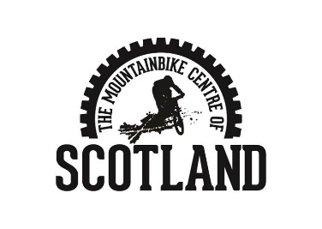
We have created this category because we recognise and wish to highlight and celebrate the very best service providers delivering mountain biking experiences in Scotland. We hope that this award will help riders find the best MTB companies in Scotland that by highlighting good practice we can raise the overall standard for mountain bikers visiting Scotland.

Please fill in the answers to the following questions, providing as much detail as possible – there is no limit on how much you can write.

When sending your application to us, please include at least 1 photo related to your project or a video if possible!

Thank you

Contact Details:

Full Name:

Business Name:

Address:

Telephone: |  | Mobile:

Email:

Aims of the Project:

Background to the project Why, where, when and how did your business begin?

Innovations

What have you done which you think is different from other MTB providers? What did you do and how did you do it? Who did you involve?

Results

What were the outcomes/results of your innovative ideas?

What one features of your project would you highlight as a particular success or unique aspect?

Future Innovations & Development

Without disclosing market sensitive information can you give us an idea into how you plan to innovate in the future?

Additional Information

Is there anything else you’d like to tell us about your business?

Guidance notes and eligibility criteria.

The award will recognise operators who provide a great service specific to MTB’ers. We are looking for the most innovative way these providers have adapted to welcoming MTB’ers or for the most innovative new MTB service. The award will be judged by a panel of experts who will judge each application individually.

- When sending your application to us, please include at least 1 high resolution photo related to your service/product!
- Your business must be registered in Scotland in order to apply for these awards.
- You must provide a service/product which is mountain bike related in order to apply.
Send your completed application to:
mtb@napier.ac.uk
Deadline for applications: Thursday 12th October

Please call 01721 722172 or email mtb@napier.ac.uk if you require any further information.

Timeline
Awards open for applications 15th September
Deadline for applications 12th October – 12 midnight
Judging – 14th October – 4th November
Shortlist Announced – 9th November

