

**MTB School/Community Club of the Year Application**

This form is designed to capture details of your mountain bike school/community club, for consideration to become the Scottish Cycling MTB School/Community Club of the Year 2018, announced at the Scottish Mountain Bike Awards on the evening of Friday 23rd November at the Scottish Mountain Bike Conference 2018, in Aviemore - with the winners having their award presented to them on the night. 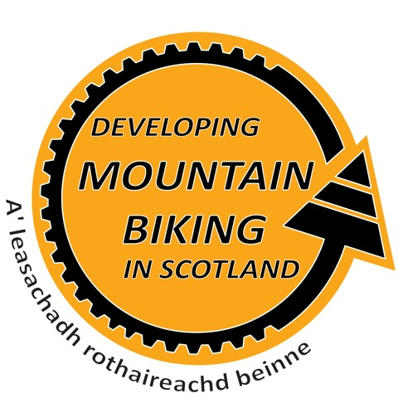

Please fill in the answers to the following questions, providing as much detail as possible – there is no limit on how much you can write.

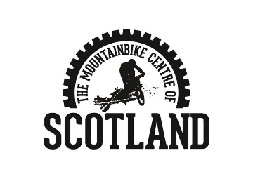When sending your application to us, please include at least 1 photo related to your project or a video if possible!

Thank you

**Contact Details:**

|  |  |
| --- | --- |
| **Full Name:** |  |

|  |  |
| --- | --- |
| **School club Name:** |  |

|  |  |
| --- | --- |
| **Address:** |  |

|  |  |  |  |
| --- | --- | --- | --- |
| **Telephone:** |  | **Mobile:** |  |

|  |  |
| --- | --- |
| **Email:** |  |

**Aims of the Project:**

|  |
| --- |
| **Background to the club What are the foundations of the club?** |

**Innovations**

|  |
| --- |
| **What have you done which you think is different from other clubs? What did you do and how did you do it? Who did you involve? (Departments/ Community groups/ Clubs/ Agencies/ Parents/ Leisure centres/ Volunteers etc)** |

**Results**

|  |
| --- |
| **What were the outcomes/results of your innovative ideas? (How many people are now part of your club? How often do you have coaching sessions? Do your riders attend events?)** |
| **What one features of your project would you highlight as a particular success or unique aspect?** |

**Future Innovations**

|  |
| --- |
| **How do you plan to innovate in the future?** |

**Additional Information**

|  |
| --- |
| **Is there anything else you’d like to tell us about your club?** |

**Guidance notes and eligibility criteria.**

This award will celebrate and recognise a local MTB club. We are looking for clubs that have made a unique impact to their local MTB community. This award will be judged by a panel of experts who will judge each application individually.

* When sending your application to us, please include at least 1 high resolution photo related to your service/product!
* Your club must be registered in Scotland in order to apply for these awards.
* You must provide a service/product which is mountain bike related in order to apply.

Send your completed application to:

[mtb@napier.ac.uk](mailto:mtb@napier.ac.uk)

Deadline for applications: Thursday 13th October

Please call 01721 722172 or email [mtb@napier.ac.uk](mailto:mtb@napier.ac.uk) if you require any further information.

Timeline

Awards open for applications 15th September

Deadline for applications 13th October – 12 midnight

Judging – 14th October – 4th November

Shortlist Announced – 9th November